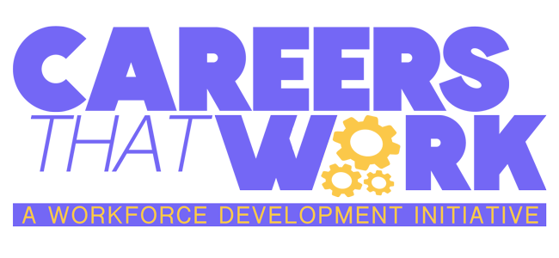
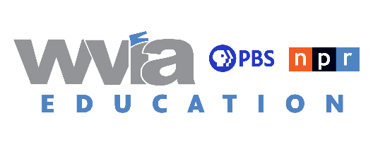

Lesson #1 - Careers That Work: Licensed Professional Counselor
Subject: Career Awareness & Preparation; Career Acquisition
Grade Levels: 4th Grade – 12th Grade

Standards
13.1.5.A - Describe the impact of individual interests and abilities on career choices.
13.1.5.B - Describe the impact of personal interest and abilities on career choices.
13.1.5.C - Relate the impact of change to both traditional and nontraditional careers.
13.1.5.D - Describe the range of career training programs in the community such as, but not limited to:
● Two-and four-year colleges
● Career and technical education programs at centers (formerly AVTS) and high schools
● CareerLinks
● Community/recreation centers
● Faith-based organizations
● Local industry training centers
● Military
● Registered apprenticeship
● Vocational rehabilitation centers
● Web-based training
13.1.5.F - Investigate people’s rationale for making career choices.
13.1.5.H - Connect personal interests and abilities and academic strengths to personal career options.
13.1.8.A - Relate careers to individual interests, abilities, and aptitudes.
13.1.8.B - Relate careers to personal interests, abilities and aptitudes.
13.1.8.D - Explain the relationship of career training programs to employment opportunities.
13.1.11.A - Relate careers to individual interests, abilities, and aptitudes.
13.1.11.B - Analyze career options based on personal interests, abilities, aptitudes, achievements, and goals.
13.1.11.C - Analyze how the changing roles of individuals in the workplace relate to new opportunities within career choices.
13.1.11.E - Justify the selection of a career.
13.2.8.E - Explain, in the career acquisition process, the importance of the essential workplace skills/knowledge, such as,
but not limited to:
● Commitment
● Communication
● Dependability
● Health/safety
● Laws and regulations (that is Americans With Disabilities Act, child labor laws, Fair Labor Standards Act, OSHA, Material Safety Data Sheets)
● Personal initiative
● Self-advocacy
● Scheduling/time management
● Team building
● Technical literacy
● Technology

Rationale
Provide the students with an opportunity to learn about and understand the intricacies of being a Licensed Professional Counselor and why it is such an important career for the health of our community.

Vocabulary
Mental health
Diagnose
Holistic
Empathy
Genuine
License
Therapist

Objectives
● Be able to explain what the Licensed Professional Counselor career involves.
● Be able to identify essential skills required of a Licensed Professional Counselor
● Be able to present on the importance of the Licensed Professional Counselor career and its impact on the health of our community

Lesson Essential Question(s)
● What is a Licensed Professional Counselor?
● What are the essential duties that are required of a Licensed Professional Counselor?
● How does being a Licensed Professional Counselor impact the health of our community?

Duration
1 class period, approximately 40 minutes

Activities
Students will view Careers that Work: Licensed Professional Counselor
When the video is finished, place students in small groups or pairs to complete tasks.
Task #1: Give a short description of the Licensed Professional Counselor career, including a definition of the job and a general list of skills required of a Licensed Professional Counselor. Have students take notes using Handout #1: General Information: Licensed Professional Counselor.
Task #2: Focusing on specific vocabulary and requirements of the Licensed Professional Counselor career, have students complete Handout #2.
1. Grades 4-8, Handout #2: Licensed Professional Counselor Word Scramble - Considering the Careers That Work: Licensed Professional Counselor video content and supplied vocabulary words, have students complete the word scramble.
2. Grades 9-12, Handout #2: Licensed Professional Counselor Career Presentation - In small groups or pairs, students will research and present on the Licensed Professional Counselor career. Be informative, creative, and persuasive while also being mindful of important public speaking skills. This project will be graded using the Career Presentation Rubric (included on the handout provided). At least 5 minutes should be spent presenting on this topic using at least 1 visual aid.

Related Materials & Resources
Handout #1: Career Information – Licensed Professional Counselor
Handout #2: Grades 4-8: Licensed Professional Counselor Word Scramble
Grades 4-8: Licensed Professional Counselor Word Scramble, Teacher’s copy
WVIA’s Careers That Work: www.wvia.org/careersthatwork
Path to Careers: www.pathtocareers.org
Pennsylvania Careerlink: www.pacareerlink.pa.gov/jponline/

