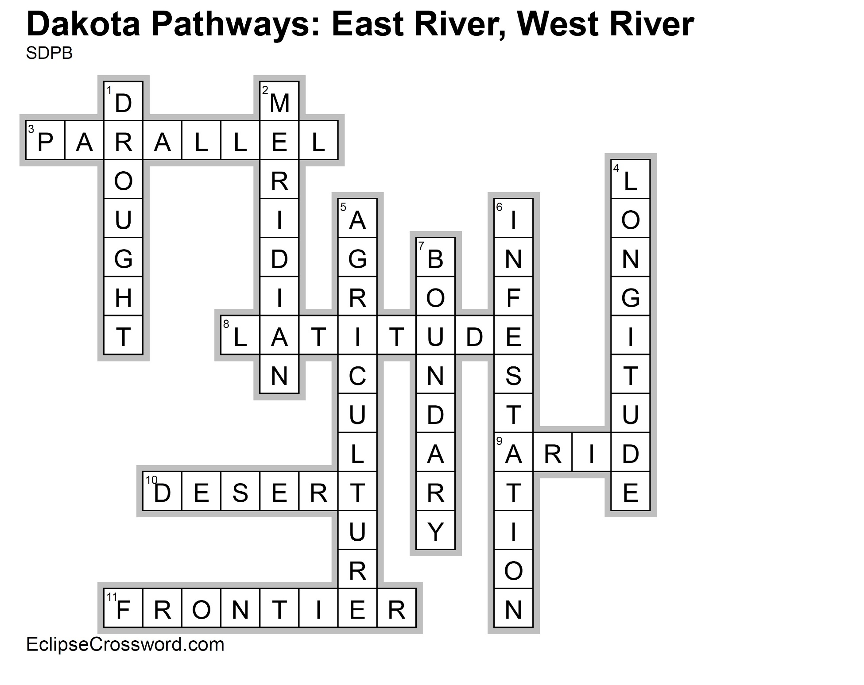

**Across**

3. PARALLEL — Another name for lines of latitude,

which run east and west on the map

8. LATITUDE — Parallel lines starting at the equator

measuring distance north and south

9. ARID — Lacking moisture; not enough rain

10. DESERT — Dry, barren, and often sandy region

11. FRONTIER — The extreme limit of settled land

beyond which lies wilderness, especially referring

to the western US before Pacific settlement

**Down**

1. DROUGHT — Prolonged period without

precipitation

2. MERIDIAN — Another name for lines of longitude,

which run north and south on the map

4. LONGITUDE — Meridian lines starting at the

Prime Meridian measuring distance east and west

5. AGRICULTURE — Science, art, and business of

producing crops and raising livestock

6. INFESTATION — Spread of something harmful

7. BOUNDARY — Something that indicates a border

or limit