Creating Writing Activity: Closing Argument

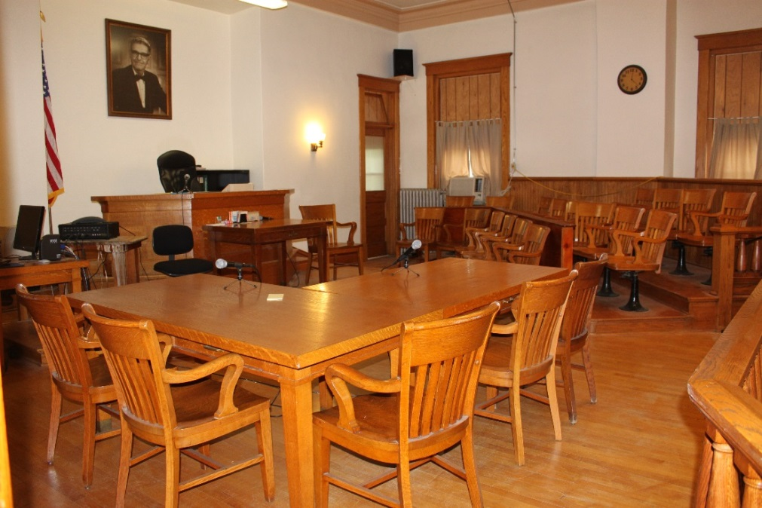
Hyde County Courtroom

In South Dakota there are three levels of court systems, the Supreme Court, circuit courts and the magistrate courts (Guide to South Dakota Courts). The highest level is the Supreme Court, which functions mainly as an appeals court of contested circuit court cases. The circuit courts of South Dakota are the general trial courts. The magistrate courts preside over less serious civil cases and minor criminal cases. The proceedings take place in county courthouses across South Dakota.

During this activity, your students will use story starters (writing prompts) to promote creative writing. The students will be introduced to real and hypothetical court cases. The students will theorize the evidence in detail and write the closing argument (summary of evidence).
According to the United States Courts system, there is a clear difference between the opening statement and closing argument. During this activity, your students will write a closing argument. Below is information about a closing argument; the information is provided by the United States Courts system. Additional information about the difference between the opening statement and the closing argument is found at United States Courts.

Closing Argument:
Only after the jury has seen and heard the factual evidence of the case are the parties allowed to try to persuade them about its overall significance. Closing arguments are the opportunity for each party to remind jurors about key evidence presented and to persuade them to adopt an interpretation favorable to their position. At this point, parties are free to use hypothetical analogies to make their points; to comment on the credibility of the witnesses, to discuss how they believe the various pieces of the puzzle fit into a compelling whole, and to advocate why jurors should decide the case in their favor.

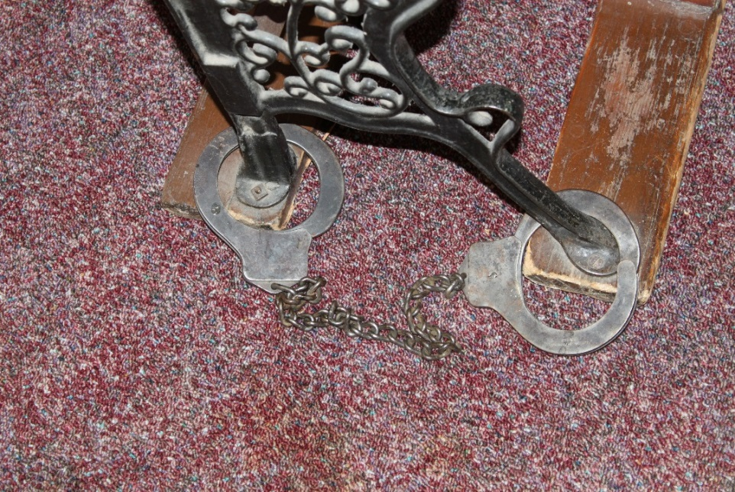
Turner County Handcuffs on Chair

Process:

- Your students will write the closing argument (prosecution or defense) for one of the real or hypothetical court cases below (or create additional cases for your school).

- First, the students should visualize/imagine the crime scene (location) of the scenario. Then, the students should chronologically imagine the crime/event and write about the evidence that supports their position (prosecution or defense). Details like tire pattern, elapsed time, samples (like hair, blood, etc.), alibies, paint chips, color of lip-gloss, no signs of a break-in, etc. are a few examples of evidence that should be considered and included in the closing argument. This activity is like the crime scenes and evidence portrayed in crime novels or episodes of crime shows like PBS’s Sherlock, CSI, or Monk.

- Selecting a court case – three separate options below:

  - The following website has the South Dakota Supreme Court Opinions for about the past 20 years. Real court cases tried in South Dakota are available at this site. If you choose to use this site, please select the cases for your students. Many of the cases are of an adult nature. Also, the cases are real, so family/friend connections are possible.

  - Write theoretical cases for your class like the examples below.

  - Below are a few examples of hypothetical cases.

- Yankton High School vs. Jeremy Smith, Yankton, SD: The Plaintiff, Yankton HS, is seeking reimbursement for damages sustained to their football field on the night of October 18th, 2024. Jeremy Smith, the Defendant, is accused of driving his 1997 Ford F150 pickup truck on the football field resulting in damage to the field/sod, the four underground sprinklers, and a wooden fence. Damage to the football field was $13,258.

- The State of South Dakota vs. Steven Smith, Beresford, SD: Steven Smith is charged with grand larceny for the September 28th robbery of Jack’s Food Town, Sioux Falls. Steve Smith is accused of breaking into the north door of Jack’s Food Town in the early morning hours of September 28th, 2023. It is estimated that $7,500 was taken from 2 cash registers and a safe. Items like baby formula and meat were also taken.

- The State of South Dakota vs. Jill Wilmerson, Newcastle, NE: Jill Wilmerson is accused of hit and run for damages sustained to a parked vehicle owned by Robert Blakenfield. Robert Blakenfield’s car was parked on Main St., Vermillion, SD, near the intersection of Court St. and Main St. when it was hit by a car believed to be driven by Jill Wilmerson. The car, believed to be driven by Jill Wilmerson, then fled the scene of the accident.

- The State of South Dakota vs. Bill Smithson, Hot Springs, SD: Bill Smithson is accused of arson on August 15th, 2022. The Rosenburg Fire burned 35 acres of the Custer State Park Forest and destroyed 2 cabins.

- Rebecca Doe, Parkston, SD vs. Robert Mathusfield, Parkston, SD: The Plaintiff, Rebecca Doe, is seeking compensation in the amount of $75,000 for medical bills and pain/suffering for injuries she received from a December 18th, 2019, fall. Rebecca Doe alleges that she fell on a sidewalk owned by Robert Mathusfield, resulting in her injuries. Rebecca Doe contends that the sidewalk was not properly maintained.

- Rutland Elementary vs. Sally Renalds: Sally Renalds is charged with larceny for the February 23, 2017, robbery that took place in the Rutland Elementary 5th-Grade Classroom. Sally Renalds is accused of stealing a green apple lollipop from the 5th grade reward jar.

- There was a two vehicle accident, with no injuries, at the corner of 6th Ave SE & Centennial St S, Aberdeen, SD (Location on Google Map – access the street view), resulting in damage to both vehicles. Paula Smith was driving a 1989 Chevy Blazer heading west, and Rick Doe was driving a 2006 Dodge Caravan heading east. Who was at fault and why?

- Winner High School vs. Ryan Smith: Ryan Smith is charged with cheating. Ryan Smith is accused of cheating on an Algebra II test on January 21st, 2020.

- Encourage creativity – Drawings and staged photos of the crime scenes/evidence can add another dimension to the creative writing experience for the students.

Contact EdServices@sdpb.org for
more information about SDPB’s educational resources



