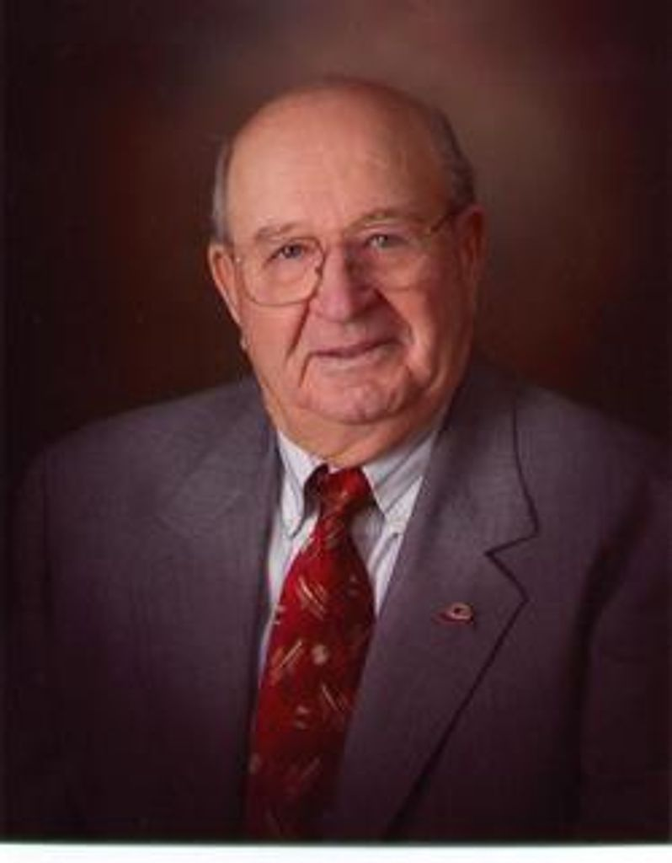
Roy C Crisman, Jr.
March 9, 1922 – July 22, 2016
Obituary
Roy C. Crisman, Jr., age 94, of Wagner, passed away on Friday, July 22, 2016 at Avera Sacred Heart Hospital, Yankton.
Wake services will be Tuesday, July 26 at St. John the Baptist Catholic Church in Wagner at 7:00pm.
Mass of Christian burial will be 10:30am Wednesday, July 27 at St. John the Baptist Catholic Church in Wagner with Rev. Robert Wullweber officiating and Rev. Richard Baumberger concelebrant. Visitation will be from 2-5pm on Tuesday at Crosby-Jaeger Funeral home and then one hour prior to the Mass on Wednesday at the church. A Rosary and Wake Service will be Tuesday at 7pm at the church.
Roy was born on March 9, 1922 to Roy, Sr. and Grace (Rude) Crisman in Wagner. He attended Aggie school in Brookings, South Dakota. He farmed for a short time before being called to service in the US Navy from 1945-1946.
On February 11, 1956, Roy married Geraldine Cahalan at Sacred Heart Catholic Church in Rockwell, Iowa. They enjoyed 60 years of marriage. To this union, six children were born – James, Charles, Maureen, Cynthia, Mary, and Paul.
Roy's avocation was his vocation – he began flying in a J-3 Cub at the Wagner Airport in 1946 under the GI Bill. He soloed in June 1947 and earned his private license in September 1947. He earned a commercial rating in 1953, a multi-engine rating in 1961, and an instrument rating in 1974. Roy started crop spraying in Wagner in 1956 and began managing the Wagner Municipal Airport in 1958 until retirement in 1998. He owned several planes over the years, taught many students to fly, sold multiple aircrafts, proved frequent air charters, pioneered air ambulance, and flew Game Fish & Parks personnel on wildlife counts. Beginning in the late 1940's, Roy gave airplane rides at Wagner over the Labor Day weekend for 1-2 cents a pound - or 50 cents a foot in height - to hundreds of people including several generations of the same families. He accumulated over 25,000 hours of flight time over a 58-year period. He received the DOT FAA Wilbur Wright "Master Pilot" Award in 2005.
Among the many organizations to which Roy contributed his time and talent include Knights of Columbus (50 years), American Legion (70 years), South Dakota Flying Farmers (68 years), South Dakota Crop Sprayers, International Flying Farmers, and Aircraft Owners and Pilots Association (AOPA). He was a member of St. John the Baptist Church, taught CCD, and served as an usher and lector. As a youth, Roy was active in 4-H. At age 11, his entry of a jet black Aberdeen-Angus calf earned grand championship honors.
Survivors include his wife, Geraldine; 6 children: James (Chris) Crisman, Ft. Collins, CO; Charles (Mariann) Crisman, Prince Frederick, MD; Maureen (James) Cadwell, Hermosa, SD; Cynthia (Steve) Stocks, Rapid City, SD; Mary (Gary) Hieb, Mitchell, SD; and Paul (Cheryl) Crisman, Morris, IL; 17 grandchildren and 7 great-grandchildren; and 1 sister, Betty Nesby, and 4 brothers, Roland (Mayme) Crisman, Melton Crisman, Burton (Gaye) Crisman, and Clark (Sharon) Crisman; and sister-in-law, Laura Crisman.
He was preceded in death by his parents, two sisters, Glyde Miller and Gloria Young, and one brother, Kenneth Crisman.
In lieu of flowers, the family requests memorials be directed to Special Olympics South Dakota, 800 E. I-90 Lane, Sioux Falls, SD 57104; St. John the Baptist Catholic Church,107 High Ave SW, Wagner, SD 57380; or the Good Samaritan Center, 515 W SD HWY 46, Wagner, SD 57380.

