Homestake's Ellison Shaft Fire - 1930
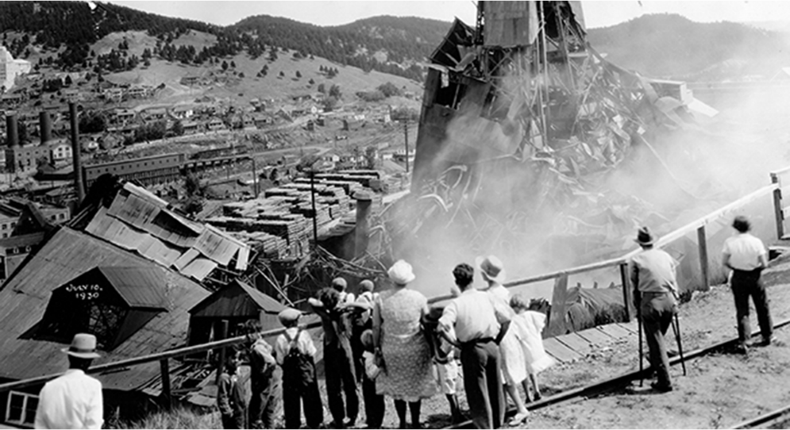
Homestake Mine - July 10, 1930, Courtesy: Deadwood History, Inc.

Reaction Rate: Surface Area
During this activity, your students will learn about a tragic 1930 fire at the Ellison Shaft, Homestake Gold Mine, which claimed the lives of two men. They will also use household items to investigate how an increase in the surface area of a solid reactant increases the reaction rate of a chemical reaction. Finally, they will learn how adding chemicals like aspirin to a sewer system is damaging to the environment and water supply.

The Homestake Mining Company began operations in 1877, ultimately developing into one of the largest and deepest underground gold mines before its closure in the early 2000s. One of the reasons for the mine’s success in producing over 40 million ounces of gold during its lifetime was its ability to generate substantial production through innovative methods and prompt decision-making, even in the face of hardships.

By 1895, the need for a new, larger shaft at the mine was apparent due to its growth and expansion and the proximity of the current shafts-- the Golden Star, the Golden Prospect, and the B&M-- to valuable ore pockets. Construction of the Ellison Shaft on the General Ellison mineral claim began in 1895. Construction on the headframe, hoist house, and crusher room got underway in 1897. The shaft was located across from the pre-existing shafts on Gold Run Gulch. A 900-foot tramway was built across the gulch to haul ore from the Ellison to the Homestake Mills. The entire shaft, headframe, hoist, crushing plant, and tramway were completed on January 1, 1902, costing approximately one million dollars.

On the evening of July 10, 1930, tragedy struck the Ellison Shaft. A fire ignited from overheated pipes in the air compressor room shortly before 8 pm. Within minutes, the headframe and many smaller buildings nearby were rapidly burning. Several dynamite caps housed nearby exploded, augmenting the blaze, which could be seen for over a mile. (Entire Story about the Ellison Shaft Fire at Homestake Gold Mine)

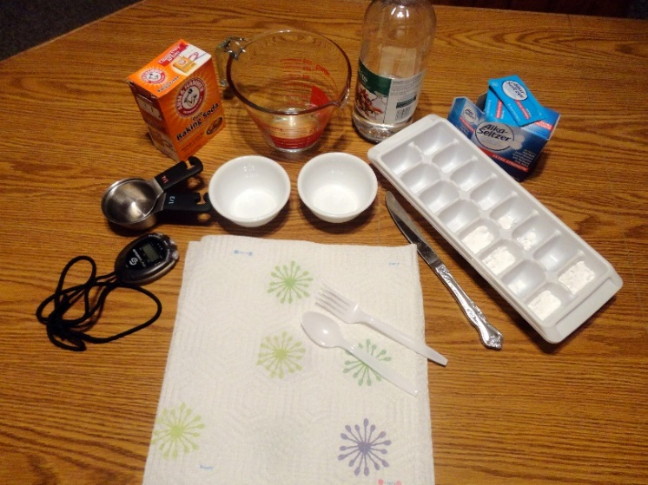

Activity:

Materials:
- Effervescent tablets
- Water
- Baking soda
- Vinegar
- Measuring devices
- Bowls or beakers
- Ice cube tray or similar container
- Utensils for stirring
- Stopwatch
- Paper towels

- Introduce the activity by teaching the students about the tragic 1930 Ellison Shaft Fire at the Homestake Gold Mine, Lead, SD.

- Next, show one (or both if age-appropriate) of the demonstrations below:
- Ask the students if they have ever tried to start a campfire. Visit about the importance of kindling and how much easier it is to start a fire with twigs, brushwood, and dry leaves in comparison to an entire log.
    - The following demonstration is quick and inexpensive, but impressive. The demonstration should not be shown to young children if there is a risk that they would try it unsupervised. Take two pieces of computer paper. Shred one piece with scissors. Using a match or lighter, light the uncut piece of paper on fire and record the amount of time it takes to burn. Next, light the shredded piece of paper on fire and time how long it takes to burn. The shredded piece of paper has more surface area, which increases the rate at which the fire burns. (Use extreme caution if this demonstration is shown to the students – photos below.)

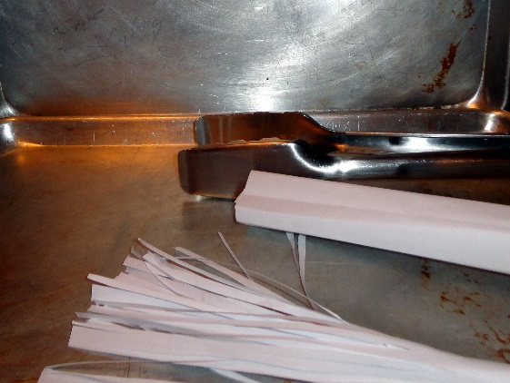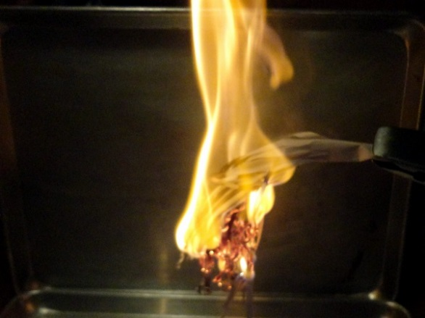

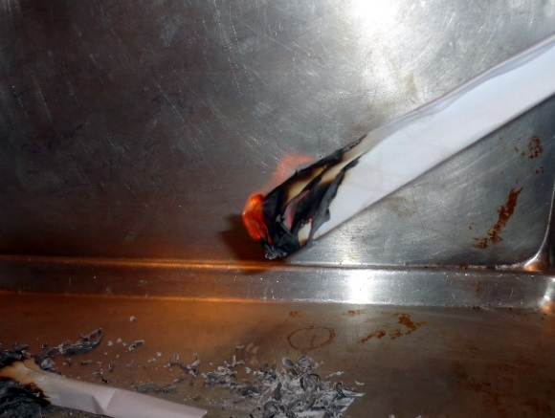

  - Ask the students if they have ever seen an effervescent tablet like Alka-Setzer? Explain how the tablet is designed to release medications into the water, like antacids and aspirin.
    - Demonstrate how much faster the reaction takes place if the tablet is crushed into a powder. Hint - An old projector works great for this if you have one available at your school. Place a transparency on the projector and then two clear glasses with water in them. At the same time, place an entire tablet in one of the glasses and the powder in the other. The shadow of the reactions will display on the screen. The glass with the powder is gone within a second or two. The glass with the uncrushed tablet will continue to react for a few seconds. An ELMO also works well. (Photos below)

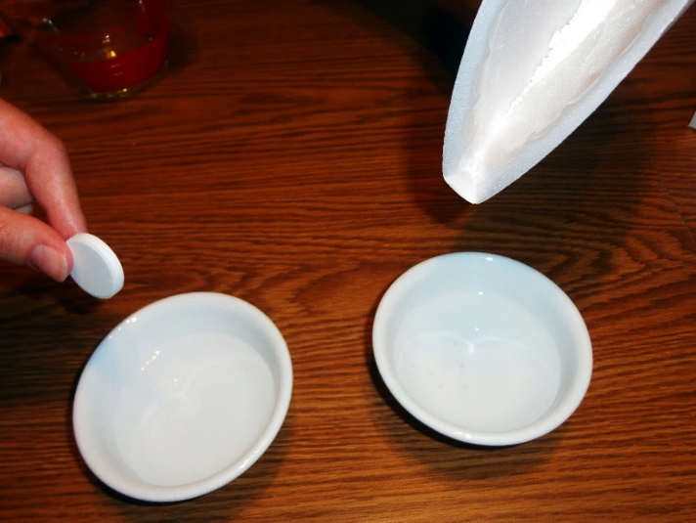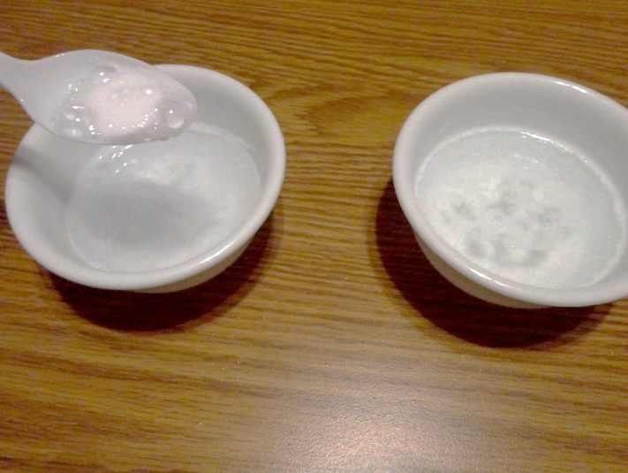

- Ask the students why they think that the reaction occurred at an increased rate. Explain how an increase in the surface area of a solid reactant increases the reaction rate of a chemical reaction.

- The students will now conduct an experiment to test if an increase in surface area leads to an increase in the reaction rate.
  - Lesson Extension: Environmental Issue (if time allows)
    - Explain how it would be convenient to use effervescent tablets during this experiment because they can be broken apart easily into increasingly small pieces. Unfortunately, many of the tablets include a mixture of medicines like aspirin. There is a growing concern about pharmaceuticals making their way into drinking water.
      - The Complicated Question of Drugs in the Water
      - Pharmaceuticals and Personal Care Products
      - Water Topics
      - USGS – Pharmaceuticals in Water
    - Ten groups, each using 5-10 tablets, would result in 50-100 tablets going down the drain. The following exponential growth video and activity could be used to help the students understand how a large population of people, each placing a small amount of medication in a sewer system, multiplies to a large amount very quickly.

- Day one - The students should use baking soda bricks and vinegar to conduct the experiment instead of effervescent tablets. The bricks are made by mixing approximately a 1:1 mixture of water and baking soda, as shown below. The mixture should be stirred as it is poured into the mold. Excess water should be removed from the mold once the mixture has settled. This step provides an opportunity for the students to practice proper lab techniques.

- Day two (once the bricks have dried) - Remove the bricks from the mold. The bricks could be cut/broken into 1/2 or 1/3 to reduce the amount of vinegar needed.

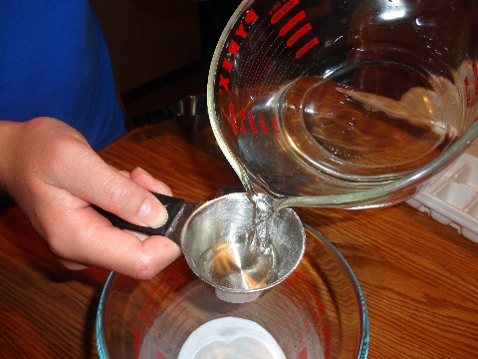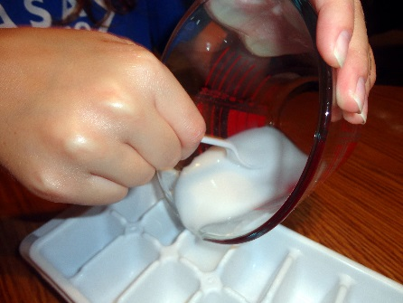

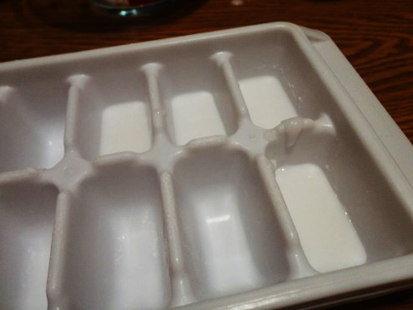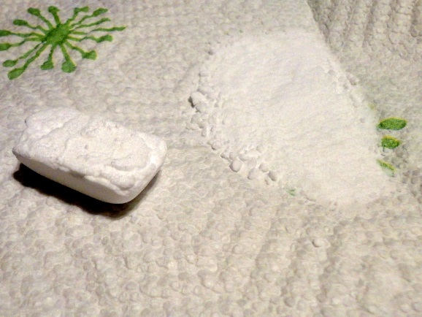
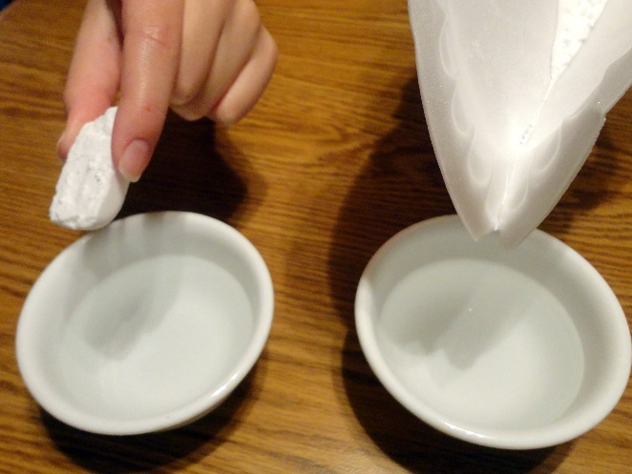

- The same-sized brick should be used each time. The students should start with a full piece and place it in the vinegar, timing how long it takes to dissolve. Next, the students should use the same-sized brick but break it into 1/2 to increase the surface area. The time taken to dissolve should be recorded. The process should continue until a powder is used (shown left). The number of bricks used can be determined by setting a specific number of trials and by reducing the initial size of the brick by 1/2 or 1/3.

- The students should record their results and journalize their experience. The journal should include drawings, a data table, a graph, a detailed description of the entire process, and the results/conclusion.

Reaction Rate Resources:

- Chemistry Matters - Reaction Rate Video
- Increase Surface Area Activity



