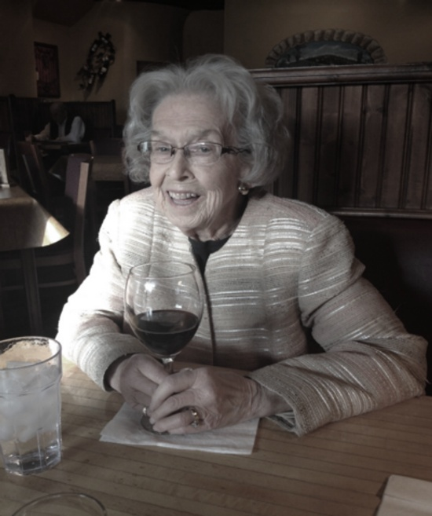
Elta May Woodard
May 29, 1925 – February 8, 2022
Obituary
Elta May (Kurtz) Woodard passed away peacefully on February 8, 2022 of natural causes at Sioux Falls hospice at age 96. Elta was born May 29, 1925 in Esterville, IA, to Fred Kurtz and Elta Lillian (Kretsinger) Kurtz Elta May's mother died when she was only 6 months old. Elta was then raised by her grandparents, Eldridge Ulysses Kretsinger, and Lottie Mae (Knodle) Kretsinger. During Elta's life span, she knew her great-grandparents, (both grandfathers were in the Civil War), to was able to meet her youngest great-grandchild in 2021.
Elta completed high school in Elkton, SD and attended business school in Rapid City in 1943. Her employers were Firestone Company in Minneapolis, Kellogg Company in Omaha, City Office in Winner, SD, and S.D. Real Estate Commission in Pierre. Elta married Vern Charles Woodard, December 27, 1946, in Flandreau, SD. They were married 67 years. Vern passed away in March 2014. She was a full-time home maker while her children were young. She enjoyed writing, especially with the Writer's Inc. group, writing poetry and an avid reader.
Elta was preceded in death by her husband, Vern Woodard and her son-in-law, Rick Sterling and we miss all three family members with thoughts and prayers. Elta will be buried next to her husband at Fairview Cemetery in White, SD this spring. She was preceded in death by her father Fred E. Kurtz, step-mother Florence Kurtz, and brothers Curtis, Fred, and Kendall Kurtz.
Elta is survived by siblings, Doreen Smith of Greeley, CO, Jo Ann and Willy Meyer of Brookings, Wallace and Carol Kurtz of Rocky Ford, CO and Leslie Ferris of Boynton Beach, FL, sister-in-law Christine Woodard of White, SD and many nieces and nephews.
Elta is also survived by her children daughter Vicki Sterling of Rapid City, sons Dirk (Eva) Woodard of Sadalia, CO, and Kurt (Judy) Woodard of Sioux Falls, three grandchildren Kyle (Yolande) Sterling of San Francisco CA, Wendy (Corey) Brink of Sturgis SD, and Monica (Adam) Kohlman of Castle Rock, CO and three great-grandchildren Brody, Maggie and Nora.

