Charles Dawes Obituary
November 23, 1925 — August 26, 2020
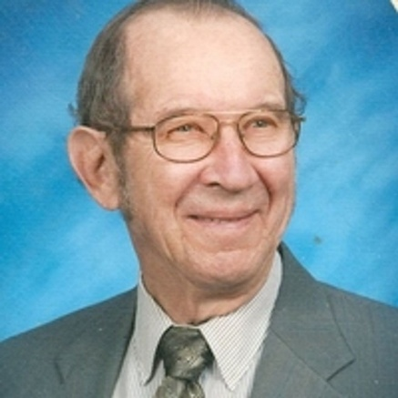
Charles Dawes, 94 of Mitchell, originally of Springfield, passed away on August 26, 2020 at the Good Samaritan Nursing Home in Lennox. Graveside service with Military Honors will be 1:00 PM Tuesday, September 1, 2020 at the Springfield Cemetery , Springfield SD.
In Lieu of Flowers, memorials can be directed to the VA Hospital.
Charles was born on November 23, 1925 in Springfield, Bon Homme County, SD to Jesse E. and Anna Dawes. He attended Quinn School, District 33, and graduated from Springfield High School in 1943. He started school at Southern State Teachers College, served nineteen months is the U.S. Army, and returned to Southern and graduated in 1950. Charles managed the bookstore, eventually managing the student union until 1963. He taught four years in public schooling, then retiring as a typing instructor at Nettleton Business College in 1982.
Charles was married to Linda Fisher Kurtz of Delmont in 1978. In the fall of 1995 they moved to Mitchell.
When living in Springfield, Charles played with the American Federation of Musicians, No. 255 of Yankton for many years. He also played in the American Legion Department Band, Mitchell City Band, and other community bands, playing the trombone. He was a lover of sports and music. He loved to dance in his younger years.
Charles was a lifetime member of The American Legion, Siouxland Chapter of Ex-Prisoner of War, lifetime member of Disabled American Veterans, and The United Church of Christ.
He was preceded in death by his wife Linda, his parents Jesse E. and Anna Dawes, brother Jesse Hobert Dawes, sister and brother-in-law Nina and Clarence Jansen, and infant brother Ray. He will be greatly missed by his nieces and nephews.

