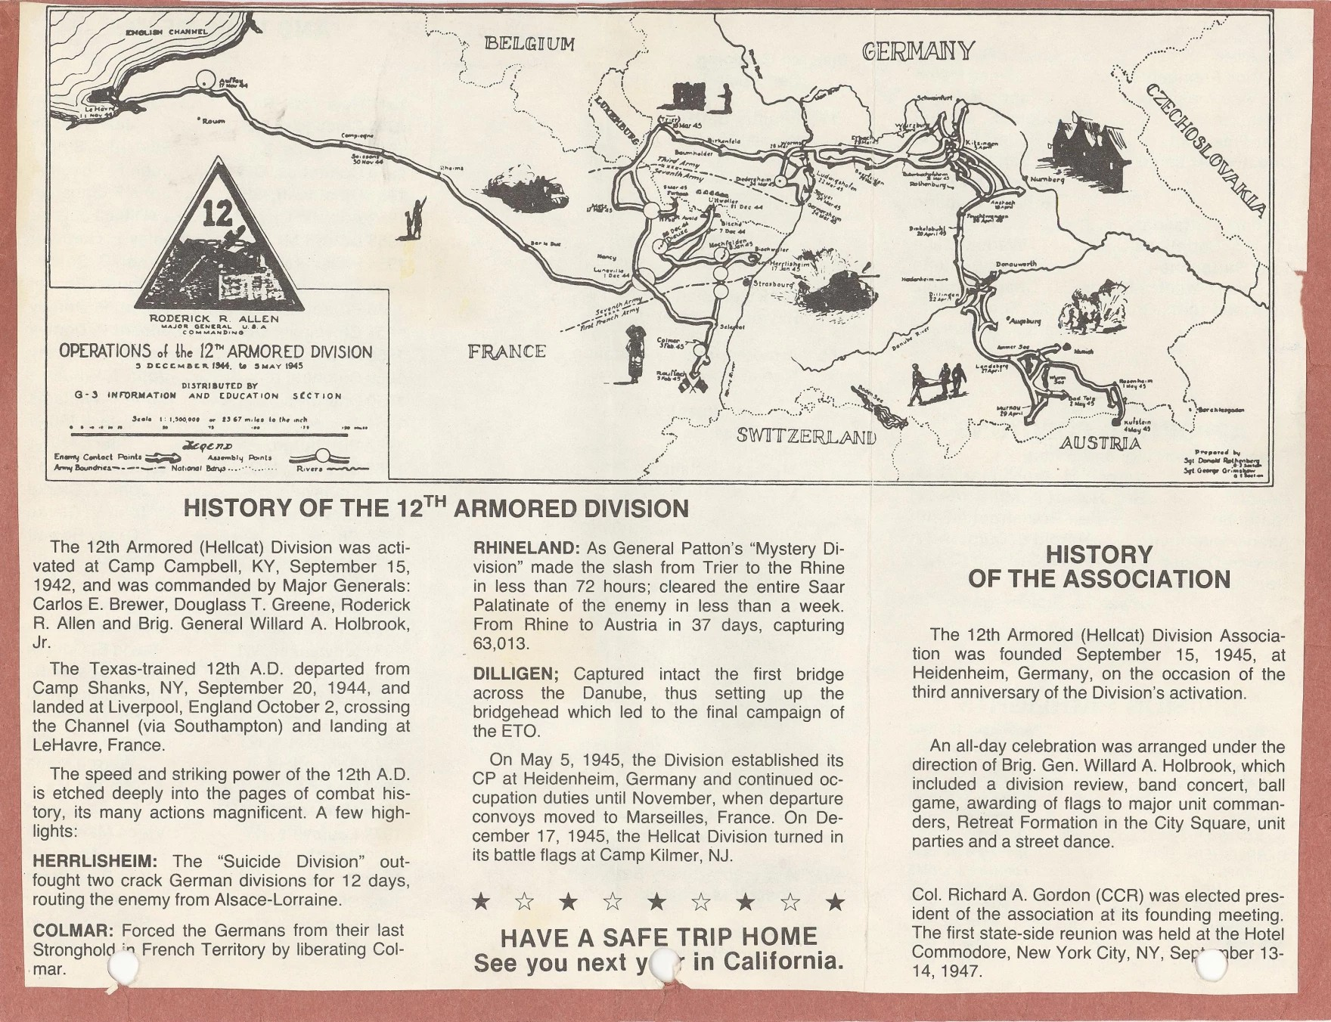
HISTORY OF THE 12TH ARMORED DIVISION
The 12th Armored (Hellcat) Division was activated at Camp Campbell, KY, September 15, 1942, and was commanded by Major Generals: Carlos E. Brewer, Douglass T. Greene, Roderick R. Alien and Brig. General Willard A. Holbrook Jr.
The Texas-trained 12th A.D. departed from Camp Shanks, NY, September 20, 1944, and landed at Liverpool, England October 2, crossing the Channel (via Southampton) and landing at LeHavre, France.
The speed and striking power of the 12th A.D. is etched deeply into the pages of combat history, its many actions magnificent. A few high-lights:
HERRLISHEIM: The Suicide Division out-fought two crack German divisions for 12 days, routing the enemy from Alsace-Lorraine.
COLMAR: Forced the Germans from their last Stronghold in French Territory by liberating Colmar.
RHINELAND: As General Patton's "Mystery Division" made the slash from Trier to the Rhine in less than 72 hours: cleared the entire Saar Palatinate of the enemy in less than a week. From Rhine to Austria in 37 days, capturing 63,013.
DILLIGEN; Captured intact the first bridge across the Danube, thus setting up the bridgehead which led to the final campaign of the ETO.
On May 5, 1945. the Division established its CP at Heidenheim, Germany and continued occupation duties until November, when departure convoys moved to Marseilles, France. On December 17, 1945, the Hellcat Division turned in its battle flags at Camp Kilmer, NJ.
HISTORY OF THE ASSOCIATION
The 12th Armored (Hellcat) Division Association was founded September 15, 1945, at Heidenheim, Germany, on the occasion of the third anniversary of the Division's activation.
An all-day celebration was arranged under the direction of Brig. Gen. Willard A Holbrook, which included a division review, band concert, ball game, awarding of flags to major unit commanders, Retreat Formation in the City Square, unit parties and a street dance.
Col Richard A. Gordon (CCR) was elected president of the association at its founding meeting. The first state-side reunion was held at the Hotel Commodore, New York City, NY, September 13-14, 1947.

