Arthur R. Moran Obituary
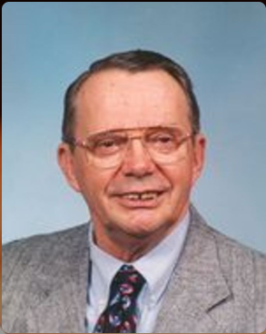
Arthur R. Moran, age 83, of 629 14th St. SW, Huron, died on Tuesday, May 20, 2008, at his home. His funeral service will be 11:00 a.m. Saturday, May 24, 2008, at the American Lutheran Church in Huron with the Rev. Steven Bransrud officiating. Burial will be at Restlawn Memory Gardens Cemetery with Military Rites by the Huron Veterans Council. Visitation will be Friday, May 23rd from 1:00 - 8:00 p.m. at the Welter Funeral Home, with the family present from 6:00 - 8:00 p.m. Friday night, or one hour prior to the service on Saturday at the church. Memorials may be made in Arthur’s name to the Gideon Foundation or the American Lutheran Church. Arthur R. Moran, the son of William M. and Ottilie (Schmidt) Moran was born on January 17, 1925, in Salem Township, Pierce County, WI. He graduated from Ellsworth High School in 1943 and attended the University of Wisconsin, graduating with a Bachelor of Science in Civil Engineering in 1949. Arthur married Mary Jane Anderson on September 14, 1945, in Glendale, CA. Arthur served in World War II with the Army Air Corps from June 1943 through November 1945. He was assigned to the 15th Air Force in Italy as a navigator for B-17s. He flew strategic bombing missions with the 301st Heavy Bombardment Group in the European Theatre of Operations from September 1944 through May 1945, spending 6 months of this time as a Prisoner-of-War in Germany. Arthur was employed by the Federal Government with the Bureau of Reclamation until his retirement in 1981. During his 31 years of employment, he contributed to water resources development in the state of South Dakota with special emphasis in the Pick- Sloan Missouri River Basin Program. Arthur was a member of the Huron Water Board; Huron Sertoma Club, past president and, the Pheasant chapter of the National Association of Retired Federal Employees, past president. Arthur served with the Air Force Reserve retiring with the rank of Major. He was a lifetime member of the American Legion and the Veterans of Foreign Wars He served on the Huron Senior Center RSVP Advisory Council. Formerly an Eagle Scout, Arthur also served as a Scoutmaster for the Boy Scouts of America. Arthur was an active member of the American Lutheran Church, the Gideons and with the Prison Fellowship Ministry in Redfield. Grateful for having shared his life are his daughter, Cheryl Vogtsberger, Sioux Falls, SD; two sons, Jeffrey (Betsy) Moran, Omaha, NE, and William (Juli) Moran, Sioux Falls, SD; 9 grandchildren, Kirsten, Christopher (Lisa), Todd, Molly, Annie, Lacee, Emily, Hannah, and Micah; and 2 great grandchildren, Madelyn and Allison. Arthur was preceded in death by his parents; his wife, Mary, in 1995; an infant son, Warren; and his brother John.
Link to original obituary

