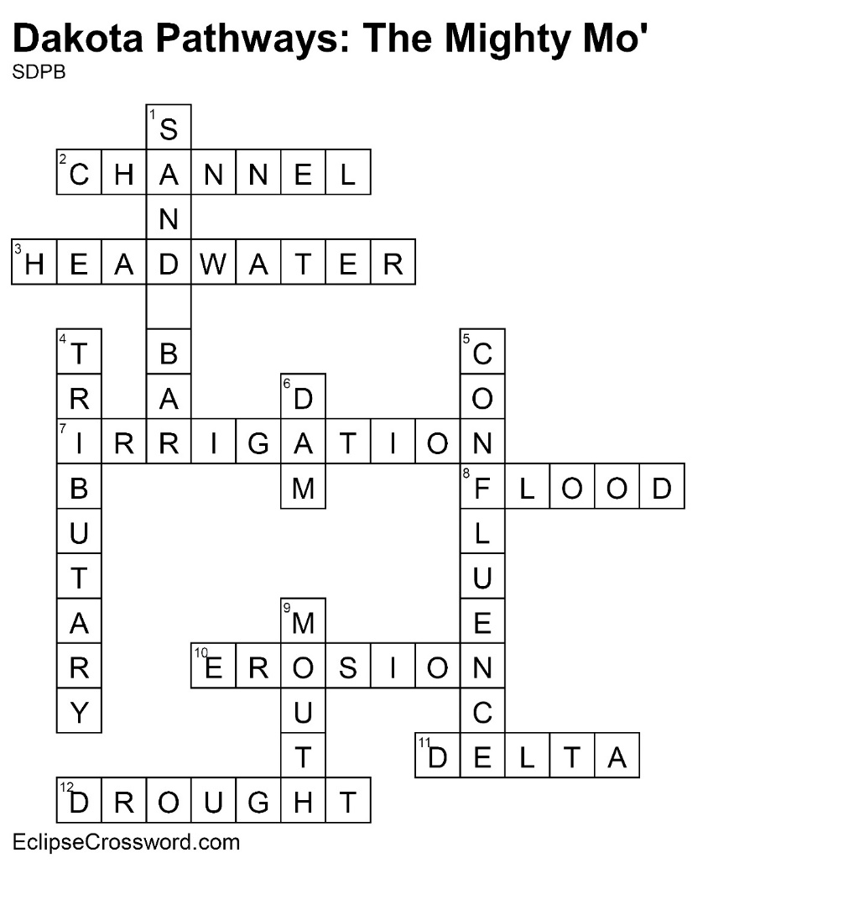

|  |  |
| --- | --- |
| **Across**  2. CHANNEL — Deeper part of a river; usually more  navigable  3. HEADWATER — Where a river begins  7. IRRIGATION — Water used for farmland  8. FLOOD — When water flows across land that is  normally dry  10. EROSION — Process of wearing away  11. DELTA — Fan-shaped area of sediment at mouth  of a river  12. DROUGHT — Long period with little or no rainfall | **Down**  1. SAND BAR — Submerged ridge of sand or gravel  4. TRIBUTARY — Stream or river that feeds into a  larger waterway  5. CONFLUENCE — Place where two rivers come  together  6. DAM — Structure designed to hold back river  water, creating a reservoir  9. MOUTH — End of a river |