Lungs: Alveoli (Increased Surface Area Activity Idea)
During this activity, your students will learn about grape-like structures in the lungs called alveoli and their essential function of increasing the surface area of the lungs to maximize gas exchange.
This is a resource from the Art Basics with Dick Termes: Drawing project.
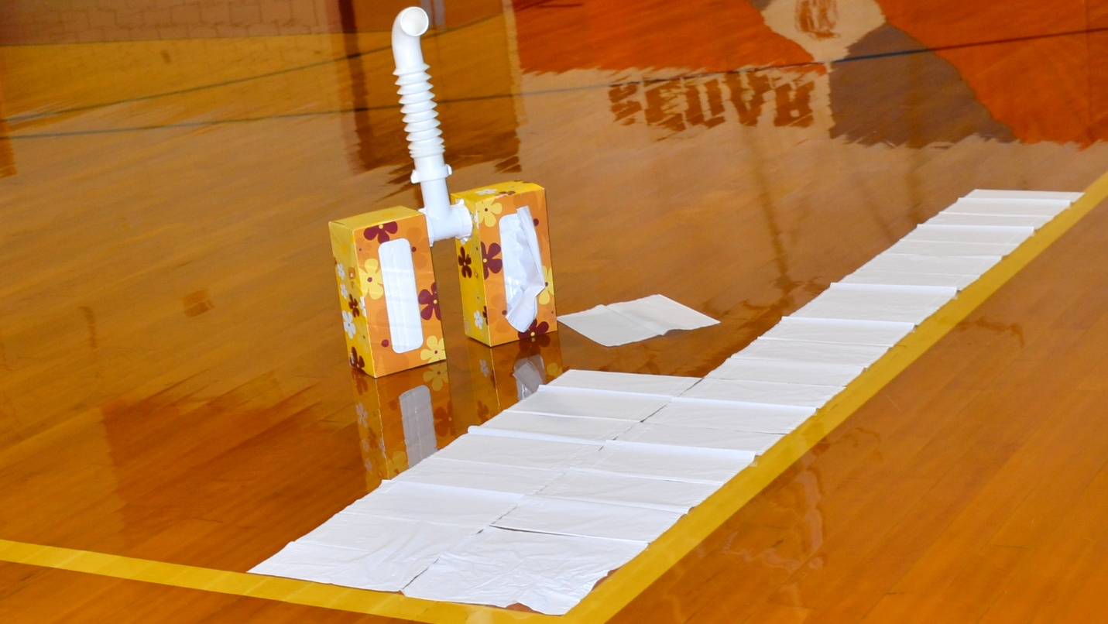

Lesson summary
Tiny structures within a human lung called alveoli increase the surface area for gas exchange. It can be difficult for your students to imagine how these tiny structures increase the surface area without increasing the volume of the lungs. The following hands-on activity will demonstrate this with the use of tissue boxes.

Introductory activity
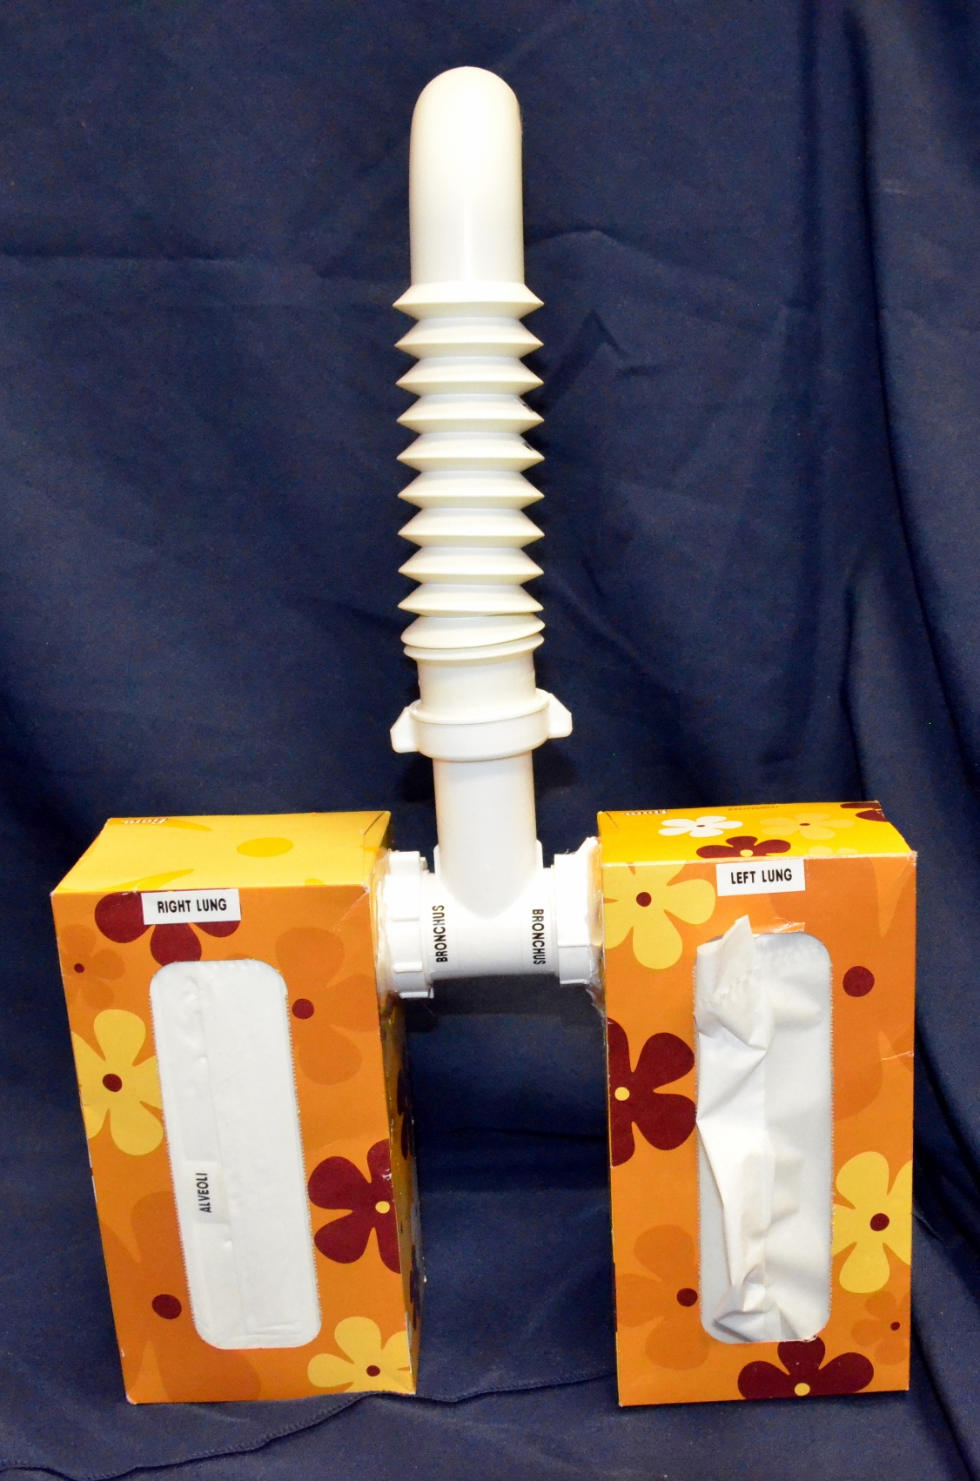
Introduce the activity by viewing Art Basics with Dick Termes: Drawing – Cube Basic. During this episode, the artist, Dick Termes, demonstrates how to draw a 3-D drawing of a tissue box.
Display multiple tissue boxes on a table in the middle of the room. Make sure there are different-sized boxes with various dimensions and volumes. Have the students select a tissue box and draw it using the techniques covered in the video. Ask the students what is similar and different about the boxes. Discuss the volume of the boxes and how the tissues packed within the boxes are like the alveoli in the human lungs. The tissues provide a tremendous surface area within a very small volume.
A model like the one shown in the photos above and below would help the students make the connection between a tissue box and the human lungs. This is a very nice analogy because every time one of your students uses tissue or looks under the bathroom sink, they will think about the alveoli in their lungs.
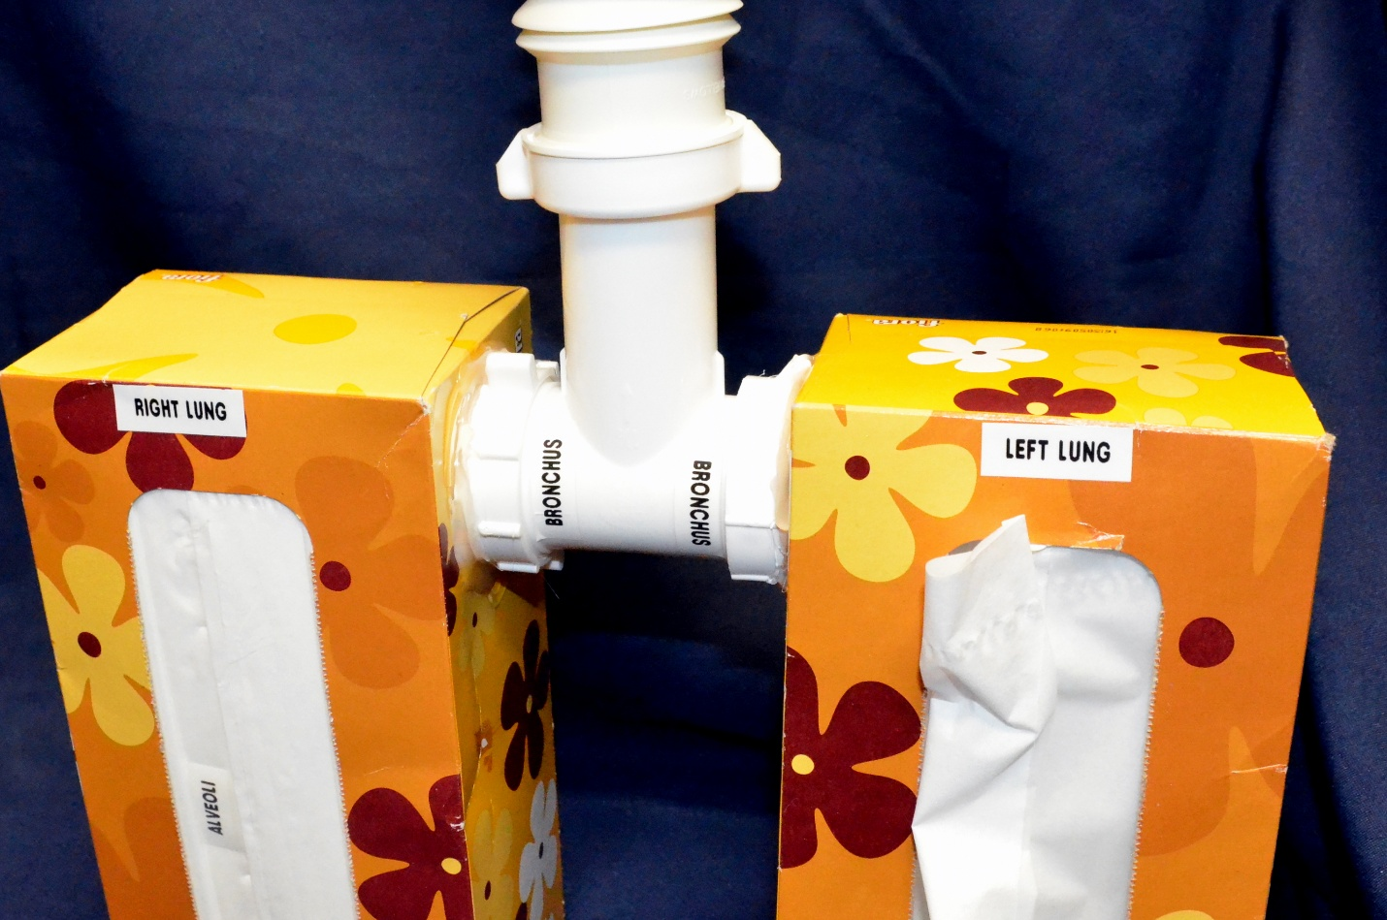
The model was constructed using drain pipe from a kitchen/bathroom sink.
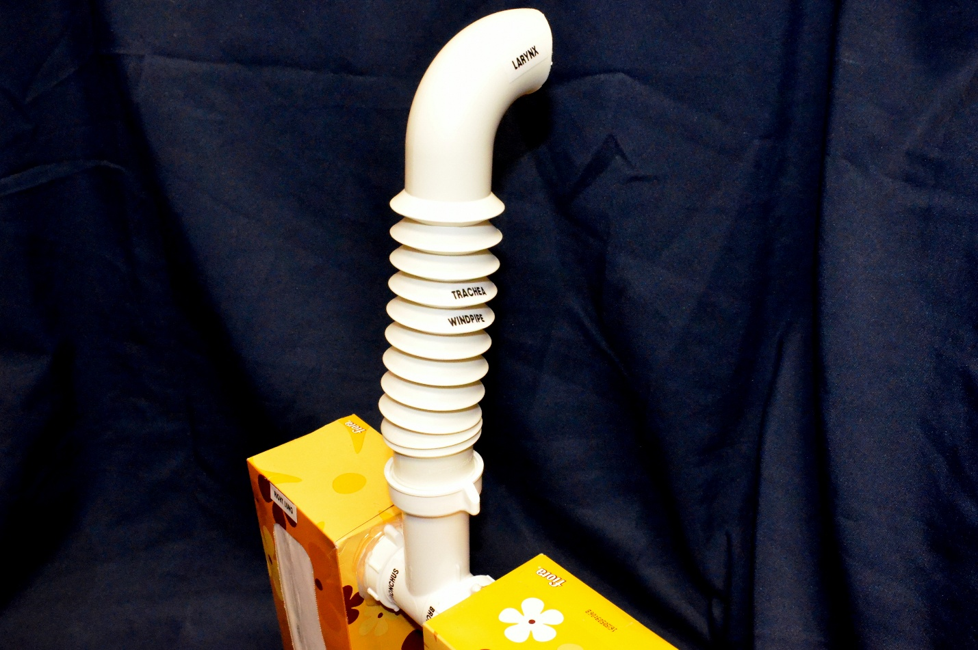
The fittings and piping are available at any hardware or department store.

Learning activities
The students (working in groups of 2-3) will compare the surface area of the tissue box with the total surface area of the tissues within it.
- The activity should be completed in a gym or all-purpose room.
- Measure the surface area of the inside of the tissue box (same as outside).
- Measure the surface area (both sides) of an individual unfolded tissue.
- Multiply the surface area of the individual tissue by the total number of tissues.
- Using a tape measure and the gym floor, compare the total surface area of the inside of the box (lung) with the surface area of all the tissues. If time allows – the students should lay out all of the tissues to get an idea of how the alveoli drastically increase the size of the surface area.
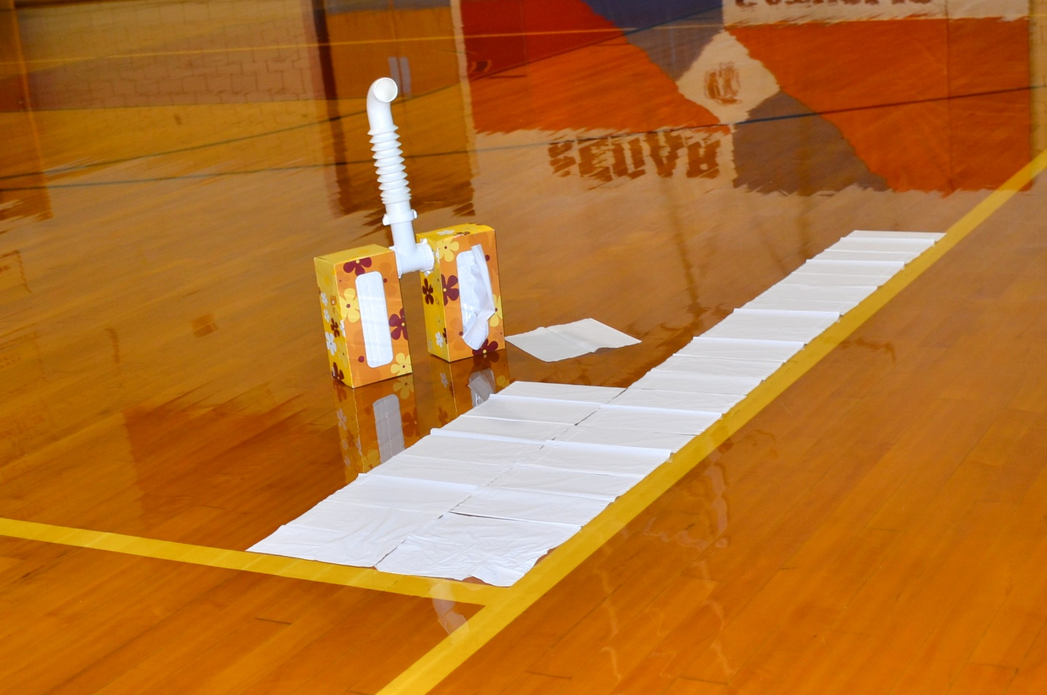
Art Basics with Dick Termes: Drawing is a companion drawing series to How to Draw Using Perspective with Dick Termes. Step-by-step, follow through both series, and soon, you will create perspective masterpieces of your own.



