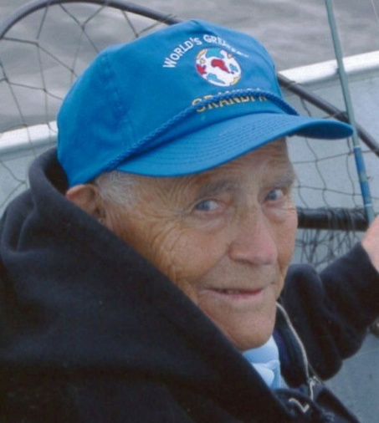
Edward William Boerboom
d. August 14, 2014
Edward William Boerboom was born on November 3, 1920, in Ghent, to Jacob and Louise (DeWisplier) Boerboom. He grew up and attended school in Ghent. Edward served in the U.S. Navy during World War II and was a recipient of the Purple Heart. He was honorably discharged in 1946. On August 27, 1947, he was united in marriage to Marie Rose Van Keulen. The couple farmed and raised their family on a beef and dairy farm southwest of Ghent. In 1979, they retired and moved to Ghent. For many years, the couple wintered in Mesa, AZ. They were active members of St. Eloi Catholic Church and Ed served as an usher. He was a lifetime member of the American Legion Post 564 of Ghent and the Disabled American Veterans and Veterans of Foreign Wars. He enjoyed fishing, playing Rolle Bolle and cards with family and friends. He also enjoyed following the Minnesota Vikings and Twins. For the past 26 years, Ed was a member of the Demontreville Retreat House.
Ed died on Thursday, August 14, 2014, at the Avera Morningside Heights Care Center. He is survived by his wife, Marie Rose, of Marshall, son Thomas (and Suzy) Boerboom of Shakopee, their children Lindsey Voigt, Taylor (and Martin) Hubbard and Rachel (and Jamie) Rippel, daughter Judy (and Dale) Crowley of Spring Valley, WI, their sons Ben (and Jen) Crowley, Jake (and Tracy) Crowley and Clint (and Annika) Crowley, Mark (and Jo) Boerboom of Ghent, their son Zac (and Jamie) Boerboom, Patrick (and Linda) Boerboom of Minneota, Their sons Tyler (and fiance Sara) and Todd Boerboom, ten great-great grandchildren, siblings Bertha DeCramer of Marshall, Vincent (and Prudence) Boerboom of Marshall and Gerie Carrow of Marshall, nieces, nephews, relatives and friends. He was preceded in death by his parents and granddaughter Jessica Boerboom and six brothers.

