Units of Measure: Gallons, Quarts, Liters, Milliliters, and More!
Your students will participate in a hands-on activity in which they will practice using customary units of measure for capacity (volume), including gallons, quarts, cups, liters, and more. Your students will also learn about the dams on the Missouri River, including the Oahe Dam, the 4th largest reservoir in the United States.
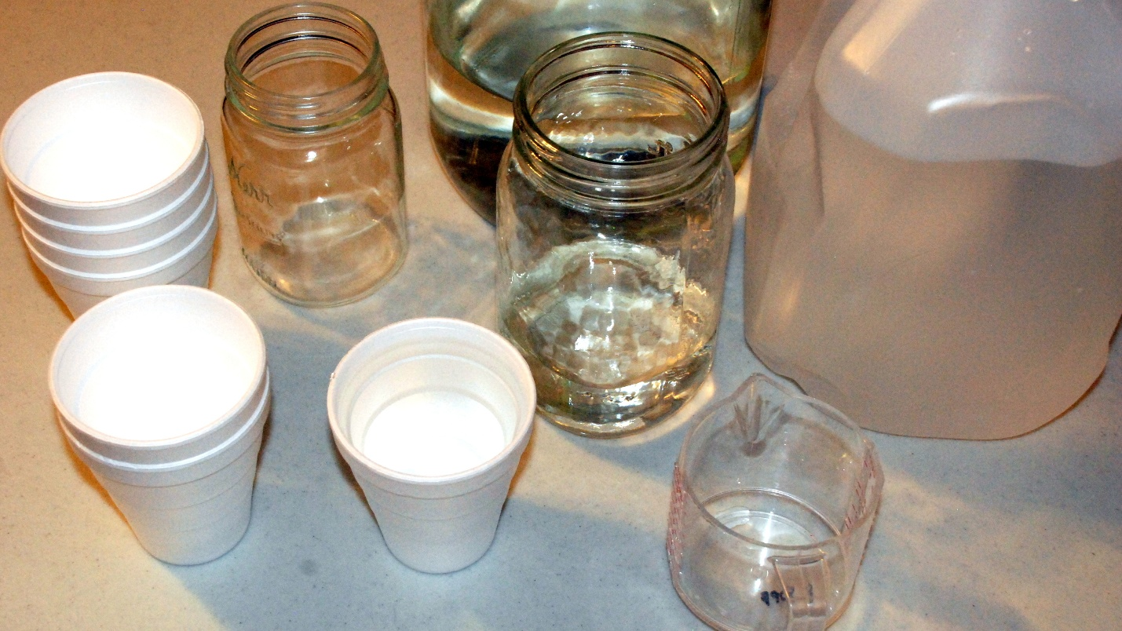

Lesson summary
Try this activity; your students will love it! This perfect hands-on activity could introduce a unit on volume or provide an entertaining and educational capstone activity.

Time allotment
50 Minutes

Learning objectives
- Students will learn about standard units of measure.
- Students will learn about cubic feet per second.
- Students will learn about the Oahe Dam on the Missouri River.

Prep for teachers
- Access the video clips and additional information below.
- Gather materials for the activity in the Supplies section below.

Supplies
- Video clips and information about the Oahe Dam and cubic feet per second:
  - Video - Building Oahe Dam / Building the Oahe Dam Part II
  - The Oahe Dam
  - About the Missouri River
  - Video - Cubic Feet Per Second Video
  - Chrome Extension - Unit Converter
- Materials (will vary depending on if you use English or metric units) Note: Items listed are for 16 cups in one gallon; additional materials will be needed for other units like liters, pints, quarts, etc.
  - Gallon jug (1 for each group)
  - Measuring cup (1 for each group)
  - Disposable cups (16 for each team - marked)
  - Various quart and pint containers (jars shown)
  - Marker

Introductory activity
- Introduce the activity by viewing the websites above.
- Then show the students different flow rates using a garden hose or a large sink.
  - Using a hose, show the students the amount of water coming out of the hose.
    - Adjust the spigot to three noticeably different flow rates.
    - Then, figure out how long it takes to fill a gallon bucket at each rate.
    - A timer can be used, or the student can count out loud.
    - Record the results for each.

Learning activities
During the Building Oahe Dam video, the students will be introduced to examples of large volumes of water. The amounts are fascinating but hard to imagine. One example, at 01:23, provides the flow rate of the Missouri River on August 2nd, 1958. The river was flowing at a rate of 8,800 cubic feet/sec. Converting this amount to gallons/sec could provide a better visual for the students (Unit Converter).
The result is approximately 65,829 gallons/sec. A typical Suburban is about 5,807 gallons in volume (using outside dimensions). It is estimated that 11 Suburbans/second capacity would pass that location in 1958.
The volume examples given in the video should lead to a discussion about measuring volume in the classroom and at home. Units like gallons, quarts, cups, liters, etc., should also be discussed.

Culminating activity
Playing the Game - The game's goal is to help the students remember standard units and practice changing from one unit to the next. The example given in the photos below demonstrates 16 cups in 1 gallon.
Procedure
- Divide the class into groups of 2-3 students; 4 – 8 groups
- The game should be played in an open area, possibly a section of a football field. The site will get wet; try to prevent slipping onto a hard surface. An empty gallon jug for each team will be placed at one end of the designated area. The students, cups, and water will be at the other end.
- The students should use a measuring cup to pour a cup of water into a disposable cup and then mark the water level. 16 cups should be marked and filled for each team.
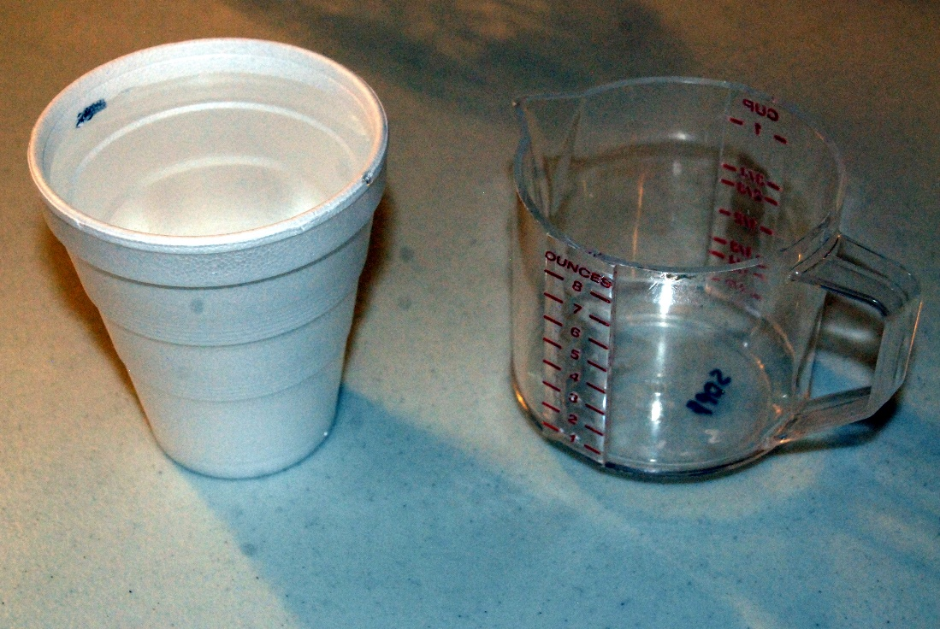
- The students will be given a maximum of 16 cups of water to fill the gallon jug.
- Relay Race - one student from each team will take a cup of water to the other end of the field and pour the water into the gallon jug. Then the student will return to the starting area, and another teammate will add the second cup to the jug. Repeat until 16 cups are added.
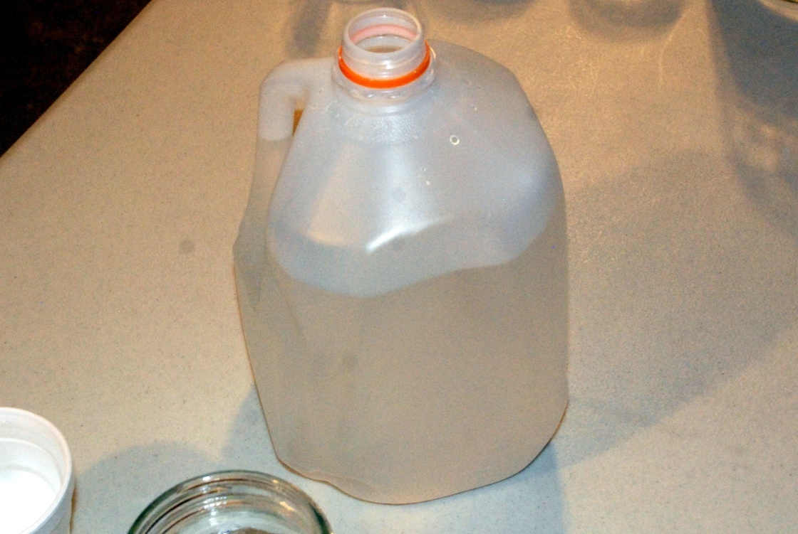
- Scoring: Each team can score in two categories. Points will be given for the volume of water and time. The team with the most water will be given the most points for volume, and the team with the least time will be given the most

Example Score Sheet for 6 Teams
- Time (Note: Least time is 1st)
Time (place) | Points
1 | 6
2 | 5
3 | 4
4 | 3
5 | 2
6 | 1

- Volume (Note: Most Volume is 1st)
Volume (place) | Points
1 | 6
2 | 5
3 | 4
4 | 3
5 | 2
6 | 1

Total of 6 Teams for this Example
Team A was the first to finish but had the least amount of water in the jug.
Score Team A:
    - Time = 6 points
    - Volume water = 1 point
    - Total score = 7 points

Team B was third to finish and had the second-greatest volume of water.
Score Team B:
      - Time = 4 points
      - Volume water = 5 points
      - Total score = 9 points
Taking it to the Next Level:
- Use various English combinations.
- Use different Metric combinations.
- Integrate additional physical activity to increase the chances of spilling the water.
  - Walking backward
  - Pushups
  - Sit-ups
  - Crawl
  - Etc.
- Make the time or volume category worth double.
- Incorporate Spill Not into the relay and introduce topics like acceleration, forces, etc.



