'Gentle Annie'
To an overseas fighter station a few days ago came a letter postmarked Wilson, N. Y., and addressed in a childlike scrawl to: "Pilot of Gentle Annie, U. S. 8th AirForce, England.”
Delivered promptly to Col. Harold J. Rau, who leads his Mustang group in theP-51, "Gentle Annie," the envelope contained a newspaper clipping, a photograph of a little girl in pigtails and this message: Dear Pilot, I saw the pikchore [sic] of Gentle Annie in the Buffalo Courier-Express. My Mummy and Daddy call me Gentle Annie to. I will pray that you don't get in as much trubol [sic] as I do. I am in the third grade.
Annie Croop
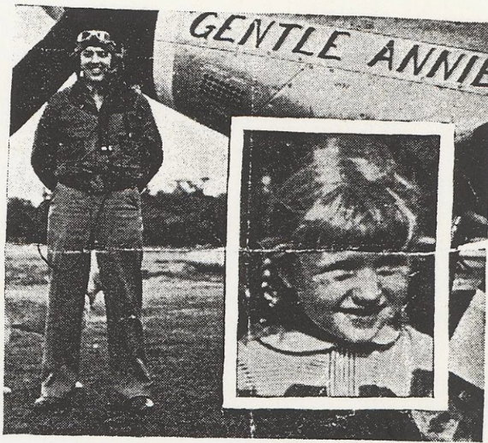
P. S. Here is my pikchore [sic]. I am 7. Colonel Rau had named his plane originally for Ann Kenyon, of Providence, R. I., a Women's Airforce Service Pilot, but, he decided, "effective immediately, Gentle Annie is named also for little Annie Croop, of Wilson, N. Y."

