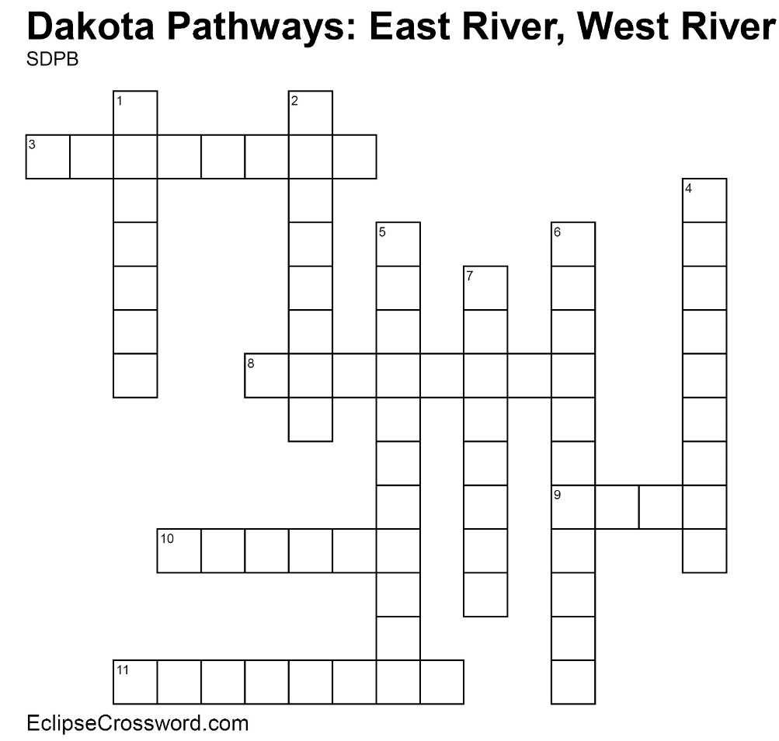

**Word Bank:** AGRICULTURE ARID BOUNDARY DESERT DROUGHT FRONTIER INFESTATION LATITUDE LONGITUDE MERIDIAN PARALLEL

|  |  |
| --- | --- |
| **Across**  3. Another name for lines of latitude, which run east and west on the map  8. Parallel lines starting at the equator measuring distance north and south  9. Lacking moisture; not enough rain  10. Dry, barren, and often sandy region  11. The extreme limit of settled land beyond which lies wilderness, especially referring to the western US before Pacific settlement | **Down**  1. Prolonged period without precipitation  2. Another name for lines of longitude, which run north and south on the map  4. Meridian lines starting at the Prime Meridian measuring distance east and west  5. Science, art, and business of producing crops and raising livestock  6. Spread of something harmful  7. Something that indicates a border or limit |