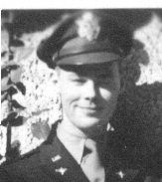

WWII WARTIME EXPERIENCE

of

Lt. Col. Lester W. Snyder, Jr.

USAF (Ret.), Rapid City, SD

When the United States entered World War II, after Pearl Harbor, I was in the employment of the Army Ordinance Department, at the Watertown Arsenal in Massachusetts.

The job, as an apprentice machinist, consisted of creating items from metal. It was challenging and also allowed attending night classes at MIT. The position was a draft deferred one, desired by many, but I soon learned that it had a downside. As the country began to get deeper into the war effort, I began to feel that I should be doing something more obvious to help my country. I wanted to join the military, but I could not. Due to the draft deferred position, it was necessary to obtain an official release.

A request for a release was submitted, but it was denied. A week or so later, another request was made, with the same results. The efforts became continual, and increasingly more frequent. Eventually I was appearing before the commanding officer every morning. Finally he consented, the release was granted. I enlisted in the Army Air Forces, or as most referred to it, the " Air Corps". I became an Aviation Cadet, and it was off to Basic Training at Greensboro, NC. When I reported for duty, at Ft. Devens, MA, I took nothing with me, as instructed. However, we were issued nothing for about two weeks. I tried to keep my clothes washed, but after train rides and drilling, my clothes obviously were not clean. Basic was followed by College Training Detachment at Michigan State College. During CTD we received ten hours of flight training. During one of our times at the airport, three P-39s landed. At that point we had not seen a military plane up close. As we gravitated toward them, three black pilots crawled out. There were not many black pilots at that time; they were Tuskegee Airman. CTD was followed by the Classification Center at San Antonio, TX. There we were subjected to numerous mental and physical tests. At that time the Medical Center there was requesting volunteers for experiments concerning "explosive decompression", which had become a concern with the advent of the pressurized B-29. The object was to determine how the human body would react when instantly changed from a pressure equal to 8,000 feet of altitude to that at 40,000 feet, as would happen if the fuselage was pierced. I volunteered to be one of the "guinea pigs". There seemed to be no adverse effects. However when the simulated decompression occurred, the body involuntarily straightened as contained gasses expanded. If an oxygen mask was put on relatively quickly, one could continue functioning in a normal manner.

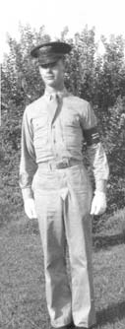
BECOMING RATED

Following the classification testing, I was given a choice of training as a pilot, navigator, or bombardier. My choice might not be considered rational to those who know the status of the pilot in the military. However, my reasoning was that navigation training might provide at least some training that could be related to engineering, my ultimate goal. That choice made, my next station was Selman Army
Air Field at Monroe, LA. There I finished Preflight School, eventually becoming a cadet sergeant, and progressed to the next level. Navigation School, where I became a cadet captain, was completed next, at the same location. At graduation, on 7 August 1944, I received my silver wings and gold bars. At that time I was selected as one of eighteen, of the class of 320, to go to Instructor School, still at the same location. Following that, I remained at Selman AAF as a navigation instructor, but only for a few months.

At that time all navigation instructors were given an aptitude test, and 75, including me, were chosen to attend Radar Observer training, a new rated position in the AAF. Victorville AAF, CA, became my new home for a few weeks. One thing that comes to mind about that period concerns an incident on a training flight in a 8-24. On the return from a bomb run I relaxed by sitting on the floor and leaning back against the front wheel, which retracted into the nose compartment. About that time the pilot decided to lower the gear, even though we were at cruising altitude. I felt the vibration as it activated and immediately rolled away from the wheel.
In doing so I accidently unplugged my "intercom" cable. The pilot immediately realized that he should have notified the nose compartment. He started calling on the intercom and, of course, got no reply. Thinking the worst, he came crawling through the passageway. He was relieved, and I learned about my disconnected cable.

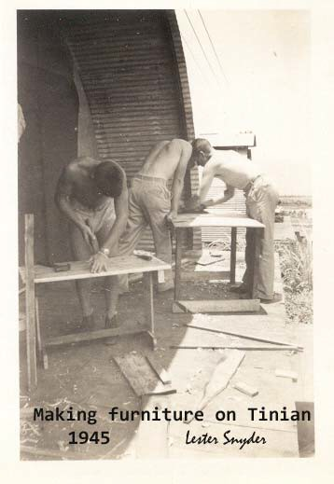

After graduating as a radar-navigator-bombardier on 24 February 1945, came assignment to a B- 29 crew and stationing at Clovis AAF, NM, for training as a crew. A B-29 crew consisted of eleven members. They were separated into two pressurized compartments in the aircraft, with a connecting "crawl-tube" over the two bomb bays. The aircraft commander was the oldest of our crew, at twenty-three. The youngest was the tail gunner at seventeen, and the pilot was only nineteen. The crew finally was declared ready for combat and we picked up

an aircraft in Kearney, NE, to fly to the Pacific Theater of Operations. 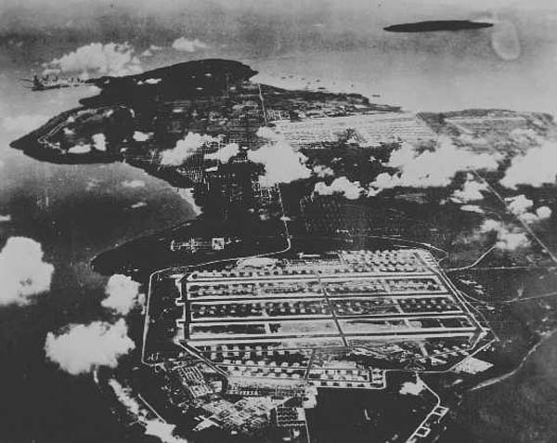
We flew out over the Golden Gate bridge and made landings at the islands of Oahu, Kwajalein and Guam. At Guam we were assigned to the 1st Bomb Squadron, the 9th Bomb Group, the 313th Bomb Wing. We were stationed on the island of Tinian, about a hundred miles north of Guam, in the Marianas Islands.

TINIAN ISLAND

Tinian is not a very large island. It is approximately twelve and a half miles north to south and maybe six miles wide at the widest part. There were two airfields on Tinian. The 58th Bomb Group occupied the "West Field". Their tail insignia consisted of a large circle around an "R", like that on the tail of the B-29 at the South Dakota Air and Space Museum.
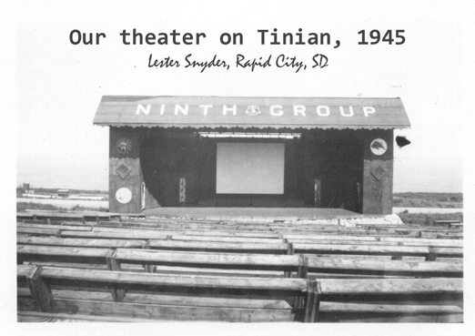
The 9th Bomb Group occupied the "North Field". That tail insignia was a large circle with an "X" inscribed. The 9th Group possessed 45 B-29s, supported by 2200 men. 111 members of the 9th Group were lost during the operations against Japan. In the latter weeks of the war the 509th Bomb Group also was assigned to North Field. That was the unit which had been trained for handling and delivering the atomic bomb. North Field had four parallel runways, which ran east and west as far as they could, across the north end of the island. It would have been more ideal had they been longer, for a loaded B-29 usually did not have quite enough flying speed at the end of the runway. Fortunately, they ended at the top of a very high cliff. The height of the cliff allowed the aircraft to nose down to pick up the necessary speed. The length of the runways never caused any serious problems. Some takeoff problems did occur with aircraft carrying mines, which were intended to mine Japan's inland sea. The mines were very sensitive and two planes had explosions during takeoff. One was rather minor and the pilot was able to abort the mission, but on the other the plane was blown apart. The tail gunner was blown clear in his compartment, but the others were killed.

The B-29 was designed for long-range missions, the type being flown by us, between the Marianas Islands and the Japanese Empire. The minimum time for that trip was seven hours each way. My longest mission was nineteen hours. The seven hours, covering about fourteen hundred miles, was allover water. Mechanical and navigation problems had to be overcome in addition to possible enemy inflicted damage. We often came back on three engines. There were a few submarines stationed along the route, but they move rather slowly and some luck was necessary for one to get to the aid of an aircraft in trouble. However, one crew from the 1st Squadron was picked up by a sub and they only lost one crew member.

It wasn't that they weren't grateful, but the crew was picked up at the beginning of the sub's two-week tour and found the two weeks of "confinement" to be very trying. One Navy crew discovered a USAF life raft in the middle of the Pacific, but the only occupant was a monkey. They brought the monkey to our Group when they docked at Tinian, and it became our pet. He ate a grasshopper leg the way one would eat a chicken leg.

When the airfield on Iwo Jima was secured from the Japanese, B-29 crews had another alternative when the trip home had to be cut short. The distance to Iwo from the Empire was about half that of the trip to the home island. A crew from the 1st Bomb Squadron, Malo's crew, was the first to use Iwo. Unfortunately, that entire crew was lost about six weeks later. Another 1st Squadron crew, the crew of the Mariana Belle, all jumped over Iwo Jima, because their aircraft could not be safely landed. I believe that my crew was one of the last to land at Iwo out of necessity. I have written a separate account of that experience. On that mission, a 20mm from a Japanese fighter caused an explosion in the bomb bay which almost ripped the plane apart. There also was a subsequent fire. The bomb bay doors were blown back on the hinges so that they could not be closed, and the drag on the aircraft was severe. That, along with the loss of some fuel and hydraulic fluid, meant that we were barely able to reach Iwo Jima. Our lives were spared, although there were a couple of wounded. A short time later we were given an R&R to Hawaii, where we stayed at a hotel on Waikiki Beach.

RADAR OBSERVER

The radar observer on the B-29 had a three-fold duty. The first was to assist the navigator whenever necessary, or to take over the navigation completely should it become necessary. That did happen for a short time on the mission mentioned in the previous paragraph. A second part of the duty was to assist the bombardier, or to drop the bombs if weather prevented him from seeing the target. A third part of the duty was to be in charge of the rear compartment of the aircraft. Although Radar was a great development, it was still in its infancy. Images on the approximately eight-inch screen of the APQ-13, were not well defined. However, water showed black and thus shorelines and rivers were fairly easy to interpret. Land gave a comparatively light (green) return, and buildings provided a brighter return. By adjusting the brightness and the range, an operator could do a reasonable job of pilotage over land, and also get quite close in bombing. Normally, one could interpret images up to about fifty miles, but there also were beacons which sent back a signal that showed as a symbol on the screen. Beacons normally could be received up to about 300 miles away. The beacon which was located on Guam was a real help to me on the return trip from one mission. The navigator lost all means to navigate. All the radio and Loran had malfunctioned.

Celestial navigation was impossible because of an overcast, and he could not determine the wind from the waves because it was night. That made the crew somewhat apprehensive over the 1,400-mile trip. However, I was able to detect the Guam beacon at a distance of 312 miles. The aircraft was only forty-one miles off course, but the crew was thinking about the amount of water south of Guam. Another capability the radar observer had, was to detect when turbulence would be encountered. That seemed to impress the pilots on our crew.

OFF TIME

Some people might be interested in the living conditions and the activities other than flying missions. There was a considerable amount of spare time, since aircraft often had to be repaired. Also, I remember the weather as being fairly pleasant. There were no mosquitoes with which to contend, because the island had been sprayed with insecticide. That did not seem to affect the ants, though. Sweets could not be kept for any great length of time. One fellow received some sweets in a round metal container. He decided to tape around the edge of the cover and tie the container to a rafter with string.

Unfortunately, when he opened it, it was full of ants. We also had to contend with rats. There were rats of all sizes, up to the size of a large house cat, in my experience. One night, while I was writing a letter and eating a chocolate bar, I laid the chocolate on the cot beside me for a few seconds. When I reached to retrieve it, a small rat was eating it. In another incident, we were awakened one night by the screaming of a man across the Quonset hut from me. He had been awakened by a rat biting on his ear. Many types of traps were made or obtained in some way. I had a couple which were set near my cot. One night, after retiring, I heard the sound of the trap being activated. A short time later there was sound of the trap moving. I grabbed my flashlight, which always was handy, and discovered a larger rat was trying to carry away a smaller dead rat, trap and all. The biggest danger the rats generated was when someone got so angry that he started shooting with a forty-five automatic pistol. Then everybody looked for a hiding place.

Since there was quite a bit of spare time, much of it was spent trying to improve conditions in and around one's Quonset hut. Some decorative additions and signs were added. Time was spent making tables and chairs from empty bomb crates. One man even made a bed, by also using tire tubes and bottle caps. There was an open-air theater and almost everybody went there every evening.
The seats were empty bomb crates and bomb fin protectors. One always brought a raincoat and a flashlight. It was sure to rain after the movie started, and it was dark going home. It also was a sure thing that the record, "A Sentimental Journey", would be played after the film ended. There were other activities, such as exploring the island, indulging in swimming, and some sports. Much of the shoreline was made up of what was referred to as "coral", but actually was solidified lava. I presume that its condition was caused by the hot lava coming into contact with the ocean water. The lava was formed into cup-like shapes, the vertical edges of which were extremely sharp. For that reason, "GI" shoes were worn whether one was hiking or swimming. There were a few sandy beaches, but even there, the sharp lava was usually encountered. One of the sandy beaches was on the west side of the

island, close to the 9th Group area. However, the living area was on the top of a high cliff. We built a stairway down the side of that cliff, for easy access to the beach. Often an air mattress was taken along to the beach to permit floating around and peering down at the beautiful tropical fish. They were truly exotic, with very bright colors.

PEACE TIME

When the war ended many things changed. Where T -shirts, or not wearing shirts, had been allowed, proper uniforms were required. Vehicles posed a problem, in that they would have to be returned to the United States. That would be expensive and time consuming. All sorts of vehicles began disappearing over the cliff. One small Crosley-made vehicle that had been used for transportation on and around the huge airfield, did not make it over the cliff. Somehow it ended up in my possession. Basically, it consisted of a low platform on four small wheels. The engine was at the front with a housing similar to a jeep. At the rear was a trunk, which formed the back of the double seat. Several weeks after the war ended the 9th Bomb Group was ordered to transfer to Clark AAF on Luzon, Philippine Islands. The information received was that ground facilities and support personnel were in place. The B-29 crews loaded their personal gear aboard their aircraft, plus other cargo. My crew was able to hoist my Crosley Pup, or "Peep", as we called it, into the front bomb bay. We had over twenty-four cases of medical whiskey in the rear bomb bay. Thus it was, that we left Tinian for the last time.

PHILIPPINES

What greeted us at Clark Field was considerably less than had been expected. There were ground facilities, in the form of tents and equipment. However, there were no support personnel to be found. In order to function, the 9th Bomb Group had to be transformed into a rather unorthodox military unit. The enlisted members of the aircrews all had maintenance qualifications which were needed to ensure that the aircraft were always ready to immediately take to the air. That meant that support activities had to be performed by the officers. Thus it was that Second Lieutenants were placed on "KP"; First Lieutenants were assigned to drive trucks and other equipment; and Captains could be found spraying and policing the area. However unorthodox, the arrangement worked, and there soon was a well functioning base. I made about fifteen flights while at Clark Field, plus a few trips to Manila in my Peep, with a buddy, usually Virgil Juliot or Charlie Trice. After a few months on Luzon I was transferred stateside on a troop ship, the "Sea Barb". It was a long voyage during which we tried to entertain ourselves with playing cards, reading the ship's newsletter, the "Barbed Wire", and watching the flying fish. We sailed into the San Francisco harbor under the Golden Gate Bridge, but never saw it because of the dense fog. Although it was August, I was so cold that I wore my heavy flight jacket all the time. I was subsequently separated from active service and proceeded to finish my BS in Mechanical Engineering. Then, when I graduated at La. Tech, in June 1949, I was asked to stay at the college as an instructor.

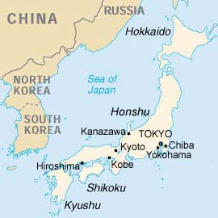

REPUBLIC OF KOREA SERVICE
by Lester Snyder, Rapid City, SD

Just as I was finishing the second year as an instructor, I was recalled into what had become the Air Force, a separate service. That meant buying new uniforms because
blue had replaced pink & green. My first assignment was to a B-29 unit at Barksdale AFB, LA. A few flights were made there, but only one stands out in my mind. On that flight, while plotting a run, I laid a pair of dividers on top of a switch box that was not entirely enclosed. The vibration of the aircraft soon caused the dividers to fall into the wiring of the box. That shorted out the whole system. I delved into the area under the floorboards and was able to locate a fuse that was causing the outage. Correcting that got the system back into operation, and we were able to complete the mission. The next morning when we landed, I called home and was informed that my first child, a son, had been born just about the time the radar system had been knocked out.

ASSIGNMENT TO KOREA

After a very short time at Barksdale, I was selected with eight other "triple-rated" observers, to go to Korea. My assignment was to the 95th Bomb Squadron, 17th Bomb Group, which was stationed at a location designated as K-9, about six miles north of Pusan. It was a B-26 unit, which meant a new experience in a different aircraft, but one suited to our training. The B-26s that we had were formerly designated the A-26, Douglas Invader. Most of the planes were painted almost completely black because most of our missions were at night. There were two types of nose configurations. One was a "glass nose" which had a bombsight for bombing, and the other was a "hard nose" with eight 50 caliber guns in two vertical rows. There were four potential crew positions in the B-26, with a pilot flying in the left seat, of course. A navigator might fly in the right seat, and, in the glass nose, a bombardier might fly in the nose position. There was a separate compartment in the rear of the aircraft, and that might be occupied by either a "radar observer" or a gunner. The radar term was used loosely, because the system installed in the B-26, actually was a Shoran system. Since I could fly in any of the observer positions and was not assigned to a specific crew, I flew a great deal. Often my missions were with the squadron or group commander, because neither had a regular crew. Sometimes there was a necessity to fly in place of another observer who had been incapacitated in one way or another.

MISSION TYPES

The K -9 base had just one runway, one end of which pointed out to the ocean. The other three sides of the base were surrounded by high mountains. The planes took off out over the ocean and landed in from the ocean.

Because of the high mountains the "go around" procedure essentially was to "pull up and pray". One foggy night a pilot missed his approach and pulled up, but he either did a vertical 270, or he could not maintain flying speed. We lost a crew right at the field. There were five types of missions flown by the B-26 crews. One was the well-known formation mission. There often were escort aircraft on those missions. I believe they usually were P-51s or F-86s, that might be flown by Americans or Australians. Both would chase the Migs, but the Aussies came back relatively quickly, while the Americans chased the enemy as far as they could. Close to the target the worry was the anti-aircraft batteries. I feel fortunate in that many of the batteries that I encountered seemed to be inaccurate. On one formation mission I was in the bombardier position in the number two aircraft and could see the "golf balls" going up between us and the lead aircraft. That never varied all the way down the bomb run. Any variation would have got one of us. On another such mission I could look down and see the explosions a relatively safe distance below, and they never varied.
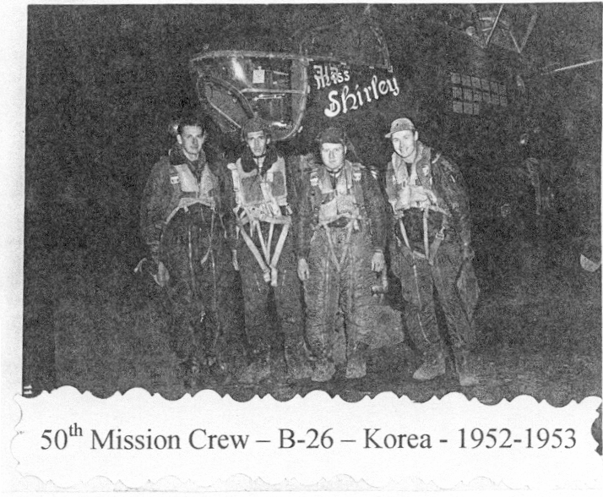
Another type of mission was the bomber stream. I flew in the lead aircraft with the Squadron Commander, LTC Ben West, on one mission of that type. The procedure was for the lead aircraft to identify the target and drop fire bombs. That aircraft then would climb to a higher altitude. As the other aircraft, on a fixed separation, called in over the "IP", the crew was directed to drop at a position relative to the established fire or fires. I also remember an instance when I was a bombardier in the bomber stream. Coming in on the run I could actually see houses in the light of the fires. We had been told that the people had been told to leave, but, "What if they didn't?" That is the only time that I can remember having to force myself to make a drop.

The other three types of missions were single plane sorties. One was the reconnaissance type, where the crew was searching for targets of opportunity to destroy.

Primarily, that meant truck convoys and trains, especially the locomotives. The latter were considered quite a prize because they could haul such huge cargos, and they were quite hard to find. One reason that locomotives were especially difficult to find was that they often could hide in one of the many tunnels. I vividly remember one of the night "recce" missions that I flew. I was in the nose position with Col. Bill Lindley, the Group Commander, as the pilot. For one thing, early in the mission we saw a bright light that looked like a locomotive headlight, and Col. Lindley headed for it. I recalled that we had lost a plane in that same vicinity the previous night. Over the intercom I asked, "Sir, when did you ever see a train up here running with its light on?". He immediately turned off, realizing that it probably was an ambush. Later that night we did spot a locomotive. Unfortunately it was located at the bottom of a high cliff on one side, and an anti-aircraft battery of the other. The Colonel decided to come in over the cliff and then encounter the gun fire when he could maneuver, on the way out. It was the right decision, but it presented a problem for me. I needed to drop two 500-pound bombs exactly at the edge of the cliff in order to hit the locomotive, but if I was too short, we would be the victims. Luckily, the bombs cleared the cliff and went up under the locomotive. Steam went soaring skyward, and we managed to escape.

A fourth type of mission was called a "radar" mission. I flew on some of those, operating the Shoran set in the rear compartment of the aircraft. Two of them I remember very well. On one the flak was getting quite intense but I started preparations for the drop. Unexpectedly, the pilot called, "Bombs away", salvoed the bombs, and got out of there. On another, we were in exactly the same kind of situation, but that pilot was more dedicated and elected to continue through the flak. Because he did, I was able to blow up an ammunition supply depot. Although we were not in a position to completely enjoy the sight, we were treated to the biggest and best "fireworks" display one could imagine. We survived, and earned the Distinguished Flying Cross. The last type of mission that we flew was called a “tadpole" mission. "Tadpole" was short for Tactical Air Direction Post mission. I flew on eight of those, but each one only earned half a mission credit toward the required "fifty missions" to go home. A tadpole mission was a low-level mission over the front lines, during which a Forward Air Controller gave specific directions for the bomb drop. Actually, in a way, those seemed more scary than others because we were at low level, in the dark, over enemy lines, and under someone else's directions. On all of my missions in Korea, I must admit that I was more apprehensive in my approach to the missions than I had been during WWII. It may have been because I was older, or because I had a family, or something else, but I did notice a difference.

A VISIT TO JAPAN

I was given an "R&R", or break, part way through my tour. I went to Japan and experienced one of the more interesting trips of my life. I had heard about historic Kyoto and decided that I should go there. I went to the railroad station but had an extremely difficult time trying to buy a ticket. It all happened because I was saying, "Keeyoto", when the station people needed to hear "K-yoto". On the early phase of the trip I encountered a man across the aisle of the car, who never would talk to me. However, we passed notes, in English, back and forth. His questions were simple ones such as: What nationality was I?, Was I married?, Did I have a family? We carried on that correspondence for quite some time and toward the end everyone in the car was gathered around that man to find out about me. Finally, I showed him my ticket, and everybody around seemed to get excited. They pushed me to the door, and one young man made it known that I was to go with him. Very soon the train stopped and, when the door opened, the young man started nudging me along to a fast pace, shouting, "Hubba, Hubba". We traveled the full length of the platform, over an overpass, and down another platform to where there was a car with an open door. He pushed me through the door, just as it closed. I never would have made it without his help. On the second phase of the trip an older lady, across the aisle, leaned over and said something simple, that I don't remember, but I had a phrase book and looked it up. I found an answer of sorts, and we carried on a "conversation", one word at a time. At one point, for want of something to say, I said what I thought was the word for train. Everybody in the car must have been listening, because they all burst out laughing. The old lady leaned over again and said the word for electric train. In error I had said the word for steam train. That was a very enjoyable trip. I spent some time there in Kyoto, and visited many of its points of interest. I even happened onto a shrine that was being reconstructed. To finance the work they accepted donations and allowed the donor to write his name on one of the shingles. My name may be on a couple of that shrine's shingles.

I completed the required missions in only about six months and was transferred back to the "States". My assignment after returning from Korea, was to Harlingen AFB, TX, as a Navigation Instructor--again. When my time was up, I again became separated from active duty, and went back to college for another degree. I did remain active in the USAF Reserve and retired in 1972.

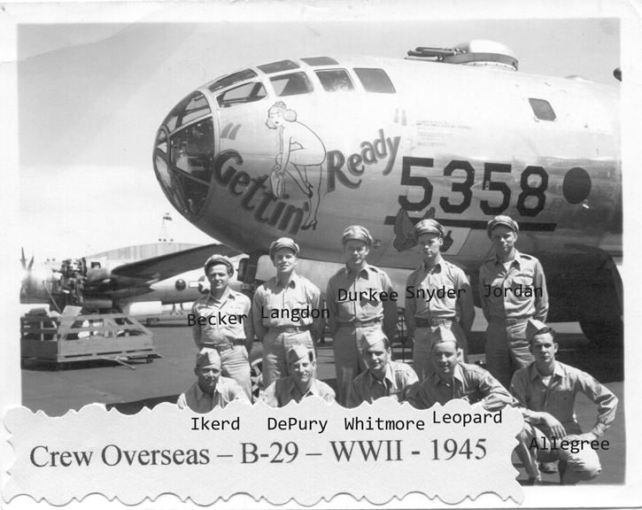

A Most Exciting Mission for Durkee’s Crew

Bombing Runs Against Japan from Tinian under Commander Nick Durkee
by Lester Snyder Rapid City, South Dakota

There are a couple of facts which may help to put this account into the proper perspective and explain why some things happened as they did. First, the Imperial Headquarters, Japan, knew every time that a B-29 took off from anyone of the Marianas Islands, of which the island where the crew was stationed, Tinian, was one. When only one or two planes took off, the Japanese assumed that there was to be either a weather or a photographic reconnaissance mission. In such cases little attention would normally have been paid to the flight. That should have meant an uneventful flight for Durkee's crew on the day we are concerned with here. However, the Japanese had been fooled within a week before, when an atomic bomb had been dropped on them. That might account for the vicious fighter attack the crew experienced. The enormity of the atomic bomb blast also might explain why the fighters broke off and left the area when the pilots saw the bomb bay doors open, especially since the aircraft was over a major city, Tokyo. But let's look at what happened, as the crew remembers it.
On the morning of August 11, 1945, Durkee's crew was briefed for a weather reconnaissance mission to central Honshu, the Tokyo area. The regular crew had received a replacement for Bill Whitmore at the Central Fire Control position. Furthermore, the crew was to be supplemented with an Instructor Navigator and a Photographer. The crew was briefed on the requirements of the mission, and during the Briefing the Radio Operator was instructed to shut down his transmitter when the aircraft was one hour from the coast of Japan. The Navigator was to advise him when the aircraft reached that position. Unfortunately, he must have forgotten and just continued handing position reports around the gun turret to the Radio Operator, even after landfall had been made. The turret mentioned was the top
forward four-gun turret. It was about four- or five-feet in diameter and extended from the top of the cabin down to within a few inches of the floor. It was directly in the middle of the forward crew compartment. The Navigator and the Radio Operator could not easily see each other.

As the aircraft approached the mainland of Japan the crew spotted what appeared to be a weather balloon at the altitude of the aircraft which was 25,000 feet. As the aircraft passed to the left of the balloon the gunners used it as a target to test fire the guns. Some of the crew later joked about the fact that somebody had been angered. The firing alerted the Radio Operator, Ed DePury, and he went over to ask the Navigator Buzz Langdon, about the position. Buzz just motioned for him to look out the Navigator's window (on the left side) to see Mount Fuji. Ed immediately returned to his position and shut down his radio gear.

The airplane was on auto-pilot and the Pilot, Gene Jordan, was watching out the front and sides when he saw three "Tojo" type fighters coming out of one-o'clock high with wing guns flashing. Someone later commented that it was reminiscent of Christmas tree lights. The Pilot, Gene Jordan, was the gunnery officer and called out the fighters and the firing orders. Once

engaged the Central Fire Control took over directing the firing. Some of the first shots pierced the right side of the ship, some coming in just above the Flight Engineer Roy Becker's position. Roy Becker was wounded slightly and his instrument panel was damaged. The engine instruments, the hydraulic system, one voltage regulator and part of the oxygen system including the Aircraft Commander and Radio positions were knocked out.

In addition to Roy, the Instructor Navigator, Brady, was wounded. He had been sitting on the forward hatch leaning back against the gun turret with his head beside the water jug which hung on the side of the turret. The position was fortunate because, although he was wounded in the shoulder, shrapnel shattered the water jug which then protected his head. Also, Ed DePury was heard over the intercom saying he might have been hit. However, after a closer look he found that he had been doused with warm hydraulic fluid.

When the Japanese shots pierced the skin of the aircraft, at 25,000 feet, obviously pressurization was lost. The Aircraft Commander, Wallace "Nick" Durkee, switched off the auto-pilot, said, "You have it", to Gene Jordan and proceeded to put on his oxygen mask and try to get some oxygen. The other regular aircrew members also routinely donned their oxygen masks. However, the Photographer, who occupied a seat in the rear crew compartment next to the Radar Observer, Lester "Les" Snyder, did not even pick his up. Les pointed to the mask, but he just put his head down on the radar desk. Les Snyder picked up the mask and tried to put it on his face. The Photographer's reaction was to push Les off his seat. Les then turned on the continuous flow knob and placed the mask by his face. As a result of that tactic the Photographer sat up and put on his mask, oblivious to what had happened.
The aircraft had been fitted with two 600-gallon long range fuel tanks in the forward bomb bay. Supposedly the fuel had been used and they were empty, but at least one of them must have had some residual fuel in it. Also, the tanks and hoses were supposed to be bullet-proof and leak-proof. It wasn't as safe as everyone thought. Evidently at least one round of ammunition must have broken a pump or connector, and fuel leaked into the bomb bay. Then something ignited the gasoline fumes. It is immaterial whether it was a 20mm projectile, a spark from electrical equipment or something else. Whatever it was, there was a tremendous explosion in the bomb bay. One actually could feel the aircraft bend upward in the middle.

The bomb bay doors were blown back on their hinges, with the actuators ripped from them, so that they could not be closed. The hatches to the bomb bay were blown open and the ring-gunner (CFC), Doug Williams, left the Central Fire Control position, convinced the hatch should be closed again.
The Left Gunner, Bob Leopard, realizing the fighters probably would be coming back for the kill, firmly convinced Doug he was needed at his gun-sight, and he returned to the position.

Then the real hero of the venture stepped forward. It should be remembered that the crew recommended that Ed DePury be awarded the Distinguished Flying Cross for his action on the mission. Apparently, the draining fuel was ignited by the explosion and the wind from the open bomb bay doors was causing a fire to swirl around in both bomb bays. Ed, whose radio position was closest to the fire, reported it on the intercom and requested a fire extinguisher. The extinguisher that had hung on the forward turret was handed to the Navigator, Buzz Langdon. He finally handed it to Ed after much difficulty. It kept slipping from his grasp because it was covered with the blood ofthe Navigator Instructor. Ed DePury took the slippery extinguisher and got out into the open bomb bay as far as he could. He sprayed the entire contents of the bottle in the direction of the source of the fire, which seemed to be located almost all the way aft in the forward bomb bay. It is amazing that he was able to maintain his footing in his precarious position with the Pilot, Gene Jordan maneuvering the aircraft. When Ed had emptied the first bottle, someone, probably Buzz, handed him another. He then proceeded to empty the second bottle on the fire. Then, believing that he had not made progress on the raging fire, he went back to his position and prayed. Miraculously the fire seemed to "extinguish itself”.

When the Radio Operator, Ed DePury, first reported the fire, the Pilot hit the Salvo switch to drop the tanks, which was the proper thing to do.

However the tanks would not jettison because the safety switch in the bomb bay was still in the "Safe" position. Although the Bombardier position on the crew was occupied by a Weather Observer, Ray Christena, who did not have the benefit of training on control and operation of the bomb bay racks or the nose gun-sight, there were no problems that arose as a result of that.

The safety switch was on another crew member's preflight check list and there was no opportunity to fire from that position since the fighters came in from the high position.

With the crew compartments depressurized and the oxygen system not operating one hundred per cent, when the Pilot, Gene Jordan, was given control of the aircraft, he pushed the nose down and opened the throttles to gain speed and get to a lower altitude and a more favorable air pressure. The fighters banked into a turn to form up off the right wing, just out of range. Then they apparently started to make another pass in an effort to finish their destruction. As the pilot made a turn into the fighters, still in a shallow dive and with full power, somebody was heard over the intercom saying that he had hit one. Smoke was observed coming from one of the fighters and it is generally conceded that it was the Right Gunner, Auston Ikerd, who had made the "kill". Then miraculously the fighters broke off their run and left the area.

With the fighters gone but the fire raging out of control a precautionary alert for abandoning the aircraft was issued over the intercom. The crew members in the rear compartment all clipped on their chest chutes, including the Tail Gunner, Donn Allegree, who had come in from his position in the tail. Les Snyder got them lined up at the rear hatch ready to jump if such an order was given. Meanwhile Les monitored the intercom for further instructions. Finally the decision was made to stay with the ship.
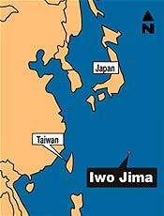
The Aircraft Commander, Nick Durkee, requested a heading out of the area from the Radar Observer, Les Snyder. Probably he asked the Radar Observer instead of the Navigator because the members in the front compartment were preoccupied with the chaotic conditions up front. Les directed the pilots to fly a heading that would take the aircraft out over the center of the bay. It was then decided that Iwo Jima was the only logical destination available to the crew. The airport on Iwo had been captured from the Japanese by the U.S. Marines a short time before. As the aircraft headed south from the Empire the pilots found that flying the aircraft was a bit tricky. The power settings on the engines had to be guessed at since the engine instruments had been knocked out. Also The Radio Operator, Ed DePury, discovered that fuel still was spraying into the bomb bay and the fumes were invading the crew compartment. In response, he advised the rest of the crew and requested that there be no smoking. The leaking fuel injected another uncertainty into probability that the aircraft could reach Iwo.

Eventually everyone settled into their positions as the aircraft headed toward Iwo Jima. Remembering that submarines often were able to pick up crews that could not make it to land, the Aircraft Commander, Nick Durkee, radioed a request for a submarine. The Radio Operator, Ed DePury, found himself talking to someone on a submarine and explained the predicament of the crew. The submariner asked for the position which Nick obtained from the Navigator, Buzz Langdon. The submariner said that he would be standing by and if it was decided that ditching was necessary, he would initiate a radio signal which could be homed in on. It was evident to all that ditching would be a last resort because of the riskiness, especially with the bomb bay doors open.

Somewhere along the way a flight of P-51 's showed up and did barrel rolls around the tail of the aircraft. They then went about their own business and finally the crew sighted Iwo. To the amazement of all, the aircraft had made it all the way, even with all the drag ftom the open bomb bay doors and the loss of fuel ftom the leaks. Then another problem presented itself. The Command at Iwo Jima did not want a ship flying over the island with open bomb bay doors. The solution was to launch a fighter to look over the situation. After looking up into the bomb bays and seeing no bombs, the pilot cleared the aircraft to the pattern.

The Aircraft Commander, Nick Durkee, entered a right pattern but the aircraft was in so tight that he decided to make a pass over the runway at pattern altitude. That correction was a blessing in disguise because the pilots observed construction equipment at the approach end of the runway and a B-24 about one third of the way down the runway and off to the right side. The pilots were desperate to land the aircraft because they knew the aircraft could not remain in the air much longer. However the ground crews evidently were able to get the runway cleared quickly for one more wreck to come in.
As the aircraft turned onto final approach both the Pilot and the Flight Engineer informed the Aircraft Commander that he had a maximum of three applications of the emergency brake system and should not release the brakes once they were applied. The hydraulic fluid was very limited since the system had been knocked out by one of the Japanese projectiles. Gene Jordan and Nick Durkee brought the plane in as slowly as they could, in a very nose high attitude and wefe able to stop the bird on the runway, on the third and last possible application of the brakes.

Finally the crew was on the ground and relatively safe. The crew was met by medical personnel and ground crews and were escorted to a tent for debriefing. The crew had joined the multitude of aircrews whose lives were saved by the capture of Iwo Jima. Although the aircraft was in very bad shape (it had eleven 20mm holes, alone, in the fuselage) she had returned the crew to safety. The maintenance engineer at Iwo could find no logical reason why the aircraft had not been blown up in mid-air. He said that the crew must have been the first one to come back alive with trouble like that.

Thanks to the Marines, the crew was able to spend the night in a tent on the sands of Iwo Jima. The next day the crew flew a B-29, that a previous crew had left for temporary repairs, back to Tinian. The day following the crew's return, the Aircraft crew chief came calling on the pilots wanting to know what had happened to "his airplane". There may have been a doubter or two on the crew but the following Sunday the entire crew showed up at the Chapel, which usually served as the mission briefing room. The members filled the front two benches. In the words of Ed DePury, "We are truly fortunate that the mission ended as it did". That could be considered as somewhat of an understatement.

