Delmer Dooley Obituary
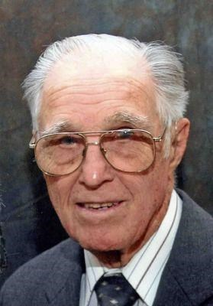
Delmer Dooley
Madison, SD - Delmer Dooley, age 95, died at Golden Living Healthcare Center on February 13, 2016.
He was born at Madison on March 15, 1920 to Frank and Theresa (DeRungs) Dooley. He married Thalia Doty at Carson City, NV on June 12, 1952.
He is survived by his wife - Thalia of Madison, two sons - Douglas of New Canaan, CT and Allen of Madison, six grandchildren, one brother - Dan of Billings, MT and one sister - Ellen Dooley of Chicago, IL.
He was preceded in death by his parents, two brothers and two sisters.
Funeral Mass will be held at 10:30 AM on Saturday, March 5, 2016 at St William Catholic Church in Ramona, SD with Rev Paul Josten officiating. Burial with military honors will be in the church cemetery.
He grew up on the Dooley homestead near Ramona. He graduated from Ramona High School in 1938. He served in the Army Air Corps during WW II and flew 50 missions as a flight engineer and top turret gunner on a B-17 over the European theatre. He served as the Executive Director of the Near East Foundation, NYC for 20 years and raised his family in East Hanover NJ. He dedicated his professional career to building or improving the educational and agricultural systems in the Middle East, Korea and Africa. He received Medals of Honor from King Hussein of Jordan and the Shah of Iran where he started two agricultural colleges. He retired in 1986, returning to the family farm in Ramona which has been in the Dooley family since 1884. He remained active in the community, serving on the Madison Hospital Board for 20 years. He was active on the Lake County Historical Society board and served as commander of the American Legion and was a member of the VFW. He was also a member of the Ramona Knights of Columbus and Msgr Thomas Flynn Assembly of the Fourth Degree Knights of Columbus. He also collected over 60 antique tractors.
There will be a Parish Scripture service to be followed by a Knights of Columbus Rosary at 6:00 PM on Friday, March 4, at Weiland Funeral Chapel in Madison which is in charge of the arrangements.
www.weilandfuneralchapel.com

To plant trees in memory, please visit the Sympathy Store.
Published by Argus Leader on Feb. 21, 2016.

