James Herman Kienitz Obituary
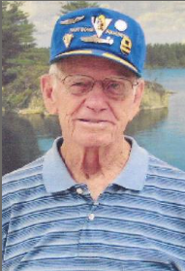
James Herman Kienitz, was born in Pipestone, MN, on August 1, 1916, and died at Sturgis Regional Hospice Care in Sturgis, SD, at the age of 97.
Jim was proud to have served our country during WWII. He flew 50 missions with the Army Air Force as a top turret gunner and radio operator.
He later enjoyed his work with the Bureau of Reclamation helping construct Angostura Reservoir and later supervising its operations as well as that of Pactola Dam.
His has many surviving family members, including his two sons; sisters, Barbara Bertsch; June Getty; also Steve's wife, Carol, his daughters Nicki and Kristen and families have been grateful to be part of his life.
Jim was preceded in death by his parents, Herman and Ruth; 3 brothers, Don; Dick; Robert; 2 sisters, Evelyn Nuttle; Elsie Renz; in his immediate family.
He was also preceded in death by his wife, Gerda, and his son, Steve.
Committal services will be held at 1:00 p.m., Monday, March 24, 2014, at the Evergreen Cemetery in Hot Springs.
Refreshments will be offered immediately following the service at the American Legion, 1045 Jennings Ave., Hot Springs.
Condolences and in lieu of flowers memorials may be sent to McColley's Chapel of the Hills, 401 N. Garden St., Hot Springs, SD 57747.
Arrangements have been placed in the care of McColley's Chapel of the Hills in Hot Springs, SD.

