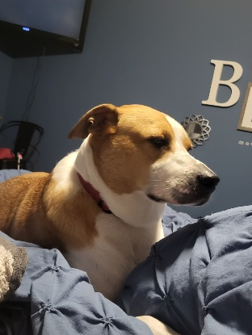 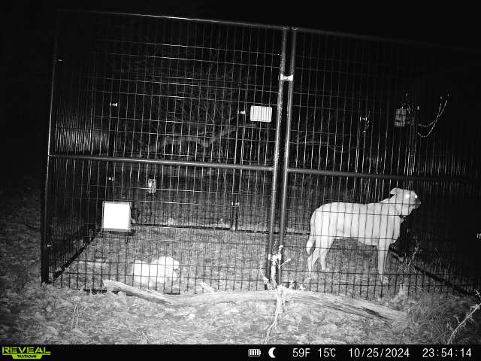 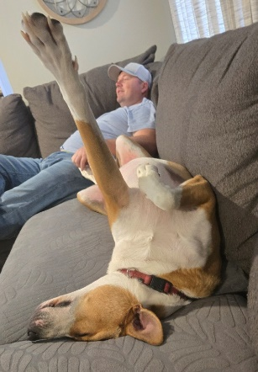

(pre getting lost) (getting captured/rescued) (being back home)

***A Message from Davis' Family:***

We are beyond grateful to have our dog, Davis, back home after a long and worrisome ten days, thanks to a number of incredible people who helped along the way – one of whom was **Mary Humphrey** of Wayland. Mary volunteered tirelessly, never losing hope or dedication. Davis went missing nearly two weeks ago while we were on vacation, and our two little girls were heartbroken.

From the moment Mary heard that Davis was lost, she was determined to bring him home safely. Using her own supplies, time, gas, and knowledge, Mary partnered with a drone company, set up trail cameras, and laid traps, tracking his every move. Davis, being the stubborn dog he is, proved to be elusive and avoided every attempt to capture him. But Mary never gave up. Night after night, she kept watch, adjusting strategies, and finding ways to outsmart our Davis.

Finally, after nearly a dozen attempts, Mary went above and beyond by bringing out an even larger cage – and that did the trick! Davis is finally safe and home again, greeted by two overjoyed little girls and a family who will never forget Mary’s kindness, resilience, and determination.

**We want to give back to Mary, who never asked for anything in return.**

She has helped many others besides Davis, in fact, this was her 80th reunion she created this year! Every dollar raised here will go to Mary as a gesture of our immense gratitude and to help cover her expenses for the equipment and countless hours she poured into this rescue and the many others she has done and will continue to do in the future.

Thank you, Mary, for bringing Davis back to his family and for filling our hearts with gratitude. And thank you, everyone, for helping us give back to someone who truly deserves it.

**https://gofund.me/85755f39**

Thank you for your consideration!