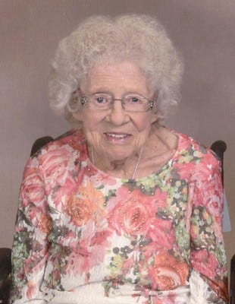
Lillian Berreth
Sioux Falls - Lillian Berreth passed away peacefully Friday, January 4, 2019. She was 94.
Lillian Ruth Sachen was born December 4, 1924 to Henry and Verna Sachen in Sioux Falls, South Dakota. She grew up in Sioux Falls, graduating from Washington High School in 1943.
On September 9, 1943, Lillian married the love of her life, Edward H. Berreth. The couple made their home on a farm in Humboldt, SD for 67 years, then they moved into assistant living December 2014.
She worked various jobs over the years. She sorted eggs in Humboldt, she worked at Cherry Rock Garden Market in Sioux Falls for 15 years, and retired from JC Penny's after working there for 26 years. After retirement, Lillian and her husband couldn't sit still and relax, so they planted a 3-acre garden that they would sell produce from at Kmart East. The last year they had their garden was the summer of 2012.
Lillian was a member of the Sioux Falls, Seventh-day Adventist Church. Lillian was a loving wife, mother and grandmother, who was dearly loved by those around her and will be deeply missed. Everyone enjoyed her uplifting spirit and her loving heart. She was always positive about everything. Everyone that came to know her the last 30+ years, knew that her heart was with the Lord. She and the Lord has fought a number of health issues together. She was a very strong lady and she had spunk, and fought hard when she had health issues. She never complained when things were looking bad. Now her fighting is over and she is sleeping until Jesus comes to take us home.
Lillian is survived by 4 sons, Edward Berreth Jr. of Delano, CA, Dennis Berreth of Sioux Falls, SD, Kenneth Berreth of Sioux Falls and Ronald Berreth of Sioux Falls; daughter, Leesa (Duane) Rang of Sioux Falls; 8 grandchildren; many great-grand and great-great grandchildren; and a brother, George (Pat) Sachen.
She is preceded in death by her husband, Edward Berreth; her parents, Henry and Verna Sachen; 3 brothers, Harry Sachen, Charles Sachen and Henry Sachen; 5 sisters, Betty Coulter, Sally Erickson, Mary Erickson, Ann Stratmeyer and Verna Miller.
Visitation will be 3:00 – 5:00 pm Saturday, January 12, 2019 at Miller Funeral Home, 507 S. Main Ave., Sioux Falls. Funeral service 4:00 pm Sunday, January 13, 2019 at Seventh-day Adventist Church, 7100 E. 26th St., Sioux Falls. Interment 10:00 am Monday, January 14 at Woodlawn Cemetery, Sioux Falls.

