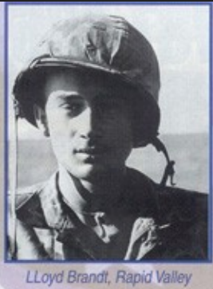

Black Hills Veterans Writing Group
A young Austrian engineering student drafted into the German Wehrmacht travels north by train through desolate landscapes. The war has been going badly on the Eastern Front, where his father is listed as missing in action. Stalingrad has already fallen, and now news has just arrived that there’s been an attempt on the Führer’s life.
Elsewhere, the youthful West Point-educated son of an Army general is piloting a B-24 over enemy-held Serbia and finds to his horror that his bomber, shot to pieces by German fighters, is going down. Injured, he roams the countryside for days with pro-Allied Chetnik guerrillas until his eventual escape.
Though once on opposite sides in World War II, Franz “Frank” Morawa and Thomas Oliver, both Rapid Citians, found each other at the Black Hills Veterans Writing Group, which meets monthly at the Rapid City Public Library.
The group grew out of a 2005 workshop designed to help Black Hills veterans write about their military experiences. Led by Vietnam-era Army veterans Bradford Morgan and Dean Muehlberg, with the helpof Navy veteran Ed Hughes of the library.
The group’s motto remains fresh:
“What I remember should not be erased from human memory. I must write. I must write now.”
Even those right next to you in combat often remember events differently, it was felt, so why have someone else write up "your" experiences.
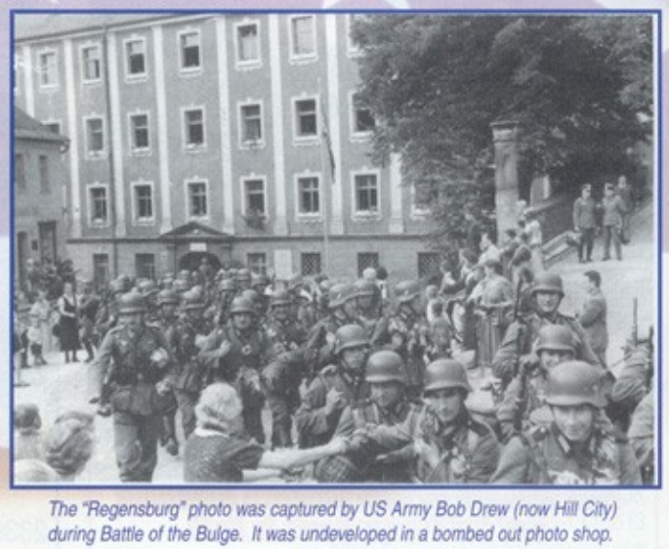
WWII veterans are dying at a rate of 1,500 each day. With them goes memories of battlefield travail, comic interludes involving wartime buddies, and other poignant lessons from personal and family experience. If people today sometimes seem lost in the throes of pop culture--sports, songs, sitcoms, and similar entertainments--then memoirs can be restorative.
Then, too, the "political correctness" much in evidence nationally among students and news outlets seems, not surprisingly, right at home in university scholarship as well. So, for some vets, book-level history often fails to represent the "foxhole" or direct experience as they remember it. This is why they choose to tell their own stories. Those in the Writers Group soon discovered that writing is like athletic performance, favoring those in shape and not rusty. Memory isn't always summoned as easily as might be expected. Names are forgotten, along with times of events and other details. Those who kept journals, letters home, and photographs find recall easier, but keeping a journal is difficult in the extremes of combat, and cameras were off-limits to the typical combatant. Even letters home faced censors, and most were motivated not to alarm family about the stark realities of war.
Rapid Valley's Loyd Brandt was involved in the Marine Corps invasions of Tinian, Saipan, and Okinawa. He was fighting on Iwo Jima's Mt. Suribachi when the famous photo was taken. Six of the seven Brandt brothers served as Marines at the same time in the Pacific. One, Herbert, was killed at Saipan. "On one reconnaissance landing in an Amtrak," Loyd relates, "we found ourselves disoriented in the dark and smoke of what we thought was a lagoon, only to find ourselves floating directly under the thundering big guns of offshore Navy ships, frantically scooping water with our helmets to keep from sinking. We were deaf for days."
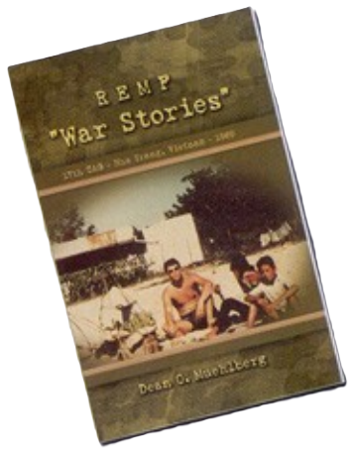
Brandt's story appears in the current issue of Militaria International Magazine, written by another Writing Group member, Dean Muehlberg, from Rapid City. Muehlberg's recent book REMF "War Stories" (see Amazon.com) is an autobiographical account of the daily barracks life of a soldier during the Vietnam War.
Having one veteran tell his story to another veteran has proved to be a good formula for the Group. WWII scholars and authors of several books in the field, Ray and Josephine Cowdery of Rapid City, wrote up the experiences of Frank Morawa, also recently published in Militaria International Magazine.
Several writers also found that "nonfiction" short stories, vignettes, or poems were the best vehicles for articulating their experiences. Vietnam vets Craig Schaffer and Bill Walker (whose book To Ride a Hurricane was just published) adopted this mode of expression, along with WWII vets Paul Priest, Bob Drew and Peter Dahlberg, who fought in the Battle of the Bulge. Lester Snyder, now 86, tells of a bombing mission against Japan during WWII and a harrowing return to a recently captured Iwo Jima aboard a badly shot up and burning B-29 bomber.
One veteran, Jerry Teachout, retired USAF pilot from Piedmont, has described his experiences in three wars: WWII, Korea, and Vietnam. He has already written twenty chapters of his autobiography. "Every time I put pen to paper or words to screen, new memories come back to me. I'm emtionally [sic] overwhelmed with the joy of re-discovering my own past," says Teachout, "so I recommend this to every retiree, military or otherwise. Just think of the values that will otherwise be lost in our superficial media-defined culture."
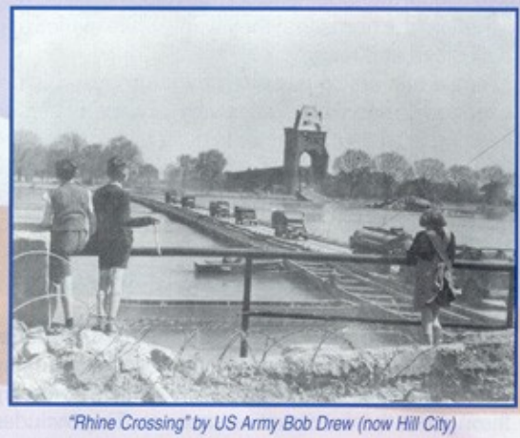
You might pass Bob drew of Hill City on the street and think he is just another older person, perhaps easily dismissed. But Bob's military experience during World War II makes him living history. This soldier fought his way across Europe, right through the Battle of the Bulge, and was among those liberating the SS prison camp at Flossenberg in the Sudetenland.
Brad Morgan is SDSM&T professor emeritus. A 1968 graduate from Berkeley ("I stood next to Mario Savio during his noted advocacy [sic] in behalf of free speech in 1964") Brad went right from this campus hotbed to Basic and Advanced Infantry Training at Fort Lewis, WA. His primary mission was to holdback the Soviet hordes from invading Central Europe where he was stationed in the late 1960s. Contact him at bradford.morgan@sdsmt.edu

