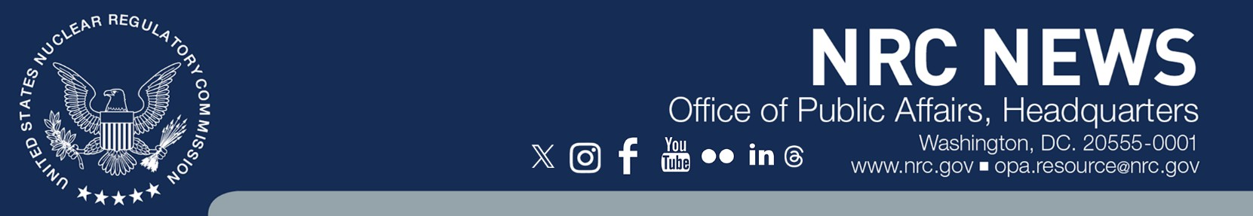

No: 25-046 July 24, 2025

CONTACT: [Maureen Conley,](mailto:OPA.Resource@nrc.gov) 301-415-8200

NRC Approves Major Licensing Actions Required for Restart of Palisades NPP

The Nuclear Regulatory Commission has [approved](https://www.nrc.gov/docs/ML2516/ML25163A182.pdf) a series of licensing and regulatory actions that will pave the way for restart of the Palisades Nuclear Plant. The pressurized-water reactor located in Covert, Michigan, ceased operations in May 2022. In late 2023, Holtec began filing licensing and regulatory requests to support returning the plant to operational status.

While these NRC approvals will allow Holtec to load fuel, there are still several licensing actions under NRC review and additional requirements that need to be met before the plant can start up under the original operating license, which would expire March 24, 2031.

Following technical reviews that were completed on schedule, the NRC has approved the transfer of operating authority for the plant and its independent spent fuel storage facility from Holtec Decommissioning International LLC to Palisades Energy LLC. The NRC has also approved Holtec’s request to reinstate various documents and programs that were in place prior to shut down. Among these are the technical specifications, emergency plan, emergency action levels, and physical security plan, as well as programs for quality assurance, maintenance, and inservice inspections. A [May 2025 report](https://www.nrc.gov/docs/ML2511/ML25111A031.pdf) contains the NRC staff’s evaluation and conclusion that there are no significant environmental impacts from restarting Palisades.

More information on the Palisades restart review is available on the NRC [website](https://www.nrc.gov/info-finder/reactors/pali.html).