Ralph Christensen
February 9, 1922 ~ August 16, 2017 (age 95)
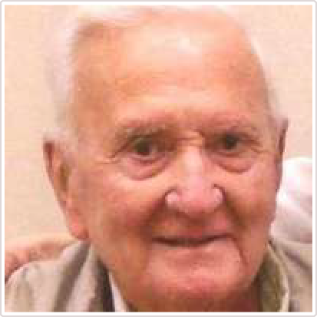
Ralph Christensen, 95 of Badger, SD died Wednesday, August 16, 2017 at the Arlington Care and Rehabilitation Center in Arlington.
Ralph Christensen lived almost his entire life within a two-block area of Badger, SD, but that definitely did not mean that he lived a small life. Ralph was born to Jens "Motorcycle" and Annie Christensen, and was their only child for the first 18 years of his life before his baby sister Mary was born. Ralph gained the nickname "Bicycle", which stuck for 90-plus years. He spent his early years farming with his father, including planting and harvesting the land that is currently Lake Albert during the dry years of the 1930's. He attended school in Badger and Arlington, graduating in 1939.
On October 14, 1942 (after Lake Albert filled with water again), Ralph enlisted in the Army Air Corps and trained in Altus, OK. Thus began the chapter of his life that led him across the Atlantic and provided him with another 75 years-worth of stories to tell. Ralph was stationed with the 100th Bomb Group in Thorpe Abbott, England as a B-17 co-pilot. He and the rest of the Lucky Lassie crew flew 33 missions, including an emergency landing after taking fire, which led to an 11-day walk through Nazi-occupied France, train trip to Paris, and ride on a C-47 transport back to London.
Ralph remained an active member of the 100th Bomb Group and loved attending reunions with his crew around the country.
After returning to Badger in 1945, Ralph married Hazel Johnson on August 1. They had two children, George and Janet. Ralph was a farm implement salesman for Owatonna Manufacturing Company, frequently flying his Cessna on his sales trips. He and Hazel raised their children, farmed, sold Vari-pols and Vari-dors (Ralphs inventions), built the community, and square-danced in Badger and the surrounding area for the next 70 years. They began spending winters in Mesa, AZ in the ?O's, where they loved any excuse to celebrate with their snowbird friends. He and Hazel traveled the world and he made many trips to visit relatives in Denmark. Ralph was a member of Badger Lutheran Church and the Badger American Legion. He loved entertaining visitors and telling stories, and was a voracious reader and Aquavit aficionado -a nod to his Danish heritage.
Ralph is survived by his daughter Janet Bjordahl, grandchildren Carrie (Jeff) Churchill, Erik (Angie) Bjordahl, Krista (Tim) Haug, Todd (Renae) Christensen, and Kurt (Mandi) Christensen; his great grand-children Hannah, Molly, Bella, Kai, Thomas, Evan and Meredith; his sister Mary's children Sarah Snudden and Geoff Snudden; faithful companion and Lincoln Town Car co-pilot Abbie the dog; and many cousins, nieces and nephews both in the USA and Denmark.
He was preceded in death by his parents, wife Hazel, son George, son-in-law Phil Bjordahl, and sister Mary Snudden.
Memorial services for Mr. Christensen will be at 10:30 am on Saturday, September 2, 2017 at the Badger Lutheran Church with Pastor David Patterson officiating, burial will be in the Badger Cemetery. Ralph requested that memorials be given to the Badger Cemetery or the Badger American Legion.

Link to original obituary.

