Old School Demonstrations: Bernoulli’s Principle

Lesson Plan: Bernoulli’s Principle (Demos)

Background:
Daniel Bernoulli was a Swiss mathematician during the eighteenth century. Bernoulli studied the physical phenomenon/relationship between the velocity of a fluid and pressure. His observations and applied mathematical explanations became known as Bernoulli’s Principle. (Detailed explanation of Bernoulli’s Principle and related resource below.)

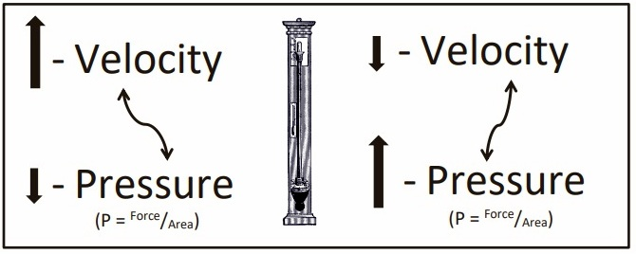

Bernoulli’s Principle describes a phenomenon in which the pressure (pressure is the amount of force applied over an area) of a fluid (gas or liquid) changes with a change in the velocity of the fluid. Bernoulli observed that an increase in the velocity of the fluid resulted in a decrease in the pressure of the fluid. Also, a decrease in the velocity of a fluid resulted in an increase in the pressure.

This handout includes demonstrations that highlight Bernoulli’s Principle. We will start with flight/lift and continue from there. Each section will include a small explanation and a related video lesson.

Images courtesy FCIT, http://etc.usf.edu/clipart & Microsoft Clipart.

Lift (airplane flight) is probably one of the most well-known and controversial occurrences described by Bernoulli’s Principle. Many times, Bernoulli’s Principle is used exclusively to describe flight. Flight is a very complex integration of many factors, including drag, Bernoulli’s Principle, Newton’s 3rd Law of Motion, gravity, Coanda effect, angle of attack, downwash, etc. During these demonstrations, we will only consider Bernoulli’s Principle when describing lift. We have included an extensive list of sites that describe mechanisms of flight/lift.

Flight/Lift

Materials:
- Styrofoam plane
- Colored round stickers (2 colors)
- Classroom with student desks
- Paper (8.5”X11”)
- Measuring tape
- Stopwatch (3-5)

Procedure:
During this demonstration, you will use a Styrofoam airplane to explain lift, and then the students will construct paper airplanes and compete in a paper airplane throwing contest.
- Place approximately 30 colored stickers on the upper and lower sides of one of the wings (representing rest). On the second wing, place approximately 40 colored stickers on the bottom (increase pressure below the wing during movement due to compression) and approximately 20 stickers on the top.
- Describe the pressure on an airplane wing at rest. The pressure above and below the wing is the same represented by the wing with the same number of stickers above and below.
- Show the wing (airfoil) from the side – draw an airfoil on the board. Air flowing over the top of the airfoil travels faster than below the airfoil.
- Now show the other wing representing movement. The wing has 40 stickers on the bottom and 20 on top. This represents a decrease in the number of air particles contacting the wing as the velocity increases. (The number of stickers does not mathematically represent actual pressure differences; this demo is for visual purposes only to help your students remember the overall concept.) The plane should be hung in the room as a constant reminder.

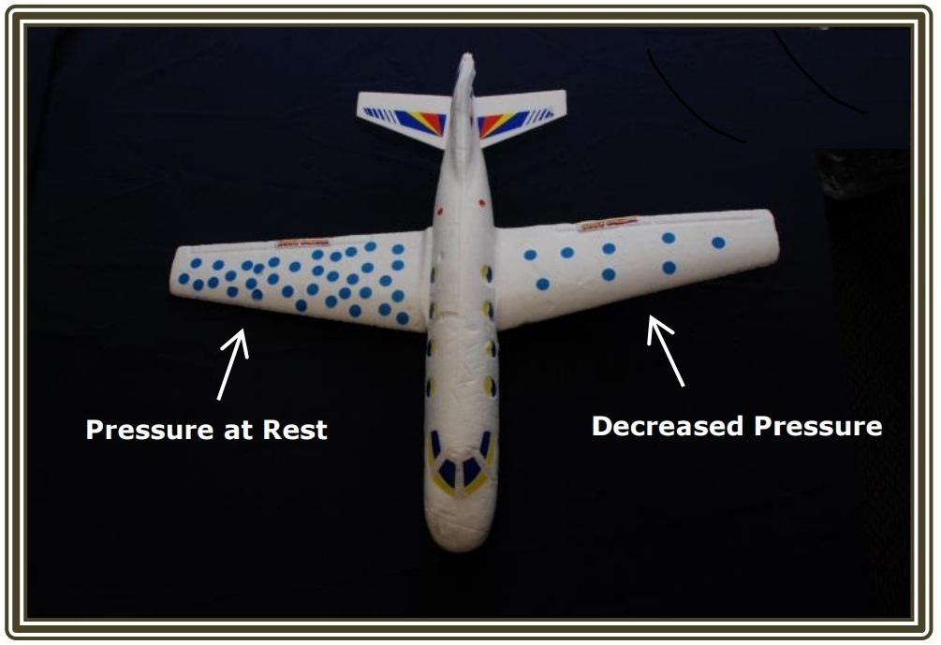

Procedure Continue (Flight/Lift):
Show the students an example of a paper airplane. Show how small adjustments can change the flight of the paper airplane.
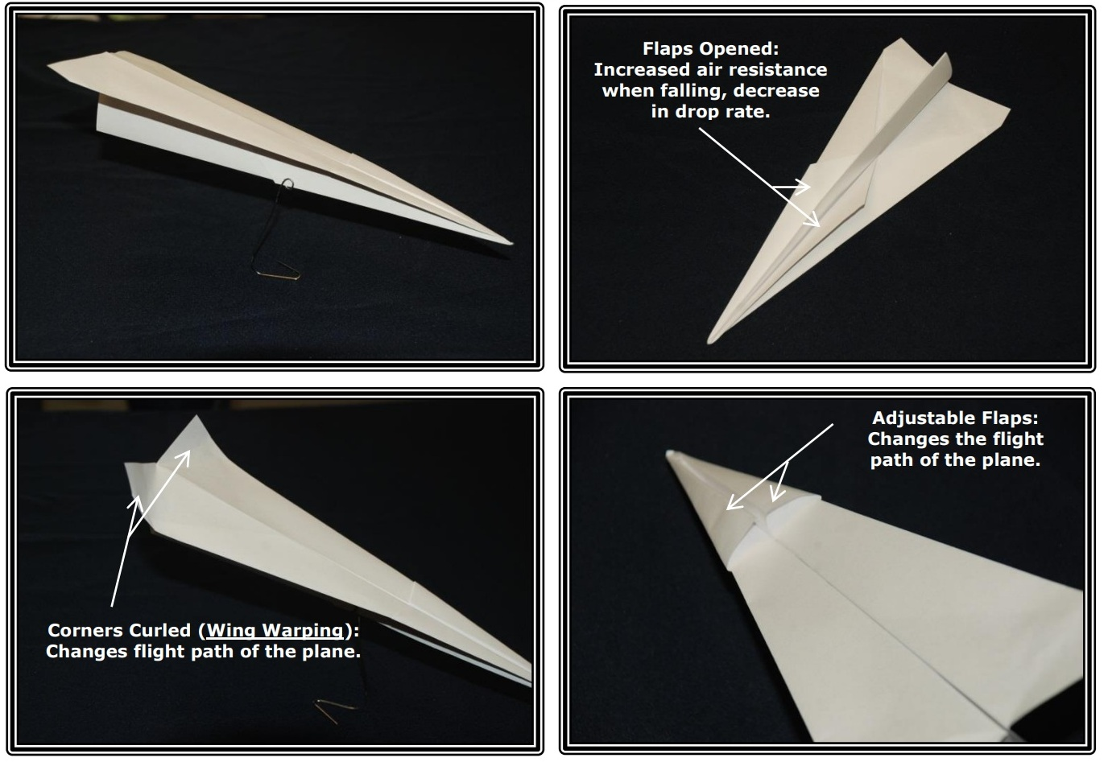

The students will construct a paper airplane and compete in a paper airplane throwing contest.
- Airplane designs are available online, examples below.
  - NASA: Paper Airplanes
  - NASA: Paper Airplane Activity
  - National Air and Space Museum Paper Airplane Gallery
  - Additional paper airplane designs can be found by completing an Internet search.
- Possible categories for the contest (choose one or more categories)
- Longest distance
- Longest time in the air
- Longest distance in shortest amount of time
- Longest distance in longest period
- Etc.
The students should observe that slight changes or adjustments in the design of a plane can drastically change the flight of the plane.

Web Resource (Flight/Lift):

Video Clips and Activity Ideas

- The Challenges of Flight (PBS LearningMedia)
- How Things Fly (Smithsonian)
- The Forces on an Airplane (MIT)
- Scientific American Frontiers: Flying Free – Episode #9 (classic video)
- DragonflyTV | Wing Shape and Stunts
- The Physics of Sailing

Flight, Airfoils, Forces, and Bernoulli’s Principle

- How Does a Wing Actually Work? (Veritasium)
- Bernoulli and Newton (NASA)
- Incorrect Lift Theory (I, II, & III) (NASA)
- Foam Wing (NASA)
- Aerodynamics of Flight – Helicopters (FAA)
- Dynamics of Fluid Demos (Auburn University)
- Turbulence and Its Impact on Commercial Aviation (Journal of Aviation/Aerospace)

Bernoulli's Ball Video Demonstration
This is a twist on the classic Ping-Pong ball/hairdryer demonstration used to show Bernoulli's Principle. A leaf blower replaces the hairdryer, and a beach ball replaces the Ping-Pong ball. This is amazing to watch.

Materials: Bernoulli’s Ball
- Hairdryer
- Ping-Pong ball
- Extension Cord
- Leaf blower
- Assortment of balls (various sizes and weights)
- Large room (gym works well)

Procedure:
During this demonstration, a hairdryer will be used to float a Ping-Pong ball, and then a leaf blower will be used to float a beach ball.
- Setup/Process
- Ask the students if they have ever seen a display in a store in which a beach ball is floating above a fan.
- Place a Ping-Pong ball above the hairdryer; ask the students how the Ping-Pong ball can float above the hairdryer without falling. Turn off the dryer.
- Turn on the dryer and slowly turn the dryer from 90 degrees to 45 degrees. The ball should not fall.
- Perform the demonstration using a larger ball(s) and a leaf blower.

What to expect:
This is a classic demonstration of Bernoulli’s Principle. Note: For both A. and B. (below) – gravity/weight is providing a downward force, and dryer/blower is providing an upward force. There are two primary explanations for this demonstration. A.) There is a moving stream of air traveling around the ball, resulting in an area of less pressure. The ball is prevented from falling out of the moving stream of air because it is pushed in by the higher-pressured air adjacent to the moving stream of air. B.) The air travels around the ball and is moving at the greatest velocity at the top of the ball, resulting in an area of low pressure above the ball (lift). The ball is drawn toward the area of low pressure. This area of low pressure can be disturbed by placing a hand above the ball. Explanation B is shown in the video.

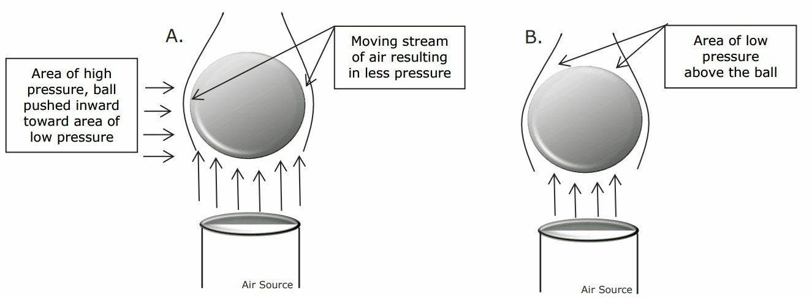

Bernoulli's Bag

Materials:
- Long plastic tube(s)
  - Different names, depending on supplier (Bernoulli’s bag, Wind Bag, Bernoulli’s tube)
      - One supplier (Wind Bag)
      - A garbage bag also works, but the demo is not as effective.
Procedure:

This classic science demonstration shows Bernoulli's Principle. A moving stream of air produces an area of low pressure (vacuum). Air moves from high pressure to low pressure, filling the bag with air.
- Setup/Process
- Have 3-4 students come to the front of the room and face the class.
- Challenge the students: each person, including the teacher, will get 5 breaths to see who can fill up the bag with the most air.
- Have each student, one at a time, blow 5 breaths into the bag.
- Order the students from most air in bag to least air in bag.
- Then the teacher (Bernoulli’s Principle) will fill the bag with one breath.
    - Hold the bag open, remove folds, and place it 6-12 inches from your mouth.
    - Blow one large breath into the bag as you step back.
What to expect:
Most students will do one of the following: A.) They will blow one breath into the bag and not remove their mouth from the bag. They will rebreathe the same breath over and over again. The amount of air in the bag represents one forced exhalation. B.) A second group of students will exhale 5 separate breaths into the bag.

The bag can be easily filled with one breath using Bernoulli’s Principle. The moving stream of air exhaled is moving faster than the air around it. This creates an area of low pressure (vacuum). This area of low pressure draws air from the area of high pressure around it, because fluid moves from an area of high pressure to an area of low pressure. The bag is filled with a small amount of air from the lungs and a large amount from the room. See diagram below

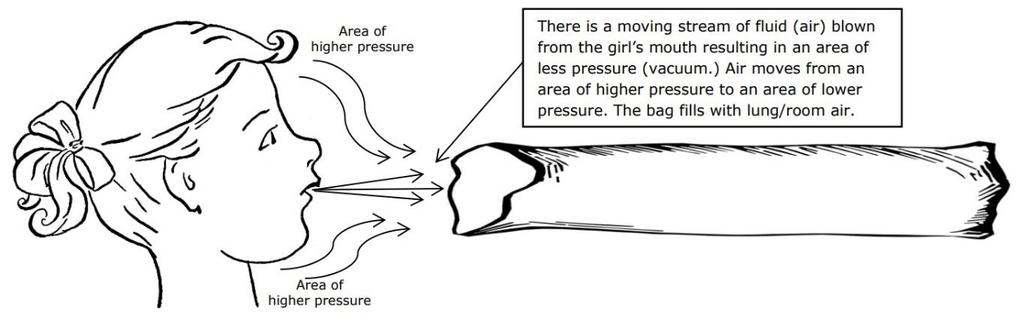

Bernoulli's TP

Materials:
- Leaf blower
- Extension Cord
- Dowel rod (normally sold in 4’ lengths)
- Toilet paper
- Paper (8.5” X 11”)
Procedure:

During this classic science demonstration, a leaf blower is used to propel toilet paper into the air using Bernoulli's Principle. A moving stream of air produces an area of low pressure. Air moves from high pressure to low pressure.

- Setup/Process
- Ask the students if a piece of paper will go up or down if air is blowing across the top of it.
- Have all the students blow air across the top of a piece of paper.
- Ask the students why the paper moves in an upward direction.
- Explain why the paper moves in an upward direction.
- Ask the students what they think will happen if air is blown across the top of a roll of toilet paper suspended on a dowel rod.
- Blow air across the top of a roll of toilet paper. (The roll should be suspended to unroll away from the blower; it works best if it unrolls from the top.)
- Explain why the toilet paper is propelled into the air.
What to expect:
The moving stream of air from the leaf blower is moving faster than the air around it. This creates an area of low pressure (vacuum). This area of low pressure draws air from the area of high pressure around it, because fluid moves from an area of high pressure to an area of low pressure. The toilet paper is pushed upward by the higher pressure below it and is propelled by the moving stream of air.

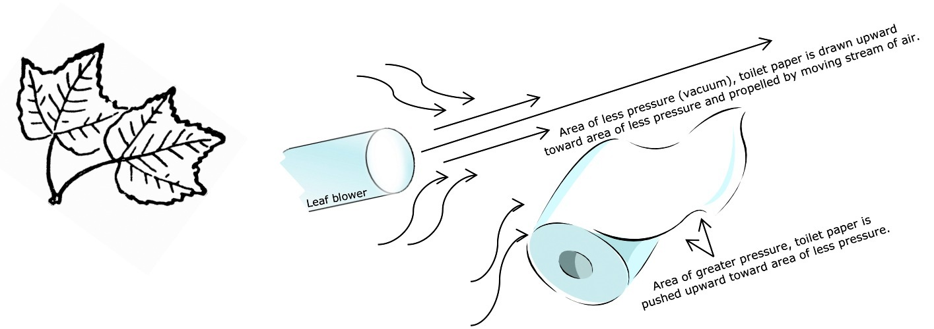

Bernoulli's (air) Tube

Materials:
- Plastic tube
  - Different names, depending on supplier (Bernoulli’s Tube, Sound Tube, Resonance Tube)
  - One supplier – Sound Tube
- Confetti (three-hole punch)
- Water may be used instead of confetti (outside)
- Paper cup to hold confetti

Procedure:

During this classic science demonstration, a plastic tube is spun, resulting in a high-pitched sound being produced.
- Setup/Process
- Hold the large end of the tube and spin the tube above your head.
- Different pitches can be produced by varying how fast the tube is spun.
- Tell the students that air is traveling through the inside of the tube, producing the sound.
- Ask the students if the air is traveling up the tube or down the tube.
- Place your hand on the bottom of the tube as you spin it, and the sound goes away.
- Place the larger end of the tube in a cup of confetti or water. The confetti/water will be pulled from the cup and propelled out the end of the tube.

What to expect:

The distal end of the tube is moving through the air faster than the end that is being held. This creates an area of low pressure (vacuum). This area of low pressure draws air from the area of high pressure at the opposite end of the tube. The inside of the tube is corrugated; the air molecules hit the ridges inside of the tube, causing them to tumble, creating vortices/vibrations. Sound is produced by these vibrations.

