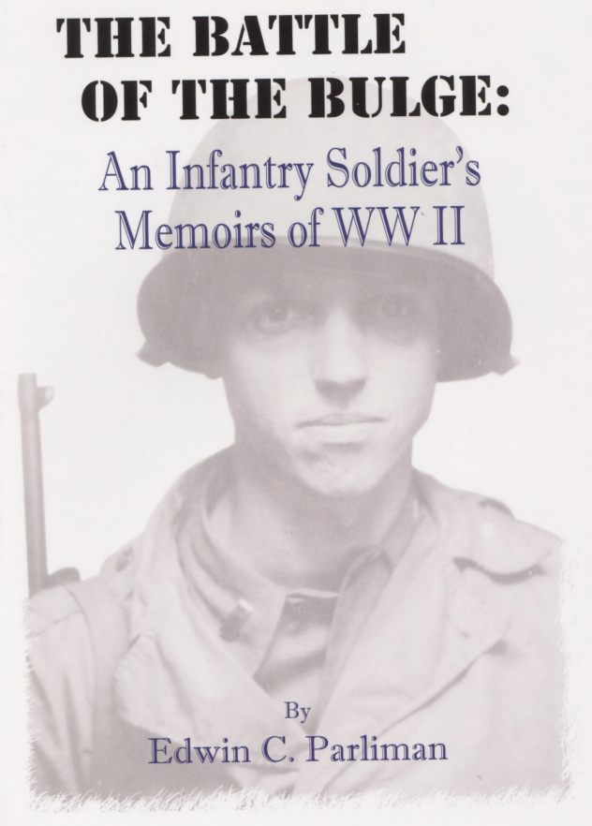
THE BATTLE OF THE BULGE:
AN INFANTRY SOLDIER'S MEMOIRS OF WWII
By Edwin C. Parliman
FOREWORD
Edwin C. Parliman was born October 21,1920 in Sioux Falls, South Dakota, to Ralph Parliman and Elsie McDowell Parliman. In 1942 he enlisted in the U.S. Army while attending the University of South Dakota and in July, 1943, he reported for active duty, eventually serving in the European Theater. He resumed his studies in 1945 at the U.S.D. School of Law after being honor-ably discharged as First Lieutenant.
While in Vermillion he married Elaine Albrecht. After completing Law school, he and Elaine moved to Sioux Falls, where they raised their children, Tom, Sally, Nancy and Robert.
He was extremely proud of his service to his country as a combat infantry soldier. However, he rarely discussed his wartime experience, except to say it was horrible and unimaginable. Finally, after the release of the movie Patton and the urging of his family members, he dictated the memoirs which follow.
Ed enjoyed an active life and practiced law for over 50 years. He died June 13, 2006 at the age of 85, just shy of his 60th wedding anniversary.
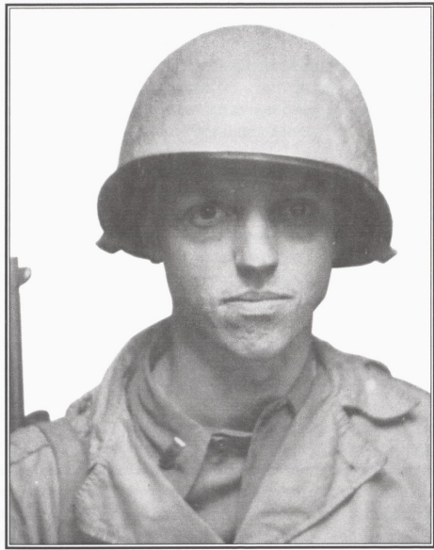
Lt. Edwin C. Parliman, son of Ralph Parliman, Jr. and Elsie McDowell Parliman.
This is an enlargement of a snapshot taken in France near the Siegfried Line about October 1, 1944, at which time he was serving with Patton's Third Army. (C)1990

I entered the service 2 June, 1942, at Vermillion, South Dakota, and served in the Reserve at University of South Dakota until July, 1943, when I left for Ft. Leavenworth and active duty. The day my orders came that summer, I got in my father's 1941 Plymouth auto and backed out. However, I neglected to first open the door of the garage. I felt bad because my father paid for a new garage door. Luckily, no serious damage was done to the car, as new cars were one of the luxuries that were no longer available. Wartime austerity.
I was shuttled from Ft. Leavenworth to Camp Ripley, Kansas, and then to OCS at Ft. Benning, Georgia. It was the location of the Infantry School, but also was home to a paratroop training center. We could see the towers where the paratroopers trained and one day as we sat on a bleacher listening to a lecture, we saw a practice jump off in the distance. The plane, large and slow, disgorged its load of troops one by one. It went well for the first soldiers, but the last three parachutes did not open, ribboned down and disappeared over the horizon. We were aghast and later heard the news that all three paratroopers were killed instantly. Our first introduction to soldier death. It brought home to us first hand, that is what war is all about: conflict, hardship and death.
In summer of 1943 there was no shortage of infantry officers, so the OCS school was tough and the company of Citadell Boys across the parade ground finished with only 43 out of their class of over 240. We fared luckier and I was one of those who made it, graduating on December 7, 1943, as a second lieutenant. I was assigned to Camp Blanding, Florida, and waded the swamps inland from Jacksonville and St. Augustine with several hundred other new shave-tails. This was mostly uneventful, except for the time our tack officer got us lost in the swamps. We were wading on a tactical problem, waist deep in water, and the excitement started when someone hollered, "Look out! Snake." We seemed to only get deeper into the swamp and the water and mud got deeper and harder to walk. Finally, the officer in charge admitted he was lost and it would be getting dark soon. One of the boys, from University of Nebraska, took over and a couple of hours later we were back in camp. He led us out of that dark swamp. It was a strange feeling, to be lost in chest-deep water, no ground above water, all wilderness around us, and no sure way out. I often wondered if that kid who led us out became a general -- he should have.
After a few weeks at Blanding I was transferred, and ended up in an officers' pool upriver from New York City, and shipped overseas on the good ship Lafayette -- a French ship captured at Martinique and staffed by the British, but with a French crew. The trip was pretty routine except for much sea sickness, as the ship rolled, being made for the Pacific Ocean and not the Atlantic. Most of the men were really sick to their stomachs and pretty gray-faced, but luckily it did not affect me. While on deck an enemy mine, with the ugly projections sticking out of its round shape, was seen about 150 yards off the port side. By the time the deck guns could be gotten around to try to explode it harmlessly, we were too far away and it disappeared in the dark chop of the waves.
We landed at Liverpool and marched and trucked across England to the Salisbury Plains and then to a camp not far from Stonehenge. Patton's armored forces were across the road from us and I first heard about his famous speech, where the nurses walked out after some of his more extra-salty language. They left before we did, and I bought a bicycle from a tanker and kept it until we moved out, about a month or so later.
About the time of my landing in England the invasions of France took place. It went well, especially after the breakthrough at St. Lo, and it looked like I would not see any real action, until Patton ran out of gas at Verdun. I was assigned to the Fifth Infantry Division and arrived with them approximately the first week of November in 1944.
My assigned regiment had been trying to take the forts at Metz and had suffered very heavy casualties. I saw action against the forts and eventually they were taken by three divisions instead of one regiment, as originally planned. They had walls over ten feet thick at the base and many tunnels and entrances, located upon surrounding hills, with inter-connecting fields of fire. They commanded all of the approaches and roads going into Metz. Although built over one hundred years ago, they were still valid and good defenses. On my first battle we jumped off against the enemy. We passed an airplane of ours, which I believe was a P-45, which had been downed by anti-aircraft fire. While I was behind it I was, for a few minutes, out of the field of fire. We were getting small arms and 20 mm anti-aircraft fire. We were about half way down a hill, with the enemy on the other side of the valley on a slight rise. The sergeant ahead of me, in one of the rifle companies, took a 20 mm round right in the stomach. I will admit I felt like running to the rear, but after a few minutes on the ground I again went ahead, and we took our objective.
Some events that remain vivid in my memory: a new recruit who, coming down the stairs, had his rifle, which he carried slightly to one side, hit and the stock shattered by rifle fire. He was a basket case. I got caught one night going from one point to another. I was exposed to the enemy but didn't think they could see me moving several hundred feet from them, in an open place. Suddenly I was fired on by Germans shooting tracer bullets, and the line they followed from their guns towards me looked like it was surely going to strike me. I moved and the line of fire followed and finally I started to run as fast as I could, with the firey tracer bullets following, until I reached a depression safe out of the line of fire. I laid on the ground, shaking like a leaf but at least I was safe.
During the siege of the forts a jeep drove up behind a wall where we were located, across the open field from the German fort. A Fifth Division ranger, a lieutenant colonel and a major got out. The major took some insignia normally worn by a United States colonel out of his pocket and put them on the ranger, who was an enlisted man. Then, with his colonel insignia in place, he stepped out from behind the protecting wall into the open field. He was a few hundred yards from the fort, across a depression and then up a slight incline. He boldly walked all this distance under the German guns, carrying a small, white flag and no weapon. His audacity must have surprised the enemy. No shots were fired at him. When he reached the fort he was allowed to enter. About thirty minutes later he came out, walked back across the valley and reported to the colonel what had transpired. About a day or two later the fort did surrender. We found they were low on food and medical supplies, which I am sure was a factor in their surrender.
We were taking a heavy shelling near the forts and caught on the forward slope of a hill. The fire we were receiving was mostly mortar and artillery fire. I got into a large foxhole, which held about ten other men, a mixture of officers and enlisted men. The shells rained all around us. The hill was peppered with shell burst and every one, as it whistled towards us, sounded like it was coming in the hold. This went on for what seemed like an eternity, but probably was only an hour. With us was a company medic, the red cross on his arm. Up ahead, where they were pinned down, a rifle company man took a hit and fell to the ground. He kept calling, "Medic, Medic," and thrashing about. After some time the medic leaped to his feet, jumped out of the hole, and ran forward through this barrage and ministered to the man. Shell burst landed close to them and splattered them with shrapnel. He went down beside the man he was treating, and I perceived no more movement from either of them. I don't know if they survived or not, but it took a lot of courage to run through that hail of fire to the wounded man. His chances of making it were almost none.
After the fort surrendered, we entered Metz. It was a border town between France and Germany, but it seemed like most of the people there were pro-German. A majority of the homes had pictures of their sons in German uniforms hanging on the walls.
We next moved into the town of Saarlautern and fought from house to house to take this German city. This was accomplished by using a beehive type explosive, which was placed on the wall and set off, blowing a large hole in the side of the building. To venture into the streets, because of enemy tanks and small arms fire, was simply suicidal. We moved from house to house through these blown holes.
My runner and I were in a house and we were talking to a civilian, who sat in one of the bedrooms on the bed. We were trying to get him to leave, as it was not safe to stay. My runner spoke French and the man seemed to understand, and yet we could not get him to leave. In the meantime, fighting was going on all around the house and we could hear the sounds of shells exploding and small arms fire. The two of us moved toward the doorway to leave the room, which exited into a central hall, when suddenly there was a loud explosion. The outside wall of the room seemed to disintegrate. Where it had been, appeared a huge ragged hole. Plaster dust and small bits of stone and plaster showered us and the force of the explosion threw both of us through the door, out into the hall. We were knocked down and got up looking like a couple of white zombies, scarcely able to recognize each other. The man was gone, as was the bed upon which he had been sitting. His body lay across the room, his whole body blown apart by the force of the shell. We looked out the door and could see the tank which had fired into the house. It moved on and we felt very lucky to be alive as nothing in the room, including the poor wretch, had survived.
In this action the machine gun platoon, which I commanded, vy was supporting a rifle company commanded by a Jewish lieutenant. He was a very brave man, taking chances that could have caused his death, but miraculously he had survived several months of this type of fighting. We were in a house with him and he wished to proceed through a door to the street and then across to the other side with his men. The fire was heavy and much danger existed. At the door he hesitated and said, "Damn, the thing is locked." Then he took an M1 rifle and fired several rounds at the lock as fast as he could pull the trigger, which bounced off the lock and back into the hallway, setting us to jumping around like jumping jacks, to get away from the ricochets. Finally one hit the key hole and the door opened and out they went, at full speed. They made it past the rifle fire in the street and into a building on the other side.
This officer never hesitated in the face of danger. I regarded him as one of the bravest men I ever met in combat, although I did have some doubts as to his brashness and judgment at times. He seemed like one possessed with a great cause or inspiration, which rendered him a super man. He always led the way and his men followed. This gives proof that the rumors that most of the Jewish boys served in headquarters outfits, back safely out of action, were false.
In December we moved out of Saarlautern in the middle of the night. We took some shell fire as we marched to the rear, but our outfit sustained no casualties. Back of the lines we were loaded into trucks and transported towards Luxembourg, for what reason at the time, we did not know. We were relieved by the 100th Infantry Division. One of the soldiers from the 100", obviously new to the war business, asked me if he should load his gun. They were later over-run by a prong of the German counter offenses, which was part of the Battle of the Bulge, and most of the division were either casualties or captured.
Our column ended up in the minuscule country of Luxembourg. On Christmas Eve we were somewhere in the country, but had not yet been committed to action. The reason, I found later, was that no one seemed to know where the Germans were. They had broken through our lines and driven many miles, recapturing territory we had captured in many weeks prior. I spent Christmas Eve in a hayloft of a barn. Earlier in the day we had been out in the snow, so the hayloft was pure luxury and we felt that the Lord had been good to so treat us on the anniversary of His Son's birth.
The snows had come only recently and were often drifted and normally about two to six inches deep. The weather was cold, often below freezing, and very wet and damp. Before that it had rained and the roads were a regular quagmire. We had no overshoes or rubber shoe packs, but only leather combat boots, which were constantly wet. Most of us suffered trench foot, which resulted from the feet being immersed in cold water for long periods of time. I had trench foot and earned a couple of days in the rear to dry out. Then back to action, still with only my leather boots.
We crossed many rivers: the Moselle River, the Nied River, the Seille River, the Roselle River, and the Sauer River. The Moselle and the Sauer were probably the hardest. General George Patton used our division to spearhead most of these river crossings. It seemed like the enemy were always on the other shore and those proceeding to cross were sitting ducks.
The enemy was located a day or two later and we were committed and on the attack again. In this action the enemy used screaming meemies, which were some sort of rocket-type projectile, called the Nebelwerfer. When they were fired they sounded like a Model T Ford being cranked, or one officer likened it to the sound of a plank being drawn across a sticky, rosin-covered barrel. A few seconds after this noise, the shells started landing. The idea was to get into a foxhole after the sound but before the projectile got to us.
I was walking back of one of the rifle outfits with my machine gun platoon when I saw what I thought was a kneeling soldier, and I walked up to him. When I got close enough I saw that he was on his knees, but a screaming meemie had taken off his head. It was a shock and added to the fear all of us had of this weapon.
The German Tiger tank was another much-feared weapon, as one Tiger could punch holes in our Sherman tanks as if they were made of tin, and only the tank destroyers carried heavy enough cannon to penetrate the thick skin of the Tiger. Later in the war a new tank was available, which could hold its own with the German tanks.
In this action we were unable to find the enemy, on one occasion, and my platoon, with part of the rifle company, was caught ahead of the American lines. By the time we knew we were behind the enemy lines, the radio sergeant didn't want to go on the air, for fear that might reveal our position, so we remained there in a house and left before dawn in the morning. I do not think the Germans ever knew we were there, as we received no fire nor did we have a fire fight, but it was a peculiar feeling to know that we were ahead of our lines and behind the enemy lines. I don't believe anybody slept very well that night.
The next day, after pulling back, we were again uncertain as to where the enemy was, and one rifle company captain, three lieutenants, a sergeant and I went ahead to reconnoiter. We had gone several hundred yards when suddenly the Germans opened up on us with small arms fire. We couldn't see them, and not knowing the location or that the enemy was so near, we were all standing or walking upright. All of us turned to the rear and tried to get out of there as best we could, but I was the only officer to make it, along with the sergeant. We zigzagged to the rear at full speed. The last 20 feet or so I dove and ended up on my back, rolling on down an embankment. I was out of the line of fire and no longer visible to the enemy. I found the sergeant also down there. We proceeded to return the rest of the way to our lines, after we stopped shaking.
The captain, it turned out, was hit in the head. I saw him later and thought he would make it, as he was able to walk, but heard later that he died, and one of the badly-wounded lieutenants, that was shot through the body, made it.
My men got pretty mean after seeing their buddies wounded and killed. They developed quite a novel way of routing the enemy out of their foxholes. Flame grenades were thrown into the hole and then, when the enemy came out, they used their rifles or pistols on them. One German came out of his hole one day and ran right past me, headed for the rear yelling, as many of them did, "Polski," with no weapon. The sergeant and several others shot at him as he zigzagged down the hill. They must have gotten off a dozen rounds, but he kept running and disappeared in a draw. I had tried to stop this, but never had any luck, especially after the Malmady massacre, which happened not very far from where we were.
Our men, including all of the front line troops, were really quite cruel to the prisoners and many of them didn't make it to the rear, none of them without getting the third degree, not torture but they would be confronted by three or four angry doughboys who would push them and yell at them, all with gestures.
I was on a hill with an artillery observer. His job was to locate the enemy and direct the fire of the artillery. We could see a building with trenches leading from it, and from our vantage point looking down, we could see the general layout. As we watched, many Germans entered the trenches. After they were in them the observer called for air burst from the artillery, and the accuracy of our supporting guns was unbelievable. They dropped shells right over the trenches and the bursts went off about 20 yards from the ground, throwing the fragments right down into the enemy. This continued until we could see no more movement or life. A remarkable job of shooting and compared only to the job our mortar lieutenant did when asked to use a fire round to set a haystack on fire about 300-400 yards away. He dropped the second round right on it and it was immediately ablaze.
In our holes one morning, it had snowed the night before and I had to shake snow off of myself to get out. The man in a hole near me couldn't get up. I went over and helped him. He was from the rifle company, and had a frothy sputum coming out of his mouth. He did not seem to be able to bend. We called the medics and they hauled him off. I don't know if he made it or not.
We then went on the defense, holding like the pin on a hinge. All the other divisions drove the Germans back. We were in houses and enjoying fires in the stoves and the luxury of being warm. I was feeling pretty good and washed my shirt to get the grease off the collar. About a half hour later the word came, move out. The move went fine, but I was somewhat uncomfortable in a wet shirt! My spirits were somewhat dampened also. We got into the basement of a building with no objective, after several days of pursuing the enemy, and I went to sleep on the floor and slept at least two days. I don't even remember getting up to go to the bathroom. My men were with me. We were exhausted and in this warm room with war temporarily far away, our bodies completely relaxed in a deep, long sleep. The time, the date and hour were meaningless.
We captured a meat curing and processing building. It had a huge fireplace in the main room and pegs on boards which formed the framework, to hold hundreds of hams, sausages and wienies above a curing fire below. We climbed step-like ladders to get at the meat and take it from the hooks. A cook stove was located in the building and also some bread, and we all had one of the best tasting meals of the whole war, fresh-cured ham and sausage sandwiches. We ate until we about burst, and then slept on the floor. A real change from K rations.
One of my most embarrassing moments was when my captain took me to a briefing session, which included several colonels, including my colonel and also a Colonel Bell of the 10" Infantry Regiment. Bell took charge and was really sharp and impressed me much. He appeared to be an old man, I would say in his 60s. We had been outside for several days, in the cold. The briefing room had central heat (unusual in the areas which we covered) and it was very warm. After sitting there for about half an hour I could not, no matter how hard I tried, keep my eyes open, and I fell sound asleep. Luckily, I woke up with only a jab in the seat and no official reprimand.
The men in the machine gun platoon were very enterprising. The machine guns were water cooled to keep them from overheating, but in the cold weather the water would freeze. Having no antifreeze, they substituted Calvados while in France and Merry Bell or white lightning while in Germany. These local alcohols made a good antifreeze and also sometimes were consumed, if we weren't on the move and there was time for a little relaxing.
I had one sergeant that spoke German and my runner, a corporal, spoke French. Many the time they saved the day for us, as the language barrier was formidable, even though I had two years of French in college. One day the sergeant saved us from taking a fork in the road while looking for the main force. Another day my corporal saved us from following a fast-talking Frenchman, who had it figured out how we could take Ft. Driant with only a few men by going through a tunnel. It was too good to be true. Luckily the corporal had the right questions and understood the implications from his knowledge of the French language and the French people. This corporal, in the last action that I was in, wrote and asked his uncle, who was a priest, to say a mass for our platoon. In the next action we lost no men, no one was killed or wounded. We later heard that the priest had indeed said the mass before we started the engagement. Miraculous! At least we thought so, as there were no atheists in the foxholes.
We proceeded on the attack again. I was heating K rations, heated in a canteen cup, inside a building. There was a window near and to the rear of us, which was sealed with straw, to keep out the cold. A shell landed outside and a fragment went through the straw in the window, buzzed past my right ear and hit my right index finger. I was in the act of drinking a concoction out of the cup and this flew all over, spilling and wasting a good dinner! The fragment was slowed by passing through the straw and did not have enough force to penetrate my hand, but did lodge in the base of my index finger. Blood was all over and at the time no one knew how bad it was. An hour or so later I was in the rear. I went to a hospital in France and then one in England. When I got back a few miles the doctors found that my feet were frozen, especially my second toe on my left foot, which had a black blister on it. The cure was bed rest and a shot of whiskey every four hours. This was very enjoyable - -not the wound, but the cure.
Later in the Bulge a Captain Durst had been on the line for a long time, so the colonel had him relieved. He was back a few miles from the front, waiting for transportation to take him out of there. He thought his captured German P-38 needed cleaning. Something went wrong, the weapon went off, and he was killed instantly.
Another officer, a captain, was headed for the rear in a Jeep, with a corporal as a driver. Shell fire came in and they stopped the vehicle and jumped in separate foxholes. The barrage was all around them and then the worse of all fears came about. A shell landed in the hole with the captain, killing him. The corporal was so shaken up they had to send him back to the rear.
Writing this has been difficult, as my mind seems to shut out the horrors of war. I came through this though, with a strong loyalty for my country, continued respect for the United States Military, and thankful that I have had a good, full and happy life in the country I served. My hardships all seemed worthy. I have no regrets.
The following is a letter from Ed, Dated 3 Feb 89
Dear Nancy and Lee,
I am glad you saw "Patton." I was really a pretty fair characterization of war and definitely caught his flamboyant character.
We were pulled out of Saarlautern, Germany in the middle of the night in last part of Dec. after the Germans first attack of the Bulge and often being shelled on the roads out were transported in trucks to Luxembourg to stop the inflow of Germans who had over-run several U.S. divisions. No one knew where the Germans were and naturally all was confusion-I remember spending Christmas Eve in a barn somewhere in Luxembourg. We went on attack for a few days and towns of Haller (pictured) and Mersheid, Hoscheid and other towns are familiar names as we fought through them. War is "Hell" and the show brought this out, at least as well as could be done without shocking people out of their armchairs. Some day I might try to write it down but it was really so terrible I don't want to think of it.
Glad you had a good stay last weekend. It was nice having you. I am about through reading Alaska. I love it-his best maybe even counting Texas.
Love, Dad
Ed was always reluctant to discuss his wartime experience. After seeing the movie Patton, and urging from family members, he dictated these memoirs of his recollection.
This letter from Gen. Patton reads:
HEADQUARTERS FIFTEENTH U. S. ARMY Office of the Commanding General
APO 408
17 November, 1945
To the Officers and Men of the Fifth Infantry Division:
Nothing I can say can add to the glory which you have achieved.
Throughout the whole advance across France you spearheaded the attack of your Corps. You crossed so many rivers that I am persuaded many of you have web feet and I know that all of you have dauntless spirit. To my mind history does not record incidents of greater valor than your assault crossings of the Sauer and the Rhine.
Concerning the former operation, I showed the scene of your glorious exploit to a civilian for whom I have the highest esteem. After looking at it for some time he said, "I did not believe there was enough courage in the world to achieve such a victory." Knowing the Fifth Infantry Division, I was sure you would achieve it and you did.
Now that peace has been re-established I am sure all of you will continue through the remainder of your lives to stand for those great qualities of America which in war you so magnificently demonstrated.
With affectionate regards and sincere congratulations, I am, as ever,
Your devoted commander,
G. S. PATTON, JR. General
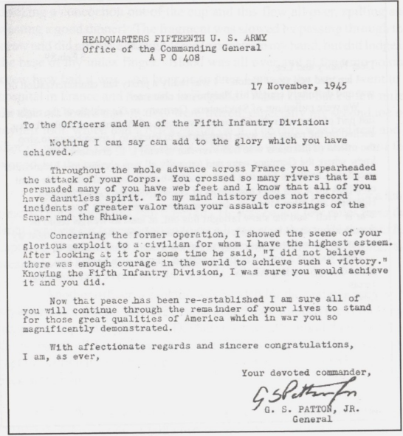
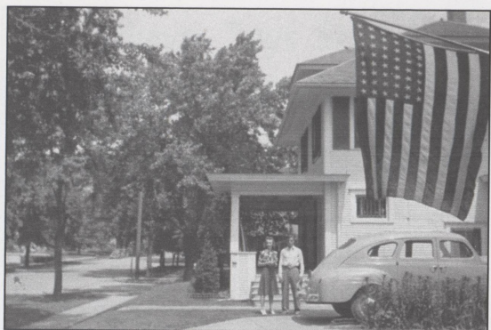
"The day my orders came that summer (July, 1943) I got in my father's 1941 Plymouth auto and backed out. However, I neglected to first open the door of the garage."
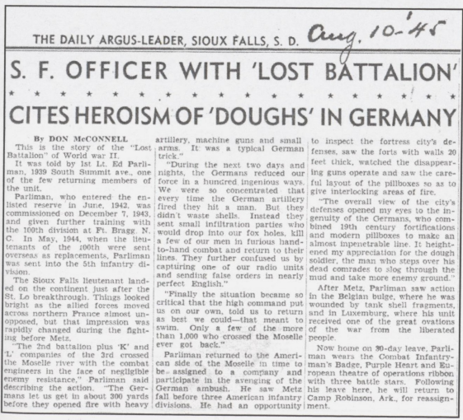
THE DAILY ARGUS-LEADER, SIOUX FALLS, S. D.
Aug. 10-45
S. F. OFFICER WITH 'LOST BATTALION
CITES HEROISM OF 'DOUGHS' IN GERMANY
By DON MECONNELL
This is the story of the "Lost Battalion of World war II,
It was told by 1st Lt. Ed Parliman, 1929 South Summit ave, one of the few returning members of the unit.
Parliman, who entered the enlisted reserve in June. 1942. was commissioned on December 7, 1943, and given further training with the 100th division at Pt. Brage N. C. In May. 1944, when the lieutenants of the 100th were sent overseas as replacements. Parilman was sent into the 5th Infantry division.
The Sioux Falls lieutenant landed on the continent just after the St. Lo breakthrough. Things looked bright as the allied forces moved across northern France almost unopposed, but that impression was rapidly changed during the fighting before Met.
The 2nd battalion plus 'K' and companies of the 3rd crossed the Moselle river with the combat engineers in the face of negligible enemy resistance, Parliman said describing the action. "The Ger-mana let us get in about 300 yards before they opened fire with heavy artillery, machine guns and small arms. It was a typical German trick”.
"During the next two days and nights, the Germans reduced our force in a hundred ingenious ways. We were no concentrated that every time the German artillery fired they hit a man. But they didn't waste shells. Instead they sent small infiltration parties who would drop into our fox holes, kill a few of our men in furious hand-to-hand combat and return to their lines They further confused us by capturing one of our radio units and sending false orders in nearly perfect English”
"Finally the situation became so critical that the high command put us on our own, told us to return as best we could that meant to swim. Only a few of the more than 1,000 who crossed the Moselle ever got back."
Parliman returned to the American side of the Moselle in time to be assigned to a company and participate in the avenging of the German ambush. He saw Metz fall before three American Infantry divisions. He had an opportunity to.
to inspect the fortress city's defenses, saw the forts with walls 20 feet thick, watched the disappearing guns operate and saw the careful layout of the pillboxes so as to give interlocking areas of fire.
"The overall view of the city's defenses opened my eyes to the ingenuity of the Germans, who combined 19th century fortifications and modern pillboxes to make an almost impenetrable line. It heightened my appreciation for the dough soldier, the man who steps over his dead comrades to slog through the mud and take more enemy ground
After Melz, Parliman saw action in the Belgian bulge, where he was wounded by tank shell fragments, and in Luxemburg, where his unit received one of the great ovations of the war from the liberated people.
Now home on 30-day leave. Parli man wears the Combat Infantryman's Badge. Purple Heart and European theatre of operations ribbon with three battle stars. Following his leave here, he will return to Camp Robinson, Ark, for reassignment.
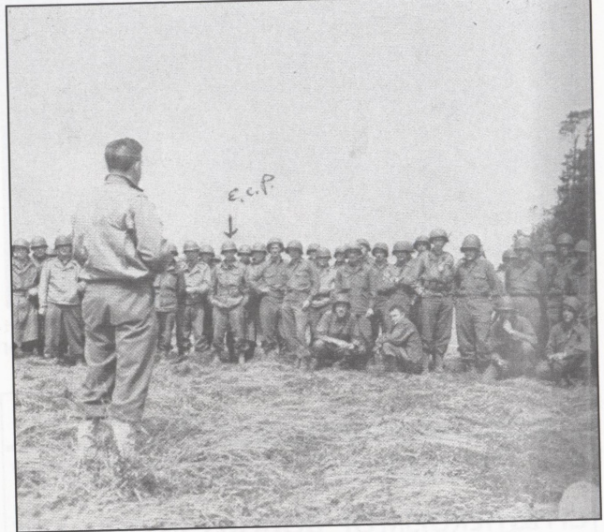
Lt. Edwin C. Parliman shortly after arriving in France.
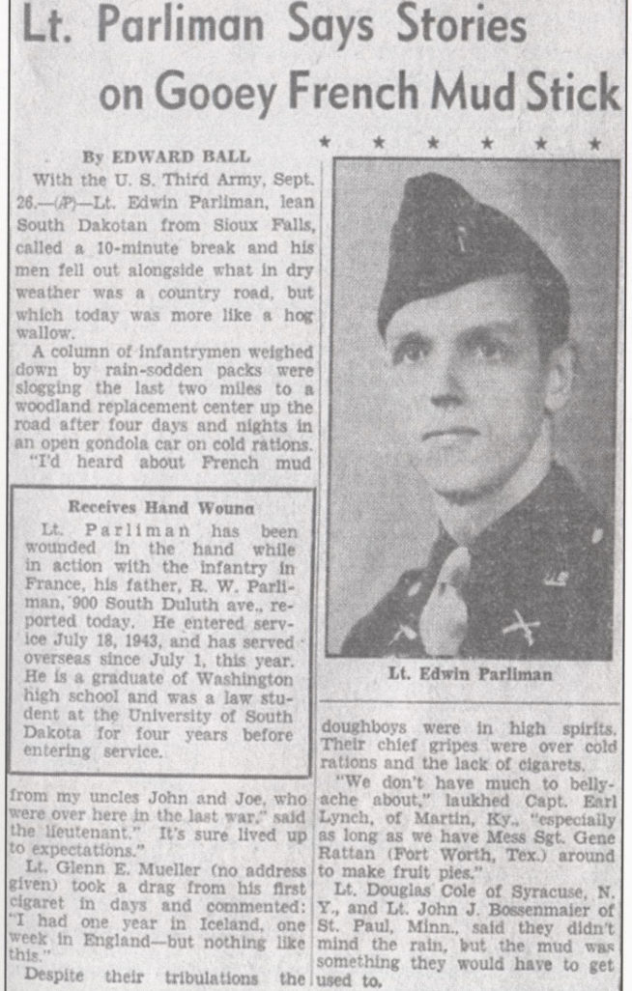
Lt. Parliman Says Stories on Gooey French Mud Stick
By EDWARD BALL
With the U. S. Third Army, Sept. 26.-(AP) Lt. Edwin Parliman, lean South Dakotan from Sioux Falls, called a 10-minute break and his men fell out alongside what in dry weather was a country road, but which today was more like a hog wallow.
A column of infantrymen weighed down by rain-sodden packs were slogging the last two miles to a woodland replacement center up the road after four days and nights in an open gondola car on cold rations. "I'd heard about French mud from my uncles John and Joe, who were over here in the last war," said the lieutenant." It's sure lived up to expectations."
Lt. Glenn E. Mueller (no address given) took a drag from his first cigaret in days and commented: I had one year in Iceland, one week in England-but nothing like this."
Despite their tribulations the doughboys were in high spirits. Their chief gripes were over cold rations and the lack of cigarets.
"We don't have much to belly ache about," laughed Capt. Earl Lynch, of Martin, Ky., "especially as long as we have Mess Sgt. Gene Rattan (Fort Worth, Tex.) around to make fruit pies."
Lt. Douglas Cole of Syracuse, N. Y., and Lt. John J. Bossenmaier of St. Paul, Minn., said they didn't mind the rain, but the mud was something they would have to get used to.
Highlighted in the article is this:
Receives Hand Wound
Lt. Parliman has been wounded in the hand while in action with the infantry in France, his father, R. W. Parliman, 900 South Duluth ave., reported today. He entered service July 18, 1943, and has served overseas since July 1, this year. He is a graduate of Washington high school and was a law student at the University of South Dakota for four years before entering service.
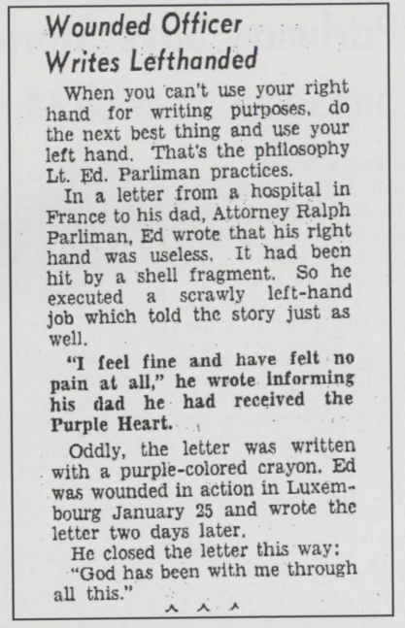
Text reads - Wounded Officer Writes Lefthanded
When you can't use your right hand for writing purposes, do the next best thing and use your left hand. That's the philosophy Lt. Ed. Parliman practices.
In a letter from a hospital in France to his dad, Attorney Ralph Parliman, Ed wrote that his right hand was useless. It had been hit by a shell fragment. So he executed scrawly left-hand job which told the story just as well. a
"I feel fine and have felt no pain at all," he wrote informing his dad he had received the Purple Heart.
Oddly, the letter was written with a purple-colored crayon. Ed was wounded in action in Luxem-bourg January 25 and wrote the letter two days later.
He closed the letter this way: "God has been with me through all this."
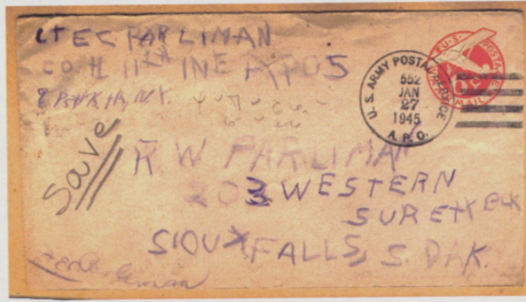
Ed sent this letter, written in purple crayon, home from a field hospital after being wounded the first time.
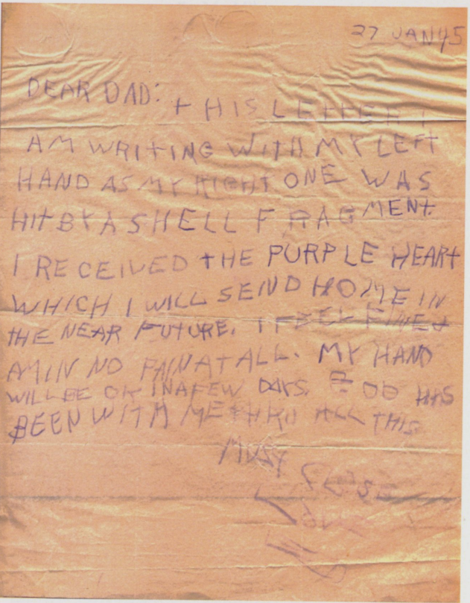
27 Jan 5
Dear Dad:
This letter I am writing with my left hand as my right one was hit by shell fragment. I received the Purple heart which I will send home in the near future. I feel fine & am in no pain at all. My hand will be ok in a few days. God has been with me thru all this.
Must Close
Love ED
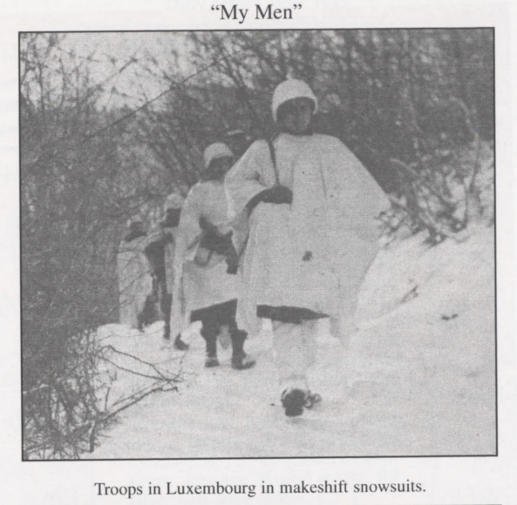
"My Men" Troops in Luxembourg in makeshift snowsuits.
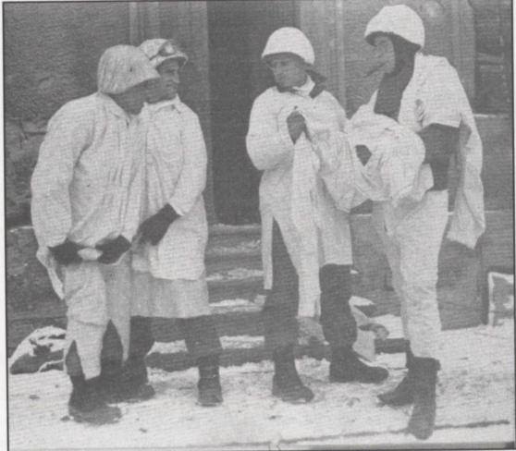
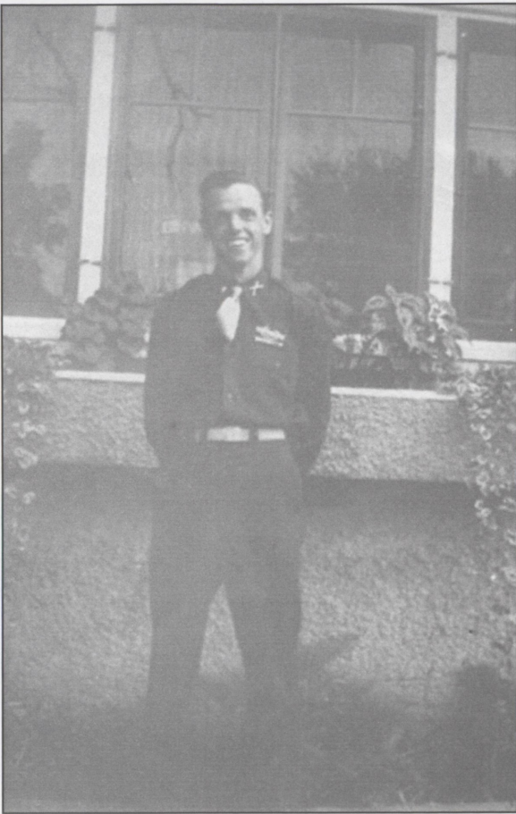
Lt. Edwin C. Parliman home on leave.
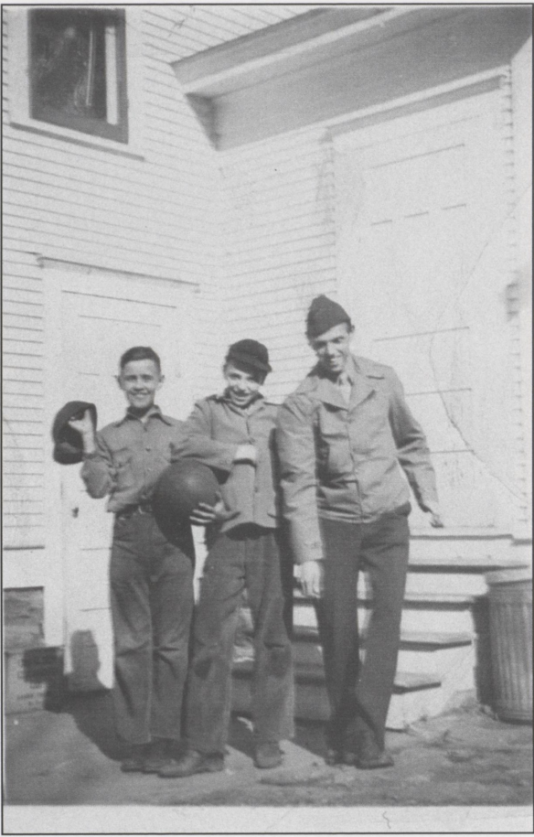
Home on leave with brother John Hubert and friend.
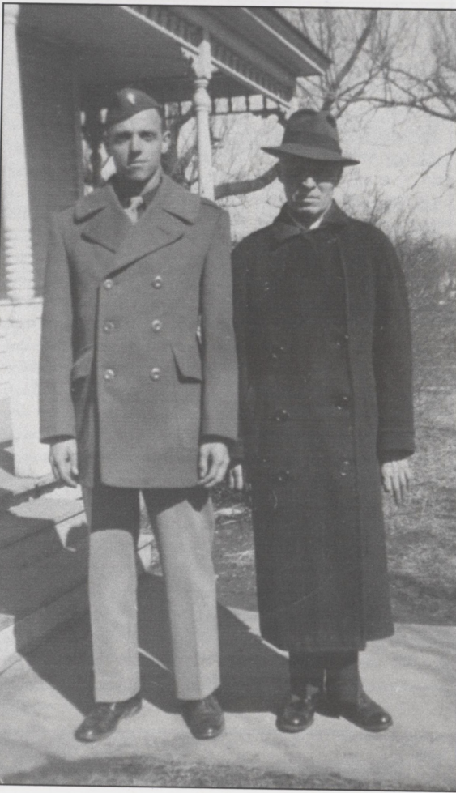
Home on leave with father Ralph.
Letter to Edwin from his father Ralph, October 4, 1944.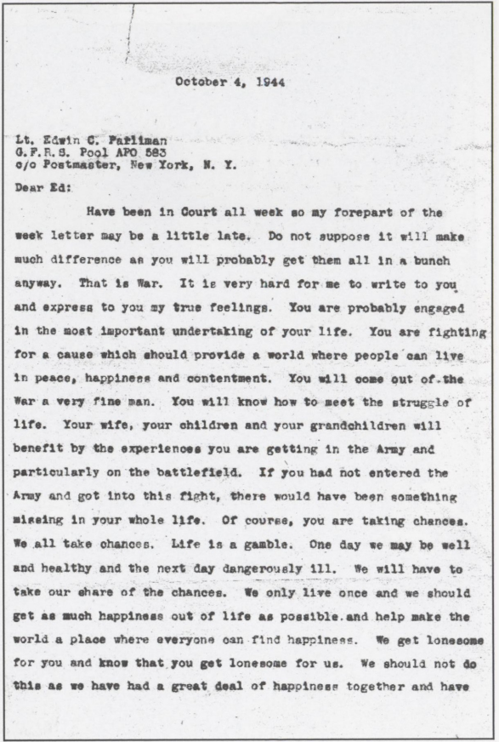
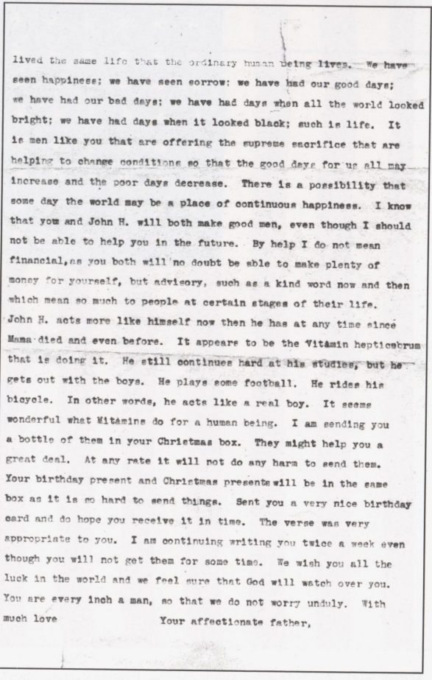
October 4, 1944
Lt. Edwin C. Parliman G. F. R. S. Pool APO 583 c/o Postmaster, New York, N. Y.
Dear Ed:
Have been in Court all week so my forepart of the week letter may be a little late. Do not suppose it will make much difference as you will probably get them all in a bunch anyway. That is War. It is very hard for me to write to you and express to you my true feelings. You are probably engaged in the most important undertaking of your life. You are fighting for a cause which should provide a world where people can live in peace, happiness and contentment. You will come out of the War a very fine man. You will know how to meet the struggle of life. Your wife, your children and your grandchildren will benefit by the experiences you are getting in the Army and particularly on the battlefield. If you had not entered the Army and got into this fight, there would have been something missing in your whole life. Of course, you are taking chances. We all take chances. Life is a gamble. One day we may be well and healthy and the next day dangerously 111. We will have to take our share of the chances. We only live once and we should get as much happiness out of life as possible. and help make the world a place where everyone can find happiness. We get lonesome for you and know that you get lonesome for us. We should not do this as we have had a great deal of happiness together and have lived the same life that the ordinary human being lives. We have seen happiness; we have seen sorrow: we have had our good days; we have had our bad days; we have had days when all the world looked bright; we have had days when it looked black; such is life. It is men like you that are offering the supreme sacrifice that are helping to change conditions so that the good days for us all may increase and the poor days decrease. There is a possibility that some day the world may be a place of continuous happiness. I know that you and John H. will both make good men, even though I should not be able to help you in the future. By help I do not mean financial, as you both will no doubt be sble to make plenty of money for yourself, but advisory, such as a kind word now and then which mean so much to people at certain stages of their life. John H. acts more like himself now then he has at any time since Mama died and even before. It appears to be the Vitamin hepticsbrum that is doing it. He still continues hard at his studies, but he gets out with the boys. He plays some football. He rides him bicycle. In other words, he acts like a real boy. It seams wonderful what Mitamine do for a human being. I am sending you a bottle of them in your Christmas box. They might help you a great deal. At any rate it will not do any harm to send them. Your birthday present and Christmas present will be in the same box as it is no hard to send things. Sent you a very nice birthday card and do hope you receive it in time. The verse was very appropriate to you. I am continuing writing you twice a week even though you will not get them for some time. We wish you all the luck in the world and we feel sure that God will watch over you. You are every inch a man, so that we do not worry unduly. With much love
Your affectionate father,
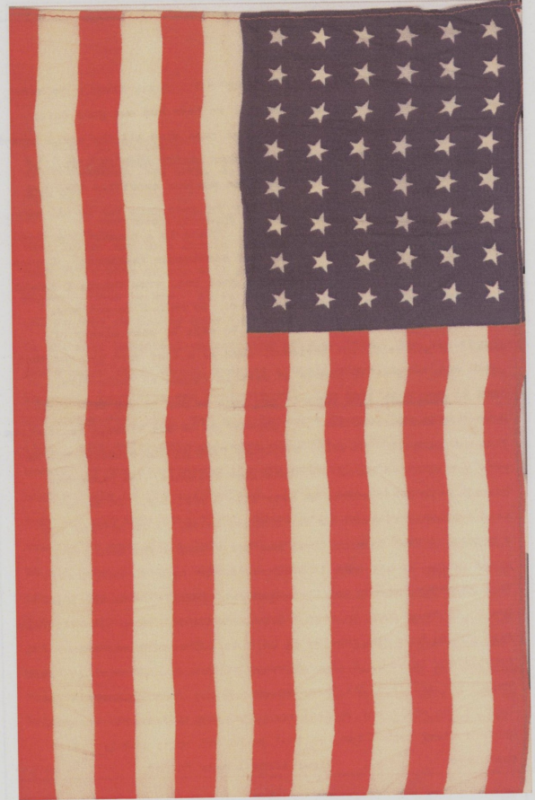
During World War II families with loved ones fighting overseas displayed an American flag. Depicted is the actual flag Ralph Parliman kept in his window until his son, Edwin, returned home safely.
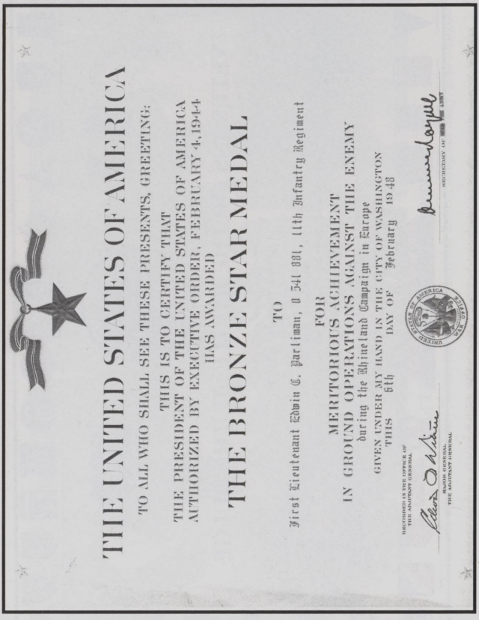
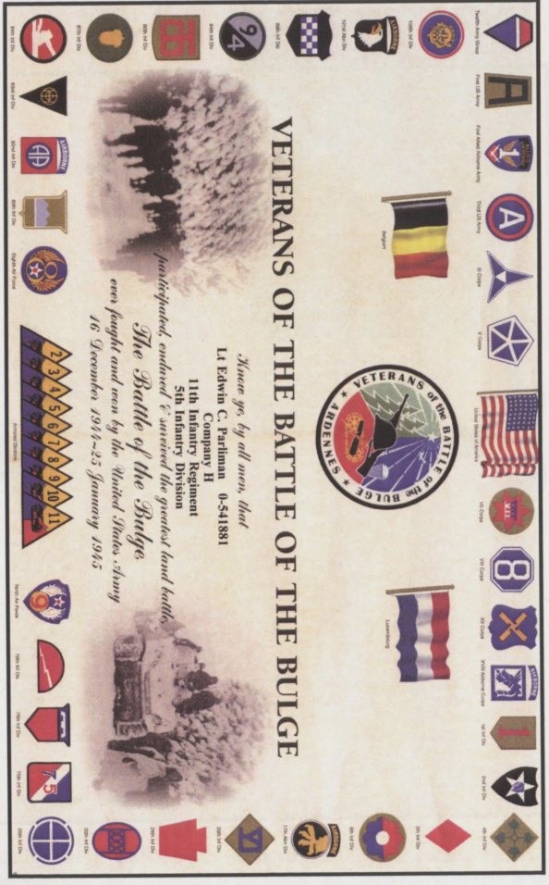

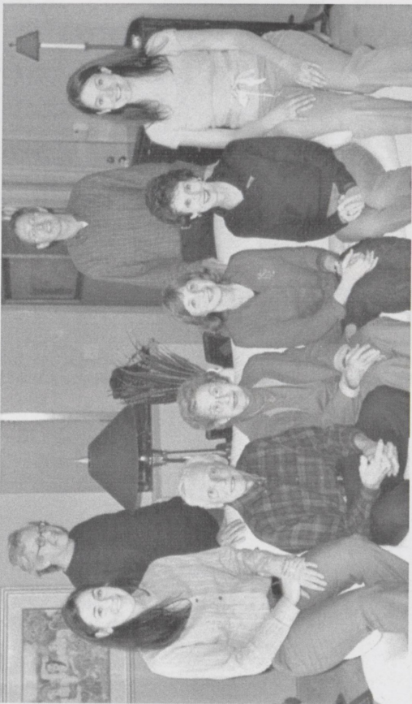
Ed and Elaine Parliman Family 2006
granddaughter Elizabeth, son Tom, Edwin, Elaine, daughter Nancy, son Robert, daughter Sally, granddaughter Sarah
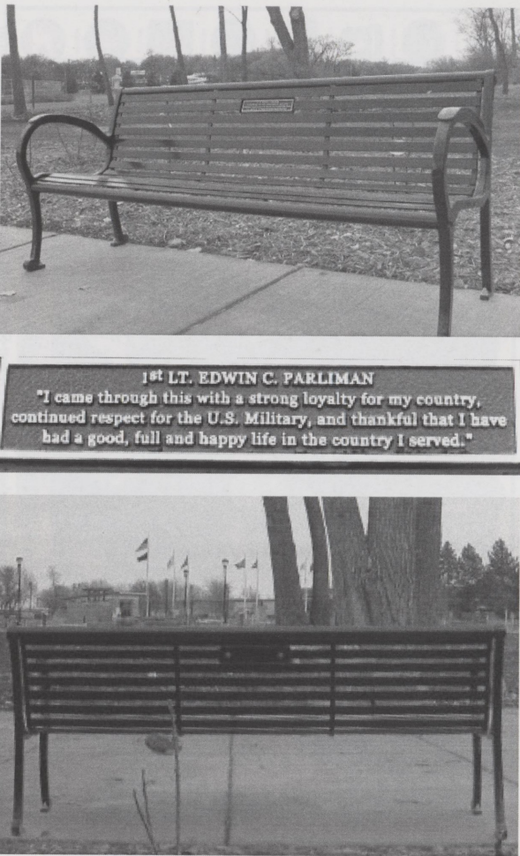
Park bench dedicated in Edwin's memory, Veteran's Memorial Park. Sioux Falls, SD Inscription reads: 1st LT. EDWIN C. PARLIMAN
"I came through this with a strong loyalty for my country, continued respect for the U.S. Military, and thankful that I have had a good, full and happy life in the country I served."
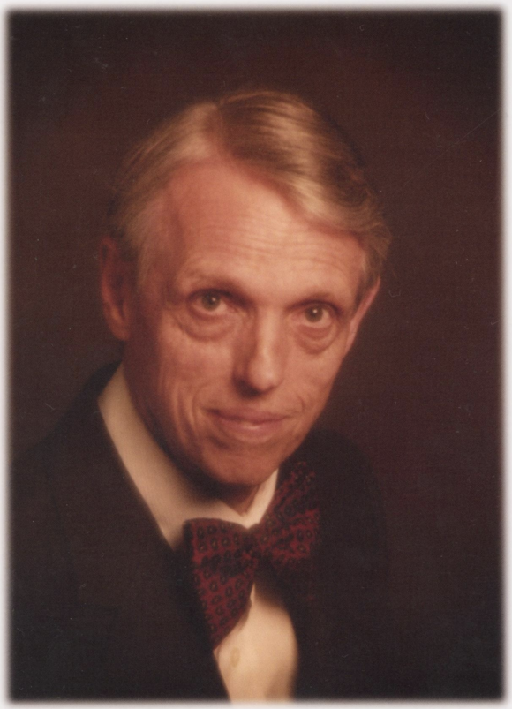
Edwin C. Parliman
1920-2006

