OBITUARY Harry T. Kelley
September 7, 1920 – October 20, 2010
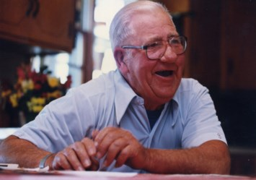

Harry T. Kelley, 90, of Basehor, KS., passed away at home surrounded by his loving family on Wednesday, October 20, 2010. Funeral services will be 1:00 p.m. Monday, October 25, 2010 at the Chapel Hill-Butler Funeral Home. Burial with Military Honors in Chapel Hill Memorial Gardens. Visitation will be 6:00-8:00 p.m. Sunday, October 24, 2010 at the funeral home. In Lieu of flowers Memorial contributions may be made to the Disabled American Veterans. Harry was born on September 7, 1920 in Kansas City, KS in the community of Rosedale to Ace Albert and Jessie K. (Johnson) Kelley. He lived in the Kansas City area all of his life. Harry served his country honorably in the U.S. Navy from 1940 to 1945. He was an ex-prisoner of war captured for three and a half years under Japan. He was a lifetime member of VFW Post #11499 in Basehor, KS. He also served as member to the American Ex-Prisoners Of War, Disabled American Veterans and MOC (Military Order Of The Cooties). Harry enjoyed fishing, and traveling during the winter months. Harry is preceded in death by his parents, son: Calvin D. Kelley, 2 sisters and 6 brothers. Survivors include the love of his life, wife of 62 years, Audrey M. (Jones) Kelley of the home, two sons: Harry T. Kelley Jr. of Joplin, MO., Carl B. Kelley and his wife Dee of Antioch, CA. Left behind to cherish his memory are his grandchildren: Shannon Greene, Justin Kelley, Rebecca Curry (Nathan), Dean Kelley, and Jessica Fouts (Travis). He is also survived by 7 great grandchildren: Adriana, Taylor, Luke, Jacob, Alexandria, Annalise, and Lily. Arrangements under the direction of Chapel Hill - Butler Funeral Home, Kansas City, KS.

