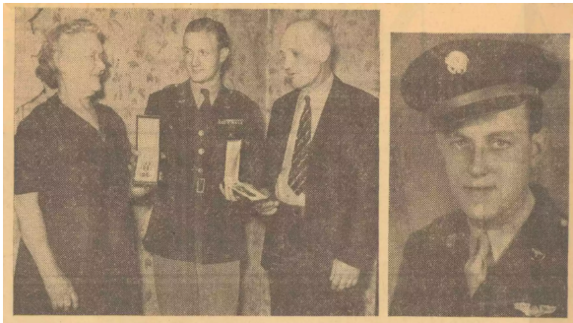
PARENTS GET MEDALS-Mr. and Mrs. William T. Vermillion, above left, of 105 Euelid-av, are seen as they received two medals awarded their son, S. Sgt. William F. Vermillion, at right, who is a prisoner of war in Germany. The medals were presented to the parents by 1st Lt. Roy B. Kirk, Jr., from Baer Field, Ft. Wayne, Ind., for the Army Air Corps.

Lima Flier Receives Two Medals For Battle Feats
"We are happy to get these but we are praying the war will end soon so our four sons and the loved ones of others can come home."
This was the comment made by Mrs. Cora E. Vermillion of 105 Euclid-av Tuesday afternoon to 1st Lt. Roy B. Kirk, Jr., of Baer Field, Ft. Wayne, Ind., after he had presented her and her hus-ward [sic], William T. Vermillion, two medals awarded their son, S. Sgt. William F. Vermillion, for his achievements with the Army Air Corps over enemy territory.
Sgt. Vermillion, who is a pris-oner of Germany, was awarded the Distinguished Flying Cross "for extraordinary achievement while serving as a radio operator-gunner on a B-26 on 25 bombardment missions over enemy occupied continental Europe," according to the citation read to the family by Lt. Kirk.
The citation regarding the air medal and three oak leaf clusters awarded in lieu of other air medals also was read by the lieutenant and informed the Vermillions these were awarded their son "for meritorious achievement while participating in 20 separate bombardment missions as radio operator-gunner on a B-26 over enemy occupied territory where the possibility of encountering enemy ships of fighter type or anti-aircraft fire involved great personal danger to all members of the crew."
Mr. and Mrs. Vermillion have two, other sons in France and a third in India, all with the Army. These three are married with William being their only single son.

