Elmer Schulz Obituary
July 15, 1922 - March 15, 2012
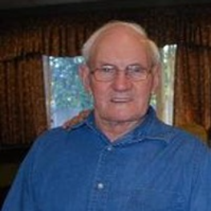
Elmer August Emil Schulz, 89, of Sioux Falls passed away on Thursday, March 15, 2012. Funeral services will be at 2:30 PM on Sunday, March 18 at Immanuel Lutheran Church south of Canova. Visitation will be on Saturday, March 17th from 7-9PM at Heritage Funeral Home in Sioux Falls.
Elmer was born on July 15, 1922 near Canova to August and Elsie (Martin) Schulz. He served his country in WWII and was a POW in a German prison camp from September 1944 through May 1945. He was awarded various metals including the Purple Heart. After the war he returned to Canova and continued farming. He loved the farm, pheasant hunting and his yellow lab best friend, Jack. Elmer was a member of Immanuel Lutheran, the American Legion, Farmers Union and regularly attended POW and DAV meetings.
He is survived by his children; Chyrell Krier of Sioux Falls, Bradley (Charlotte) their son David and Rebecca Schulz of Appleton, Wi.; brothers Ralph (Jeannie) and Ardell (Gerry) and sisters Viola Keena, Marlys (Ken) Strobel and Phyllis Lewis.
He was preceded in death by his parents, his wife, Eldine, 1 brother and 6 sisters.

Link to original obituary

