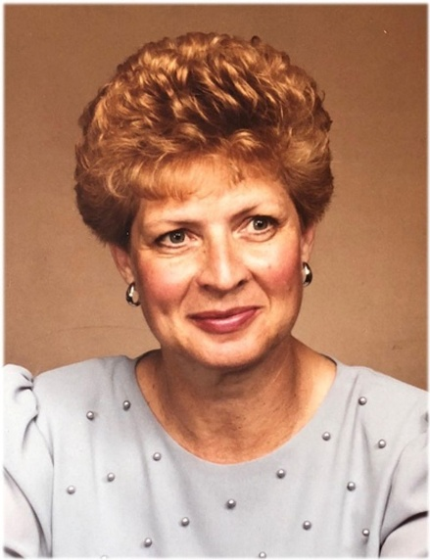
Helen Crosswait
November 19, 1930 – August 19, 2018
Helen Goodwin Moorhouse Crosswait, 87, of Spearfish, SD, passed at the Spearfish Regional Hospital on Sunday, August 19, 2018. She was a resident of the Dorsett Healthcare Facility.
Helen was born on November 19, 1930 in White River, SD, to Albert Clive Moorhouse and Florence Esta (MacDonald) Moorhouse. She spent her childhood in White River. The family moved to Martin, SD, when Helen was in the eighth grade. She graduated from Bennett County High School in 1949.
In 1953, Helen and Bruce Crosswait were married. The couple had two children, Connie and Mark. They lived in Martin, Wall, Hot Springs, Kansas City, KS, Brookings, SD, and Rapid City.
In Rapid City, she worked at the Minneluzahan Senior Center, and was certified as an LPN. After Helen and Bruce divorced, Helen went on the adventure of her life in the pursuit of a Bachelor's degree at the University of Nebraska-Lincoln in Women's Studies. There she took up writing, and published three collections of stories and poetry about the challenges of adult life, her childhood, her grandparents' journey west to homestead in White River and general observations of those characters she encountered. We wish she were here now to add more color to this write-up!
She was a South Dakota Humanities Scholar and traveled around the state sharing her writings, sometimes adding songs accompanied on her guitar. Helen also lived for a time in Chadron and enjoyed friendships and conversation with university writers and musicians.
Helen was active at the United Methodist Church in Brookings, SD, the Canyon Lake Methodist Church in Rapid City, and the United Methodist Church in Spearfish. She sang in the Spearfish Senior chorus, and in all the choirs in her churches. We will remember her for her ability to remember the words to nearly every song written between 1930 and 1960.

Her brother, Alfred Moorhouse and her parents, Albert and Florence Moorhouse, preceded Helen Crosswait in death. She is survived by her sister, Constance Slattery of Martin, SD; her son, Mark (Kari) of Rapid City, and granddaughters Hailey and Danica Crosswait; her daughter, Constance (Todd) Hubbard of Spearfish and grandchildren, Tobias (Salt Lake City) and Elizabeth (Hillsboro, Oregon).
Memorial services will be at 10:30 am on Thursday, August 30, 2018 at the United Methodist Church in Spearfish. Inurnment will take place at a later date.

