Lavern B. Mazourek Obituary
January 24, 1918 – September 26, 2011
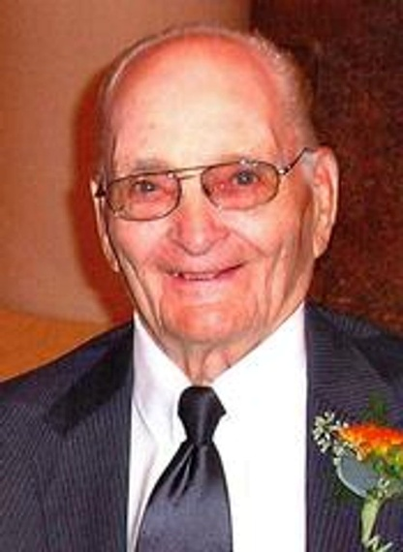
Mass of Christian Burial will be 10:30 a.m. Monday, September 26, 2011 at St. John the Baptist Catholic Church in Wagner. Burial will be in St. John Catholic Cemetery, rural Wagner, with military honors. Visitation will be Sunday from 2 to 6 at Crosby-Jaeger Funeral Home in Wagner, followed by an 8 p.m. rosary/wake at the church.
LaVern Benedict Mazourek, son of Emil and Rose (Kocmick) Mazourek, was born on a farm south of Dante, SD on January 24, 1918. He died Thursday, September 22, 2011 at the Community Memorial Hospital in Wagner. LaVern attained the age of 93 years, seven months and 30 days.
LaVern attended country school through the eighth grade and one year at Wagner High School. He worked on a dairy farm in Lakefield, MN from 1939 to 1941. LaVern returned home and then volunteered for the U.S. Army in 1941 beginning with training in Troop A 4th Calvary at Fort Meade, SD. He served in five battles during World War II: Normandy, Northern France, Rhineland, Ardennes and Central Europe. LaVern earned five battle stars and a distinguished unit badge. He served for 4 1/2 years and was honorably discharged in October of 1945.
LaVern returned to the Dante/Wagner area and worked at the Wagner Lumber Yard and the Ford garage. He married Delores McGuire on February 18, 1952 at St. John's Catholic Church. Four children were blessed to their union. They farmed southeast of Wagner for 36 years and then retired and moved into Wagner. Delores died June 13, 1997. Due to failing health, LaVern went to live with his daughter and her family in Yankton from March 2009 to August 2011, where he received tender loving care. He then became a resident of the Good Samaritan Society in Wagner.
LaVern was a member of St. John's Catholic Church, a 50 year charter member of the V.F.W. and a member of the American Legion in Wagner. He also proudly served as a committee member for the Wagner Armed Forces Memorial.
LaVern will be remembered for his love of playing cards, especially the family pinochle games, listening and watching the Big Joe Polka Show, speaking and teaching the Czech language, riding his three-wheel bike, fishing, telling his children and grandchildren about his experiences from his time serving overseas during WW II. Papa Vern enjoyed watching his grandchildren in their various activities. He will also be remembered for the many nicknames he gave to family and friends and how proud he was of his "TWINS". But most importantly his unwavering devotion and LOVE for his children, grandchildren, and great grandchildren.
Thankful for having shared his life are his sons: Ron and wife JoAnn of Wagner and Ken and wife Julie of Lennox; twin daughters: Marcia and husband Dave Withrow of Yankton and Marla and husband Dave Hewitt of Wagner; 12 grandchildren: Angela (Tony) Maibaum, Sam and Taylor Yost, Hunter Hewitt, Mitchell, Michael and Matthew Mazourek, Hannah, Landon, Alex, Cole and Kyle Withrow; two great-grandchildren: Dalton and Sawyer Maibaum; two sisters: Elaine (J.B.) Weber of Parkston and Evelyn (Eugene) Dvoracek of Rapid City; and sister-in-law, Lillian Mazourek of Yankton; and many nieces, nephews and friends.
LaVern was preceded in death by his wife, parents and brother Thomas.

Original obituary link.

