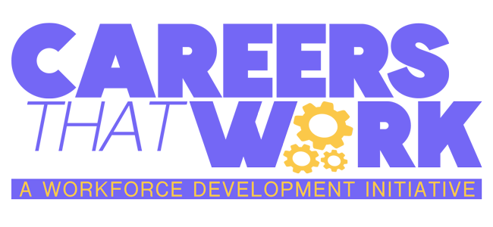


Lesson #1 - Careers That Work: Care Manager
Subject: Career Awareness & Preparation; Career Acquisition
Grade Levels: 4th Grade – 12th Grade

Standards
13.1.5.A - Describe the impact of individual interests and abilities on career choices.
13.1.5.B - Describe the impact of personal interest and abilities on career choices.
13.1.5.C - Relate the impact of change to both traditional and nontraditional careers.
13.1.5.D - Describe the range of career training programs in the community such as, but not limited to:
● Two-and four-year colleges
● Career and technical education programs at centers (formerly AVTS) and high schools
● CareerLinks
● Community/recreation centers
● Faith-based organizations
● Local industry training centers
● Military
● Registered apprenticeship
● Vocational rehabilitation centers
● Web-based training
13.1.5.F - Investigate people’s rationale for making career choices.
13.1.5.H - Connect personal interests and abilities and academic strengths to personal career options.
13.1.8.A - Relate careers to individual interests, abilities, and aptitudes.
13.1.8.B - Relate careers to personal interests, abilities and aptitudes.
13.1.8.D - Explain the relationship of career training programs to employment opportunities.
13.1.11.A - Relate careers to individual interests, abilities, and aptitudes.
13.1.11.B - Analyze career options based on personal interests, abilities, aptitudes, achievements, and goals.
13.1.11.C - Analyze how the changing roles of individuals in the workplace relate to new opportunities within career choices.
13.1.11.E - Justify the selection of a career.
13.2.8.E - Explain, in the career acquisition process, the importance of the essential workplace skills/knowledge, such as,
but not limited to:
● Commitment
● Communication
● Dependability
● Health/safety
● Laws and regulations (that is Americans With Disabilities Act, child labor laws, Fair Labor Standards Act, OSHA, Material Safety Data Sheets)
● Personal initiative
● Self-advocacy
● Scheduling/time management
● Team building
● Technical literacy
● Technology

Rationale
Provide the students with an opportunity to learn about and understand the intricacies of being a Care Manager and why it is such an important career in medicine, for the economy, and for the health of our community.

Vocabulary
- Care Manager: A professional who coordinates and oversees the care and services provided to elderly individuals.
- Assessment: The process of evaluating an elderly person's needs, abilities, and preferences to create a personalized care plan.
- Care Plan: A detailed plan outlining the types of care, services, and support an elderly person requires.
- Geriatric: Relating to elderly people and their health care.
- Home Health Care: Medical and non-medical services provided in the elderly person's home.
- Nursing Home: A facility that provides 24-hour medical care and assistance with daily activities for elderly people who cannot live independently.
- Social Work: Professional support that helps elderly individuals and their families cope with various challenges, including mental health issues, family dynamics, and accessing services.
Objectives
● Be able to explain what the Care Manager career involves.
● Be able to identify essential skills required of a Care Manager
● Be able to present on the importance of the Care Manager career and its impact on the health of our community

Lesson Essential Question(s)
● What is a Care Manager?
● What are the essential duties that are required of a Care Manager?
● How does being a Care Manager impact the health of our community?

Duration
1 class period, approximately 40 minutes

Activities
Students will view Careers that Work: Care Manager
When the video is finished, place students in small groups or pairs to complete tasks.
Task #1: Give a short description of the Care Manager career, including a definition of the job and a general list of skills required of a Care Manager. Have students take notes using Handout #1: General Information: Care Manager
Task #2: Focusing on specific vocabulary and requirements of the Care Manager career, have students complete Handout #2.
1. Grades 4-8, Handout #2: Care Manager. Upon viewing Careers That Work: Care Manager, review the vocabulary words and definitions. Have students complete the Word Search.
2. Grades 9-12, Handout #2: Care Manager Career Presentation - In small groups or pairs, students will research and present on the Care Manager career. Be informative, creative, and persuasive while also being mindful of important public speaking skills. This project will be graded using the Career Presentation Rubric (included on the handout provided). At least 5 minutes should be spent presenting on this topic using at least 1 visual aid.

Related Materials & Resources
WVIA’s Careers That Work: www.wvia.org/careersthatwork
Path to Careers: www.pathtocareers.org
Pennsylvania Careerlink: www.pacareerlink.pa.gov/jponline/

