Density Bowling

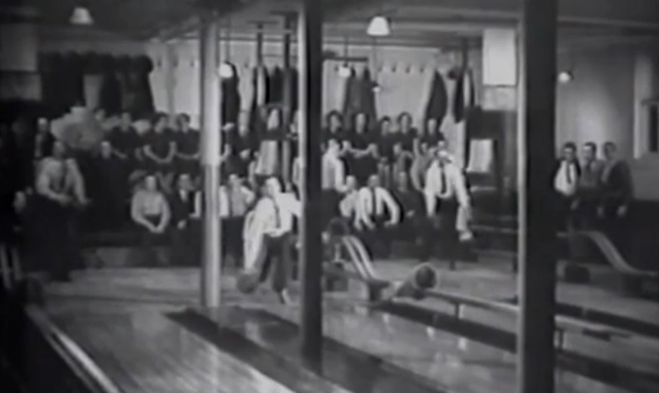
Homestake Opera House: Bowling Alley (Still from film by Historical Footprints, Inc)

Overview:
During this activity, your students will learn about the Lead Opera House and Recreation Center, which opened in 1914 as a gift from the Homestake Mining Company to the people of Lead. They will also use household items to investigate density. They will complete an activity in which they will construct a density tube and use it in a game of Density Bowling.

The Homestake Mining Company began operations in 1877, ultimately developing into one of the largest and deepest underground gold mines before its closure in the early 2000s.

The Lead Opera House and Recreation Center opened in 1914 as a gift from the Homestake Mining Company to the people of Lead and the surrounding area.

Phoebe Hearst, widow of Homestake co-founder George Hearst, and Thomas J. Grier, Homestake Superintendent, at that time, collaborated on the facility's conception and construction. Among other things, the magnificent structure housed social and card rooms, a billiard room, a bowling alley, a 1,000-seat theater, a swimming pool, a shooting range, and a library. Watch a video and learn more about the Lead Opera House and Recreation Center at the following website. (Image of the Past: Video about the Historic Homestake Opera House - Lead)

Hands-on Activity:
During this hands-on activity, your students will use household items to investigate density. They will complete an activity in which they will construct a density tube and use it in a game of Density Bowling.
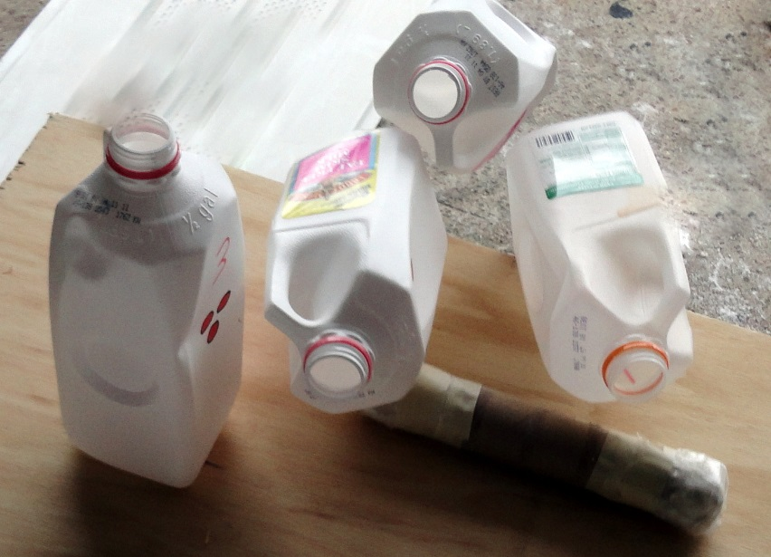

Process:

- This would be a great activity for a unit on density.

- Introduce the activity by teaching the students about the Lead Opera House and Recreation Center. Discuss why the Homestake Mining Company would build such an elaborate building that includes so many amenities, like a bowling alley.

- Try this demo if you have time. Do bowling balls sink or float? The answer is both; in general, a bowling ball that is less than 12 lbs. will float while a ball that is more than 12 lbs. will sink. However, a ball that is 12 lbs. will hover almost perfectly because it is very close to the density of water.

- Tell the students that they will be completing a hands-on experiment in which they will build a density tube out of a paper towel roll that will be used to compete in a game of Density Bowling.

- Materials:
  - Paper towel roll (11”)
  - Masking Tape (1 yard)
  - Plastic food wrap
  - Fill (food item)
  - Ramp
  - Knife or scissors (teacher)
  - Pins (milk jugs, cups, etc.)
  - Add more to customize the activity for your class.

- Homework: The students will make a density tube at home that will be used to compete in the Density Bowling game. The goal of the game is to build the densest tube using edible items from the kitchen.

- Rules for tube construction (adapt to meet the needs of your class)

  - Each student should use the materials listed above to make their tube.

  - The total length of the tube should be 9” when complete.

  - The fill selected should not spoil at room temperature.

  - The fill should be a solid at room temperature.

  - The fill selected should be edible or used as an ingredient to make an edible food.

  - The fill should not leak out of the tube.

  - Each tube will be cut open at the end of the activity to verify that the filling was edible.
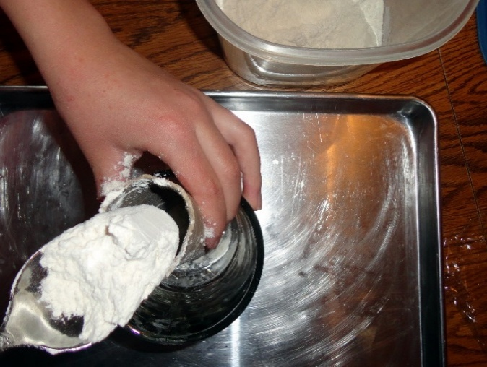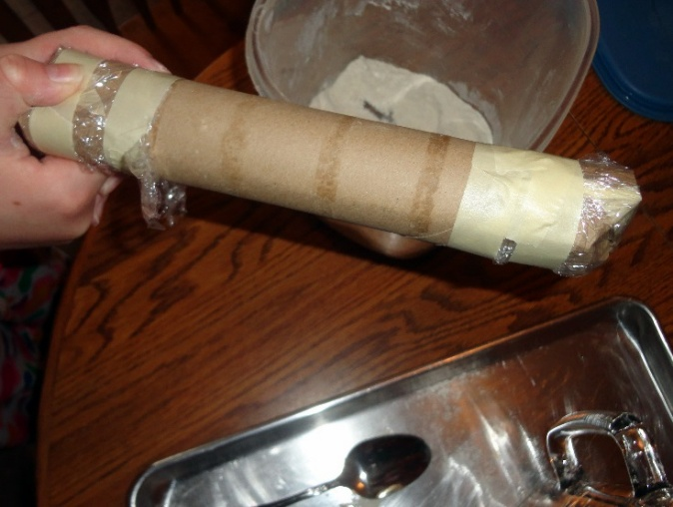

- The Game – Each student will roll their tube down the ramp. Keep track of the number of pins knocked down or moved. The students with the most tipped pins will advance. Use a process of elimination to end up with one student. Increase the distance the pins are from the end of the ramp to make the challenge more difficult. The students will soon realize that a balanced tube is also important so it will roll down the ramp straight.
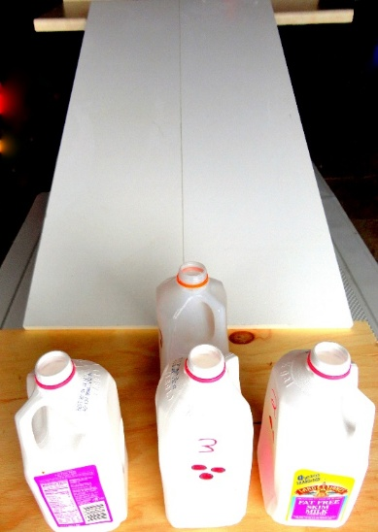

- The weight of the tubes should be taken before the tubes are cut open. The volume of the tubes should be the same if the length of each tube is 9” and the diameters are the same. A comparison of density could be made if the weight is known. Have the students guess the contents of each tube before they are cut open.

- This is a great activity because the students will remember this activity every time they are looking for something in their kitchen.



