Pouring Gold at Homestake 1938 -2002

Building a Tower

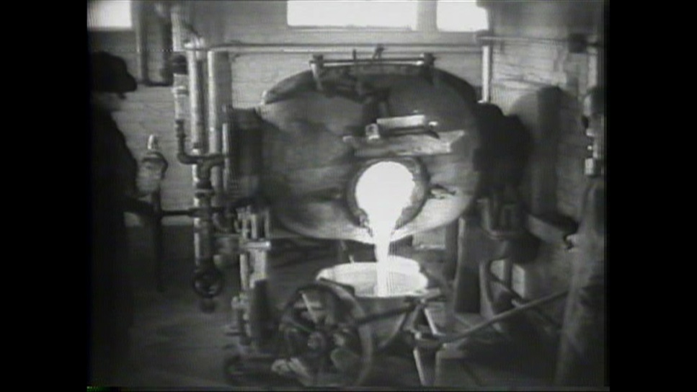
Homestake Mine – 1936 Gold Pour (Video still)
During this activity your students will learn about the process of
extracting gold ore from the earth and extracting gold from the ore. The students will see how the process changed over time, but the end result was the same, gold bullion of greater or lesser purity. They will also learn that it took a great deal of ore to produce an ounce of gold; and they will see how massive machines made the process possible. The students will look for historical clues in the video footage to help identify the age of the video. The students will then participate in a hands-on activity in which they will build a simple tower that will convey the importance of starting with a solid foundation/base when designing a machine or building.

Process:
Introduce the activities by viewing the videos, listening to an interview, and by reading the information about the Pouring of Gold at Homestake Mine - 1938 -2002.
The information on the website above explains how massive machines, tons of ore and many hardworking miners were needed to produce a bar of gold. The processes of extracting gold ore from the earth and removing gold from the ore have changed over time but the result is the same, gold bullion of greater or lesser purity.
Activity: Passing of Time - It is fascinating to have three videos (spanning almost ¾ of a century: 1938, 1954 & 2002) showing the mining process at Homestake Gold Mine. Use the three videos to complete the Passing of Time activity detailed below. During this activity the students will use their observation skills to study historical videos.
  - Introduce the activity by telling the students that they will be viewing three videos; one video is from 1938, one is from 1954, and the last video is from 2002. In combination, the videos are historical treasures because they visually show how history has changed over time.
    - Each student should have access to a computer.
    - The students should identify 8-10 historical clues from the historical content or the way the video was produced that distinguishes the age of the video. 1-3 examples from the list below could be given to help get the process started.
      - The last video includes more safety considerations like masks, goggles and gloves.
      - Clothing styles have changed (hats, facial hair, etc.)
      - Multiple voiceovers (including a female) in later version
      - Camera angles and zooming variety
      - Cinematic (early) vs. documentary like
      - Music (also type of music)
      - Style of watch worn by worker in lab
      - Early animation (similar to early cartoons)
      - Camera quality
      - Color vs. B&W
      - Age of workers (aged over years)
      - Quality of video when expanded
  - Going farther – In groups, the students should photograph a scene or shoot a video that includes 2-3 historically incorrect items, content, etc. Place the photos/videos on the screen and see if the other groups can identify the historically incorrect clues. This is a great observation activity. (Example: H₂O bottle Downton Abbey)

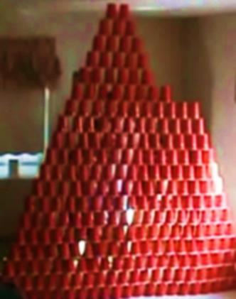

Complete the activity at your own risk - SDPB is not responsible for any accidents that could occur because of completing the activity.

Activity: Foundation is Everything - The three Homestake videos show many large machines used to process the ore. Many of the machines in the videos were moving at high speeds; without a strong foundation (base) and balanced mechanics the machines would have failed. During this activity your students will build a tower using 18 fl. oz. disposable cups; they will learn that a solid foundation and a balanced system are essential when designing a building or machine.

Materials:
      - Large multipurpose room or gym
      - 18 fl. oz. disposable cups (FYI – The initial cost of the cups is expensive, but they are very durable. The number of cups needed for the hands-on game will depend on the number of students and the required height of the towers. From my experience, local beverage distributers may provide a discount on the cost of the cups if it is for educational purposes.)
      - Dodgeballs (many)
      - Stopwatch

  - Divide the students into 4 groups (6 groups for a larger-sized class). Each group will be given the same number of cups. The students should be instructed to build a tower. The specific building requirements for the tower are decided by the instructor. In the past, I usually had the students build a cup structure that was 10-16 cups in height. The tower picked above was 20 cups in height. The height requirements of the tower will depend on the age of your group and the number of cups available.

The students should be given time to design/build and test towers for durability. They will soon discover that a solid/wide foundation and consistent spacing (like bricks) of each cup is the key to building a sturdy tower.

Then, the students should be instructed that they will be given 5 minutes to build a tower (providing the required height) that will be used in the catapult (dodgeball) competition. Each group of students should protect their tower while trying to knock down the other towers. All “local” dodgeball rules apply that have been established by your school. The game continues until one group’s tower remains or a specific amount of time has passed.

Your students will have an amazing time with this engineering activity; they will learn that it is important to have a solid foundation when designing a building and they will exercise at the same time.

