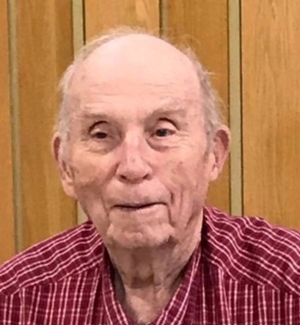
Frank Eugene Rasmussen
January 23, 1929 – September 1, 2019
Frank Eugene Rasmussen, 90, of Hot Springs, SD, passed away September 1, 2019, at his residence in Hot Springs.
Frank was born January 23, 1929, to Fred and Bethel (Wilder) Rasmussen in Oral, SD. He helped with the building of the Angostura Dam in 1947- to early 1948 on the cement crew. Frank entered the Army in November 1948. Serving three years and ten months in Germany during the Korean War. He received the Good Conduct and the German Occupation Ribbons while in Germany. After Frank's honorable discharge in 1952, he returned to the Hot Springs area. Frank started working at the V. A. Medical Center in November 1952 and worked there 32 years until his retirement in February 1984. On January 31, 1955, he married Rita Standing Soldier Bergen. He also joined the Army National Guard in 1955, serving with the Guards until he retired with 21 years as Sergeant.
Frank was a life member of all the Vets Club in Hot Springs, VFW, the American Legion, and Disabled American Vets. Rita also belongs to the VFW and the American Legion Auxiliaries.
Frank is survived by his children, Ron (Loretta) Bergen of Hot Springs; Sylvia (Raymond) Ecoffey of Hot Springs; Fay Holloway of Hot Springs; Frank G. (Deb) Rasmussen of Edgemont, SD; Floyd (Michelle) Rasmussen of Alliance, NE; Filma (David) Jones of Alliance, NE; brother, John Rasmussen; sister, Mary Flyte; 19 grandchildren and 40 great grandchildren.
Frank is preceded in death by his wife, Rita; parents, Fred and Bethel Rasmussen; daughter, Karen; two granddaughters; great granddaughter; and thirteen siblings.
Christian Funeral Vigil will be held 7:00 p.m., Monday, September 9, 2019, at St. Anthony of Padua Catholic Church in Hot Springs, SD.

Christian Funeral Mass will be held 10:00 a.m., Tuesday, September 10, 2019, at St. Anthony of Padua Catholic Church in Hot Springs, SD with committal services following at Fairview Cemetery in Oral, SD.
At the family's request, please bring your favorite picture of Frank to display at the service.

