The Fawick Fkyer: Texting How Far?

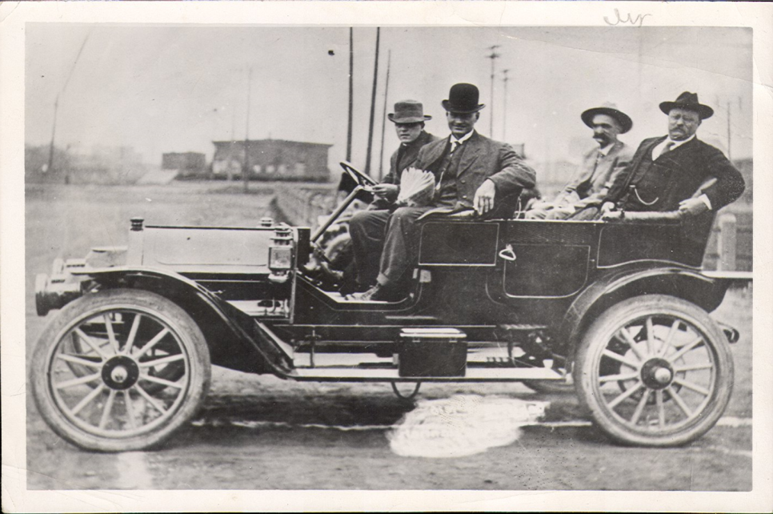
Photo: Teddy Roosevelt & Seth Bullock in a Fawick Flyer, Sioux Falls, 1910. Siouxland Heritage Museums
During this lab, your students will participate in a hands-on activity in which they will convert miles/hour to ft/sec. They will calculate the speed of an object. Then, they will calculate how far an object travels in a specific time based on a given rate. Next, they will test how long it takes to send and receive a text message. The times obtained will be used to calculate how far a car travels at different rates during a text message. They will learn about Thomas L. Fawick of Sioux Falls who built the Fawick Flyer, which was the first four-door automobile ever manufactured in the U.S.

In 1908, 19-year-old Thomas L. Fawick built an original automobile in his shop on West 13th Street in Sioux Falls. Originally named the Silent Sioux and later the Fawick Flyer, the car could seat five passengers.

Fawick built 5 of the automobiles in Sioux Falls and sold them for $3,000 each. Each of the autos was slightly different. One variant included doors for both the front and rear compartments, making it the first four-door automobile ever manufactured in the U.S. The coach was made of aluminum instead of steel. The four-cylinder, 40-horsepower engine propelled the car at up to 60 miles per hour. The speed limit in Sioux Falls at the time was 7 mph, 4 mph around corners. (Fawick car blog)
Process:
- Gather the materials below (per group):
  - Paper/pencil
  - Calculator
  - Tape measure or football field
  - 1-2 cell phone(s)
  - Stopwatch
  - Student Handout (download)

- Introduce the activity by having the students convert the speeds given above for the Fawick Flyer from miles/hr. to ft/sec. Also, convert 80 miles/hr. (SD Interstate speed) to ft/sec. The conversion and answers are provided below. (Younger students will need help with this step.)

Original Speed (miles/hr.) |  | Conversion | Converted Speed
4 miles/hour | X | 5280 ft/mile x 1 hr/60min x 1 min/60sec | 6 ft/sec
7 miles/hour | X | 5280 ft/mile x 1 hr/60min x 1 min/60sec | 10 ft/sec
60 miles/hour | X | 5280 ft/mile x 1 hr/60min x 1 min/60sec | 88 ft/sec
80 miles/hour | X | 5280 ft/mile x 1 hr/60min x 1 min/60sec | 117 ft/sec
Round to the nearest whole number
- Take the students outside to a large open area. A football field would work well because it has yard markings. (Note: Multiple tape measures are needed if a football field is not available.)
- In groups of 2-4, have the students calculate how far each vehicle above would travel if the vehicles traveled for 1 second & 2 seconds.

Final | Time (1 sec) | Time (2 sec)
6 ft/sec | 6 ft | 12 ft
10 ft/sec | 10 ft | 20 ft
88 ft/sec | 88 ft | 176 ft
117 ft/sec | 117 ft | 234 ft

- Using a tape measure or the yard markings on the field, have the students measure how far each vehicle would travel for both 1 second and 2 seconds.

- Using their cell phones, the students should send a typical length text message to a friend. Time how long it takes to complete the message. Next have the students read a text message. Time how long it takes to read the text message.

- Have the students calculate how far each vehicle above would travel during the time it takes to send and read an average-length text message.

- Have the students measure (on the field) how far each vehicle would travel during the time it takes to send and read an average-length text message.

- Discuss the dangers of texting while driving. Reinforce the fact that a moving vehicle can travel a great distance in a few seconds.

Additional Resources and Going Further:
- Dstrctd Drvng (Distracted Driving): The Dangers of Cell Phones and Driving
Watch Distracted Driving Online / Grade: MS-HS
An informative look at distractions and driving. For many of us, the dangers of distracted driving are just becoming known. That's in part because of people like Rob Reynolds. Reynolds' daughter Cady was killed in a crash when another car collided with hers in Omaha. The other driver was distracted. Reynolds took the tragedy of his sixteen-year-old daughter's death and started telling people about the danger distractions in a car can present. Things like cell phones, passengers, grooming, and eating. (SDPB Radio - Texting and Driving)

- Have the students design an experiment in which they calculate how fast they walk/run.

- Test additional speeds posted on city and county roads.


Contact EdServices@sdpb.org for more information about SDPB’s educational resources.


