Habitats and Discoveries
During this activity, your students will participate in a hands-on observation challenge that will encourage them to look closer at the habitats around them.
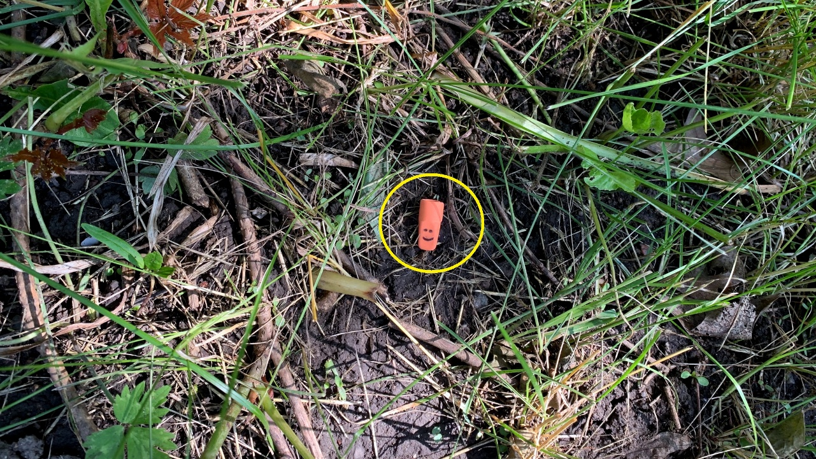

Lesson summary
They will also learn about Horatio Ross, the man who is credited with discovering gold in the Black Hills. He found gold in 1874 on French Creek near Custer, SD.

Time allotment
50 Minutes

Introductory activity
- Introduce the observation challenge by presenting information about Horatio Ross, the man credited with discovering gold in the Black Hills.
  - Horatio Ross & Custer's Black Hills Gold Find
  - Discovery of Gold in the Black Hills
  - Panning for Gold
- Discuss the importance of keen observation skills in the discovery of gold.
- A prospector looking for gold uses observation skills to find something normally not there. A miner might fill many pans before finding the rare metal. They are looking for something normally not found in the pan's small habitat. The pan has organic and inorganic content that we expect to see, but not gold.
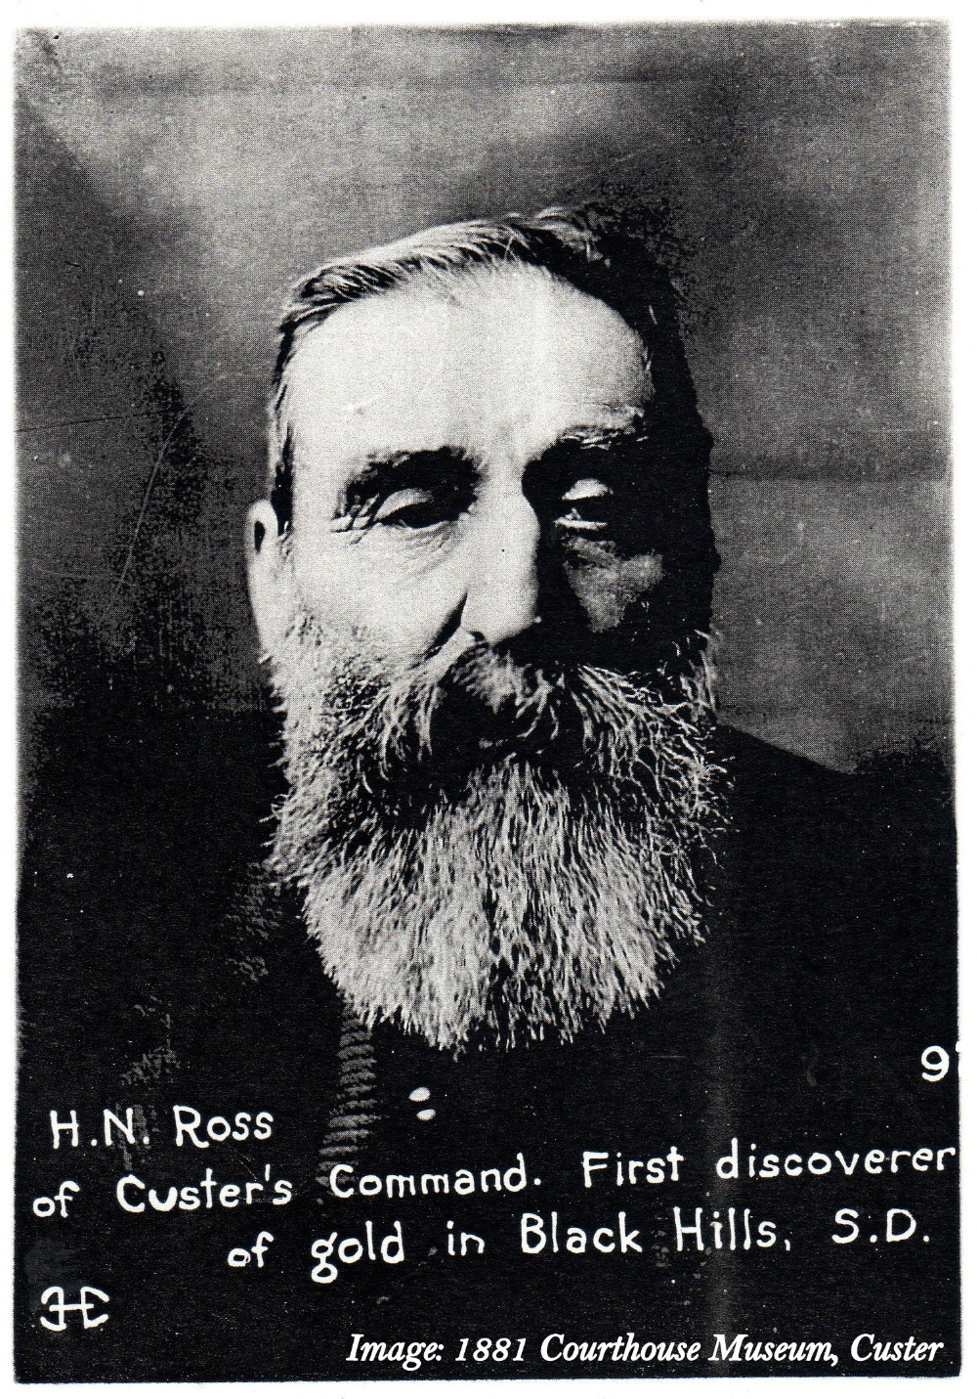
- We can learn about habitats similarly by recognizing what should and should not be there. For example, a technician can look at a blood smear and identify an abnormal finding, like a parasite or cancer cells, by knowing what should and should not be there. A biologist can identify an invasive species in the same way.

Culminating activity
The following I-spy activity has the students looking for an item that does not belong in the habitat where it is placed. When completing the activity, the students should discuss things they notice, like insects, plants, animals, sounds, smells, etc., while looking for the missing item. The discussion should take place each time they return for a new clue.
The teacher will hide an item before class, and the students will use their observation skills to find it.
- Select an item.
  - Eraser
  - Button
  - Coin
  - Etc.
- Photograph the item.
- Select a location to place the item. Ideally, this activity would be completed outside but it can be completed inside during adverse weather. Typically, a playground and surrounding area would work nicely. The site should be large and have different types of ground cover (tall grass, short grass, sand, wood chips, mud, dirt, cement, water, trees, etc.) representing multiple habitats. Place the item; it can be placed on a tree, a bench, in the grass, etc. Take 4-6 photos of the item at different distances. Example photos are given in the example below.

- Record details of the immediate area surrounding the item.
  - Smells
  - Humidity
  - Color
  - Any plants, animals, or insects
  - How the area surrounding the item feels to the touch
  - Differences in the temperature of the air surrounding the item and the temperature of the area it is placed
  - Ground cover
  - Etc.
- Groups can be assigned, or the students can work independently. Start the activity by showing the students a (closeup) picture of the item in its "habitat" or providing a clue from above. The students should be given 3-5 minutes to see if they can find the item. Have the students return to the starting point. Check if anyone has located the item. If not, show the next photo. Continue to show the pictures and give clues until the item is located. The goal of the activity is to find the item first.
- Clues about the location should be given at the teacher's discretion.
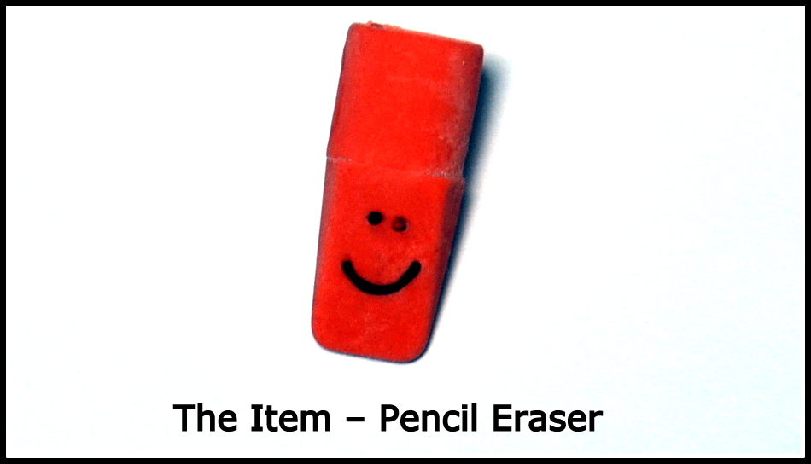
Below is an example of a challenge completed inside due to adverse weather conditions. A pencil eraser was placed in a three-story building with over 100 rooms. The rooms in the building had multiple styles of furniture, textures, floor coverings, different types of lighting, temperature differences, etc.
Below are some photos and descriptive clues used during the activity.
  - Room feels cool
  - Texture – rough/fuzzy
  - Dark grey
  - Dirty
  - A faint smell of food
  - Natural light
  - High pedestrian traffic
  - Manufactured structure
  - Noisy
  - Etc.
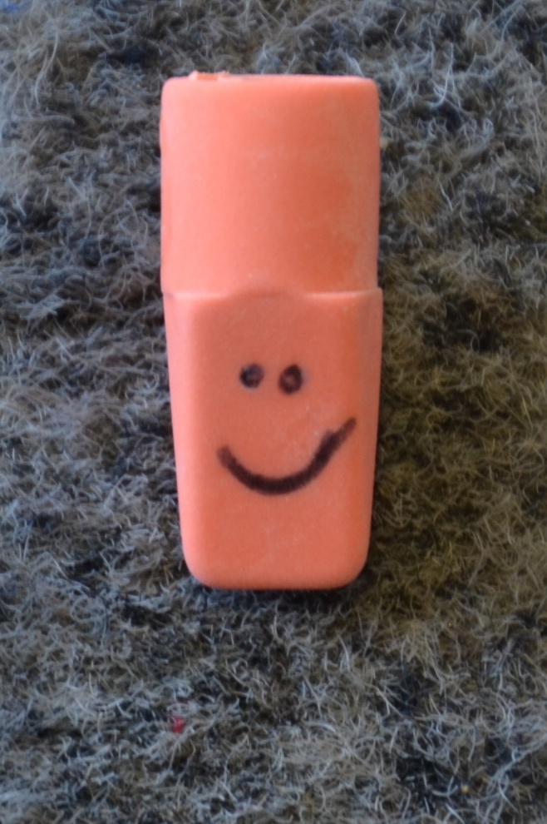
Closeup photo of the eraser lying on a fuzzy grey carpet.
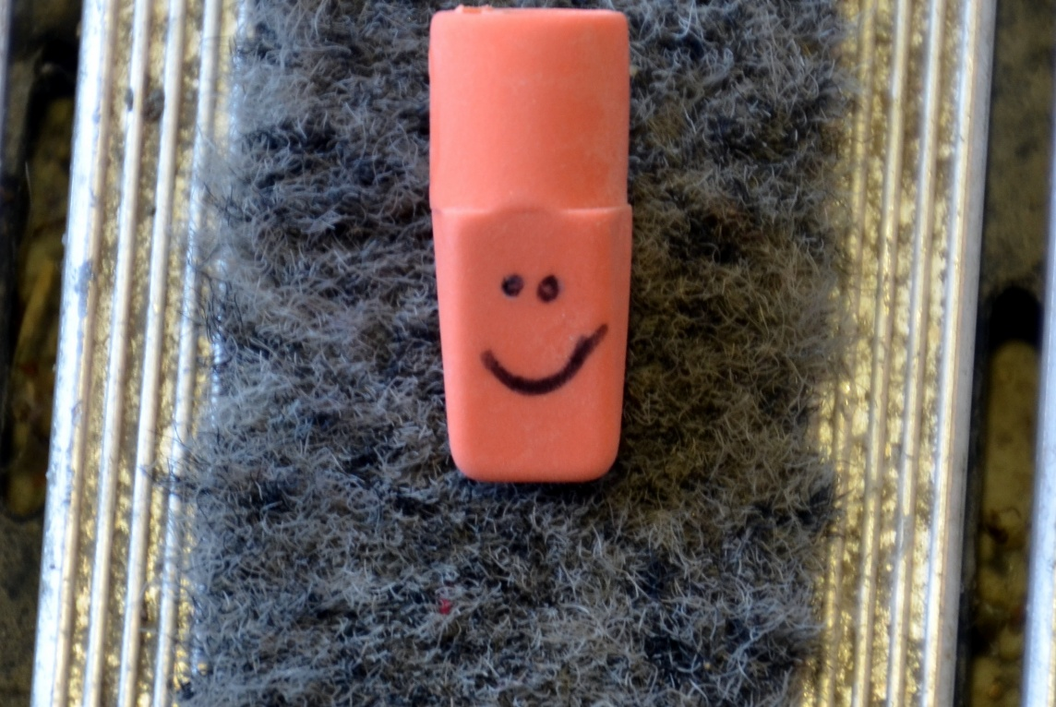
A closeup photo of the eraser shows more ground cover, lying on a fuzzy grey carpet. Striped shiny silver metal is on the left and right sides of the grey carpet.
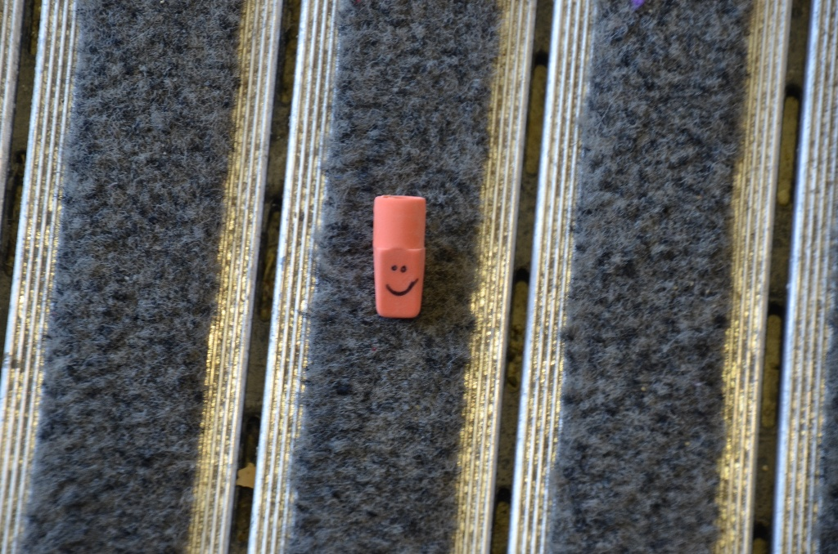
A closeup photo of the eraser continues to show more ground cover, lying on a fuzzy grey carpet. Striped shiny silver metal is on the left and right sides of the grey carpet. Two additional strips of grey carpet are shown with metal strips between each.
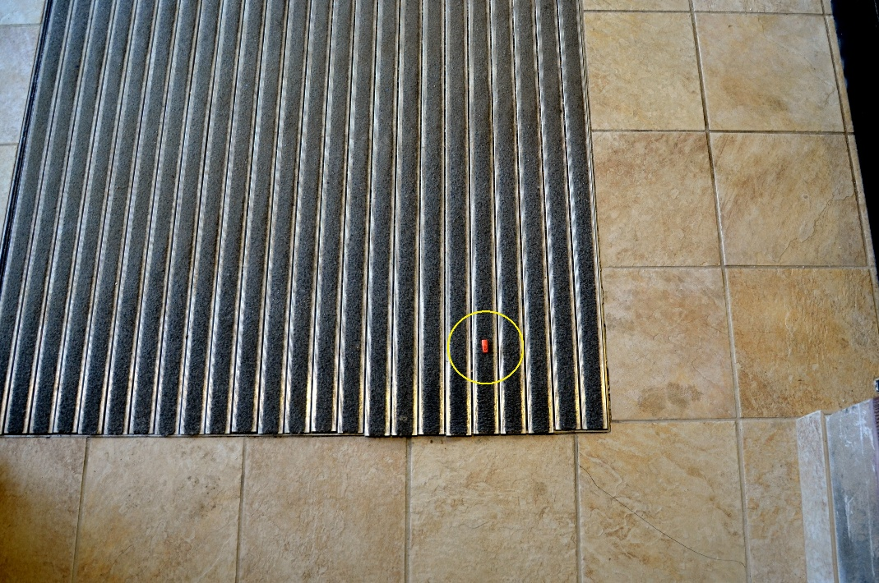
Progressing to a wider view, the photo of the eraser now shows that it was lying on an entry carpet. The carpet is made of alternating strips of grey carpet and shiny metal. Tannish-colored tiles surround the carpet. A yellow circle indicates the location of the eraser.
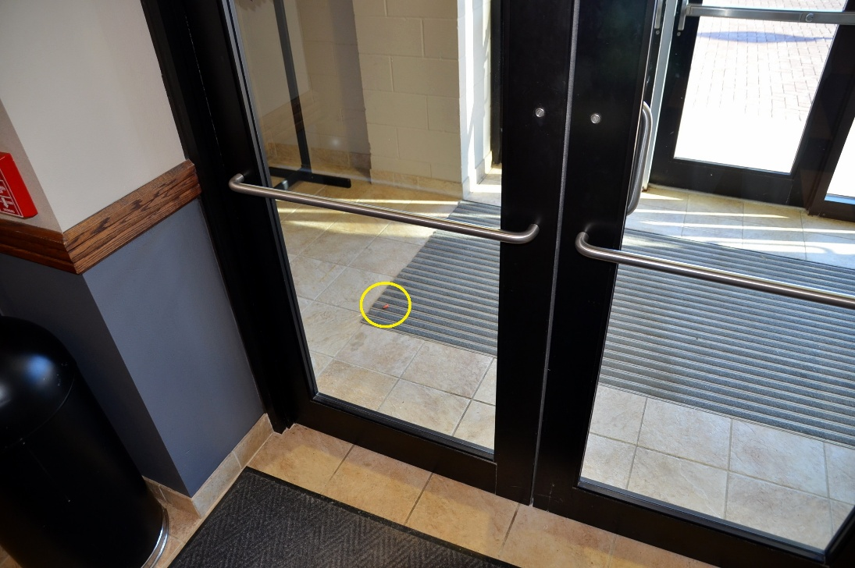
The carpet and tile are shown through glass entry doors. A yellow circle indicates the location of the eraser. Progressing to a wider view could be necessary, especially for younger students.
This is an educational and entertaining way to study habitats your students will enjoy.



