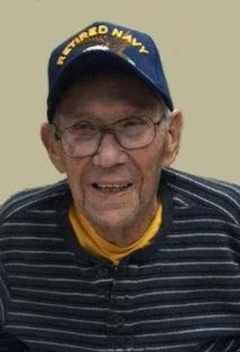
Donald Roger 'Don' Tillotson
April 8, 1926 – December 7, 2017
Donald Roger 'Don' Tillotson, 91, of Hot Springs, SD, passed away December 7, 2017, at the VA Medical Center at Ft. Meade, SD.
Don was born April 8, 1926, in Hot Springs, to Bartley James and Juanita Katherine (Ranger) Tillotson. He was very proud of his Navy career. Don quit school and enlisted at age 17. Don proudly served in the US Navy from 1943 until his honorable discharge in 1962. After his discharge he returned to Hot Springs and worked at the VA Medical Center until his retirement. He finally got his High School Diploma in his 60's.
Don had so many hobbies there were never enough hours in the day for hunting, fishing, gardening, wood working, cribbage and poker. He also loved cheering for his Phillies.
Don is survived by his son, Donald (Lee) Tillotson of New Port News, VA; daughter, Nita (Rod) McClure of Rapid City, SD; three grandchildren, Eric (Simret) Tillotson New Port News; Cara (Javier Ramos) McClure of Rapid City, Jacob (Jennifer) McClure of Rapid City; one great grandchild, Lincoln McClure of Rapid City; sister, Emma Rene Malloy of Rapid City as well as numerous nieces and nephews.
He was preceded in death by his wife of 71 years, Irish Tillotson; parents, three brothers and one sister.

