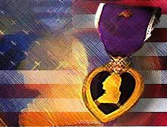

The Purple Heart
by Harry E. Nollsch

It was a bright, sunny day in October. It was cool in the early hours, and I was wearing an Air Force leather jacket which I had scrounged up somewhere. We had most of our observation planes in the air by this time on early missions. We flew missions, helping the field artillery to get the huge 155mm cannon zeroed in on targets behind the German lines. A G.I. barber was with our outfit that morning; he was giving haircuts to anyone who needed one. The barber was working on his first customer (or victim!). I was next in line.

The Germans began shelling our area about that time also. The barber, his first customer, and myself were in a large pyramidal tent. The shells came closer and closer. Suddenly one landed just outside the tent. Pieces of shrapnel half as large as a hen's egg were shrieking by.

We had "hit the dirt" by the time the second round came in. The man getting his haircut was struck in the temple with one shell fragment. The blood ran down his face. A small piece struck me just above my left elbow.

