Edmunds County In World War II

Published by Veterans of Foreign Wars Post 4807 Ipswich, South Dakota
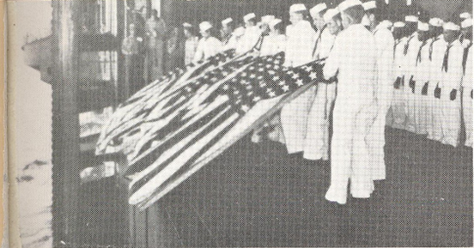
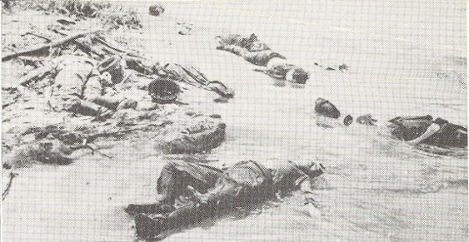
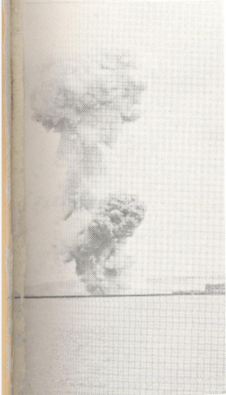
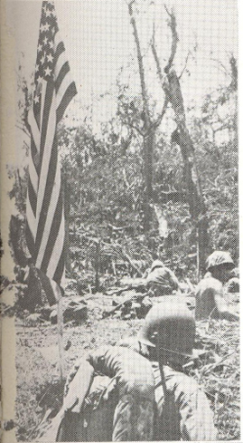
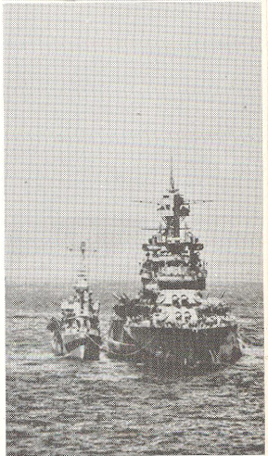
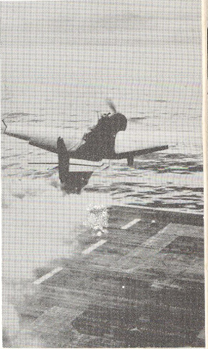
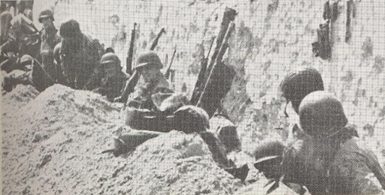
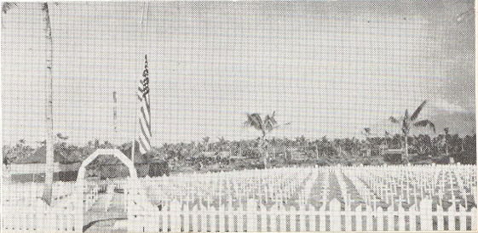

DEDICATION: to those who gave their lives that we may look out across our land still fearless and free.
At the U. S. Military Cemetery in Hamm, Luxembourg; Private Howard O. Samp of Ipswich kneels at the graveside of his brother, Private Roy E. Samp, who was killed in action in Saarlautern, Germany -- 14 December 1944.
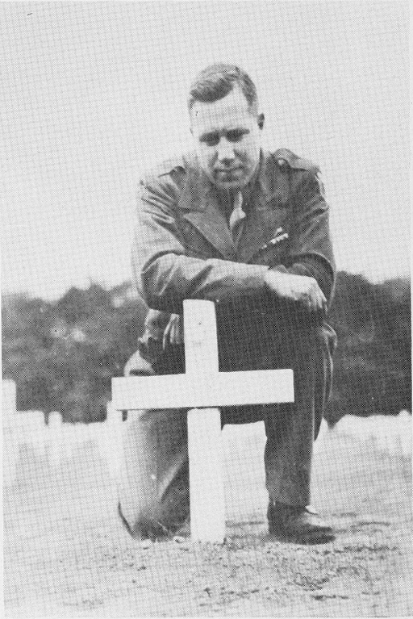

Flight Officer Ernest J. Noehre, left [below], son of Mr. and Mrs. Otto Noehre of Roscoe, enlisted in the Army on 7 July 1938. Following training at Bismarck, North Dakota, and Ft. Ord, California, he joined the Parachute Troops in 1940. In 1942, he transferred to pilot training; and on 12 August 1943, he graduated as a Glider Pilot with the rank of Flight Officer. On 28 February 1944, he shipped overseas. While engaged in flight operations over Germany on 24 March 1945, he was wounded, and six days later succumbed to his injuries.
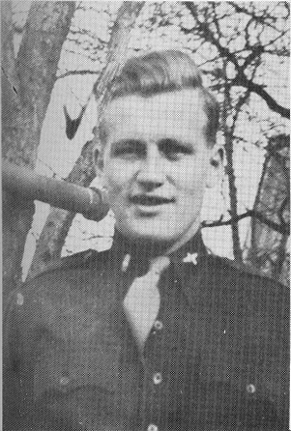
The first Edmunds County boy to be lost in the war was Edward L. O'Leary, right [below], son of Mrs. Hazel O'Leary Meier, formerly of Roscoe. Eddie enlisted at Aberdeen in June, 1939; and following recruit training at the Great Lakes, he was assigned to duty aboard the USS Indianapolis. While on sea duty in the Pacific, he was transferred to the Flagship of the Asiatic Fleet, the USS Houston. On 4 February 1942, the Houston with a small task force engaged an enemy fleet off the coast of Java. Coxswain's Mate O'Leary was killed in action at his anti-aircraft gun station.
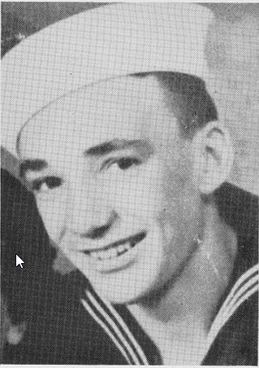
Bruce E. Ruby, left [below], son of Mr. and Mrs. Lloyd Ruby of Spearfish, entered service from Ipswich. Reporting for duty at Ft. Snelling on 26 April 1944, he received Infantry training at home camps; and on 9 October 1944, he shipped overseas to England. Upon his arrival, he was immediately assigned to combat duty in France; and on 9 November 1944, he was killed in action along the Franco-German border. His body was interred at the U. S. Military Cemetery, Epinal, France.
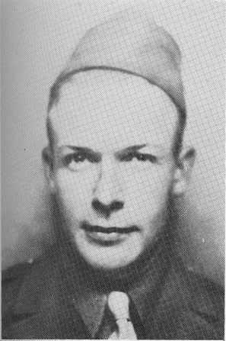
S/Sgt. Joseph W. Mastel, right [below], son of Mr. and Mrs. Bill Mastel of Ipswich, entered service on 15 July 1941. Entraining for Ft. Bragg, North Carolina, he later trained at Camp Livingston, Louisiana, and Camp Gruber, Oklahoma. In November 1944, he was sent overseas landing at Marseilles, France, on12 December 1944. On 9 January 1945, he was wounded in action near Hatten, France, while engaged in Infantry combat following a German break through. He died on January 13th as a result of his wounds, and his body was interred at Epinal, France.
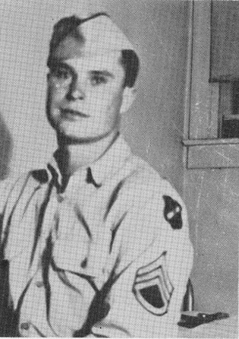
Lt. Leonard L. Hellstrom, left [below], son of Mrs. Anna Hellstrom, formerly of Mina, enlisted at Aberdeen on 7 January 1942. Qualifying for training in the Army Air Corps, he received flight training at a number of air fields; and he was commissioned a 2nd Lieutenant as a bomber pilot at Turner Field, Georgia, August, 1943. Shipping overseas from a Louisiana port, he arrived in England; and as his first combat mission, he engaged in the air assault of Normandy on D-Day. On 10 August 1944, his plane was destroyed by anti-aircraft fire near St. Margite, France; and he was buried at St. Andre-de Eure Cemetery in France.
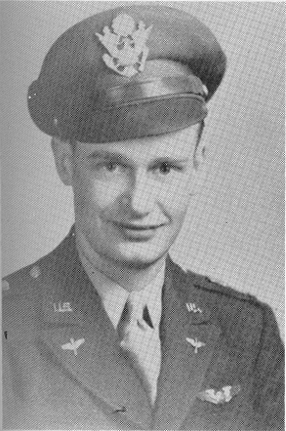
Pfc. Andrew Leboldus, right [below], son of Mrs. Constantine Fiehnnann who formerly lived near Roscoe, entered service at Ft. Snelling on 24 February 1942. Having received training for duty in the Infantry, he was sent overseas in June, 1942, directed to the Pacific Theater of Operations. Following active combat duty on Guadalcanal and New Georgia, he was killed in action on 19 September 1943 in the Battle of Vella Lavena.
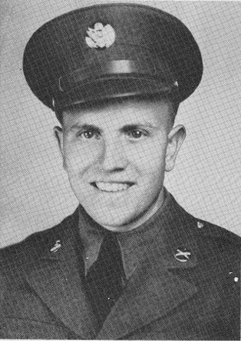
Lt. Leonard H. Woodworth, left [below], son of Mr. and Mrs. H. L. Woodworth of Ipswich, entered service at San Diego on 20 December 1941. "Bud" reported to Parks Air College in St. Louis for Elementary Flight Training; was transferred to Randolph Field, Texas, for Basic Training, and completed flight training at Ellington Field, Texas, where he was commissioned a 2nd Lieutenant as a pilot of attack bombers. Thereafter, he was sent to Anderson Field, South Carolina; and during the course of flight duty, was killed in a plane crash at Eglin Field, Florida, on 29 September 1942.
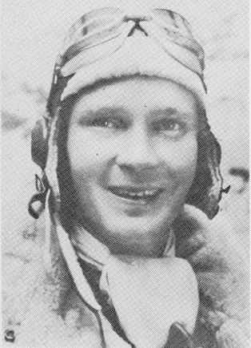
Pvt. Edwin J. Dumdei, right [below], son of Mr. and Mrs. John Dumbei of Bowdle, entered service in Florida on 1 December 1943. Following training in the Infantry at Camp Blanding, Florida, he shipped overseas on 9 June 1944. Serving as a Squad Leader with Company L, 357th Infantry Regiment, he was killed in action in Alsace-Lorraine on 11 September 1944.
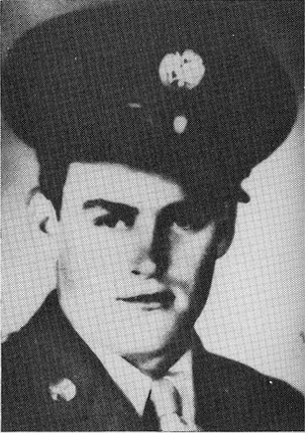
T/5 Adam A. Malsam, left [below], son of Anton G. Malsam of Hosmer, reported for duty at Ft. Snelling on the 6th of March, 1942. Adam received most of his home based training at Camp Cooke, California; and was sent overseas to England in January, 1944. On the 17th of December 1944, he was killed in action in Luxemburg.
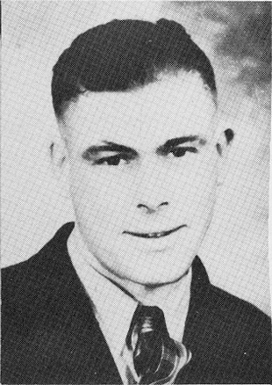
T/5 Plynn K. Duvall, right [below], son of Mr. and Mrs. J. G. Duvall of Ipswich, entered service at Portland, Oregon on 7 September 1942. Following training at Camp Lewis, Washington, and Camp Vap Doren, Mississippi, he went overseas on January, 1945, attached to Company A, 263rd Engineer Combat Battalion. On February 28, 1945, while engaged in laying anti-tank mines in an area between the Saar and Siegfried Line, Flynn's entire unit was destroyed by a direct hit of an artillery shell. He is buried at the Military Cemetery, Epinal, France.
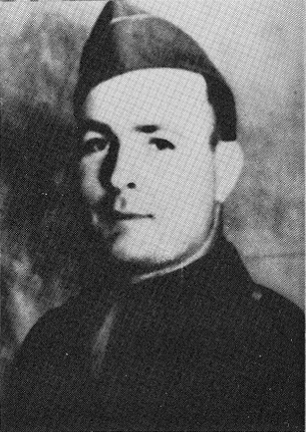
Private John A. Malsam, left [below], of Mina, reported for duty at Ft. Leavenworth on 14 April 1942. Following a period of training at Camp Roberts and Camp John Knight in California, he was directed to overseas duty in the Pacific in December, 1942. John engaged in active combat duty with the Infantry in New Guinea; and on 18 December 1944, he was killed in Infantry action near Colasian, Leyte, Philippine Islands.
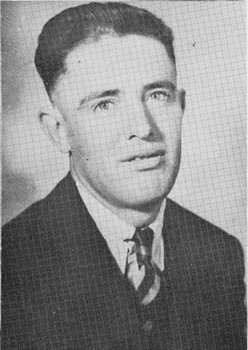
Harold E. Schauer, right [below], son of Mr. and Mrs. Andrew Schauer of Roscoe, entered the Navy on 16 September 1940. Serving aboard the USS Chicago as a Machinist's Mate, Harold departed the States for sea duty in the Pacific during March, 1941. On 30 January 1943, Harold lost his life when the USS Chicago was torpedoed and sunk while engaged in the Battle of the Solomon Seas.
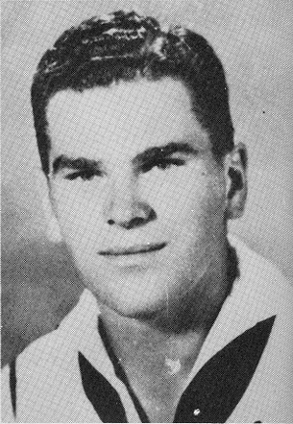
Randolph Pickett, son of Mr. John Pickett of Ipswich, received training at Ft. Bliss, Texas. Killed in action in the Pacific on 20 December 1943. Further details of his service not available.
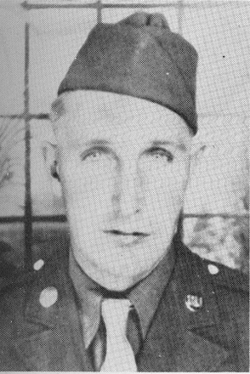
Lt. Thomas F. Archer, right [below], son of Mr. and Mrs. Frank Archer of Ipswich, reported for active duty on 10 February 1941 at Brookings, where he was a student at State College and an ROTC member. Qualifying for duty involving flying, Tom received training at Montgomery, Alabama, and Maxwell Field, Texas; and on 11 June 1942, he was commissioned as a 2nd Lieutenant bombardier at Midland, Texas. The following month he went overseas to Africa, and was immediately assigned to combat missions. On 1 September 1942, he was killed on a combat mission over Egypt.
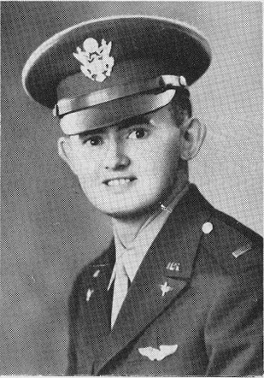
Pfc. Carl Pickett, Ipswich, son of Mr. John Pickett, was killed in action in Italy on 13 October 1943. He had served with the Infantry in North Africa before engaging in combat duty in Sicily and Italy. Further details not available.
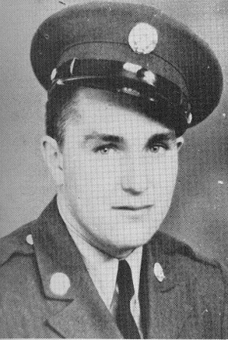
Private Roy E. Samp, right [below], son of Mr. and Mrs. Fred Samp of Ipswich and husband of Helen Engle-Samp, was inducted at Ft. Leavenworth on 10 February 1944. Following training at Ft. McClellan, Alabama, he shipped overseas in August, 1944, serving with Company c; 320th Engineer Battalion, 95th Infantry Division. In company with a squad of Engineers engaged in checking the streets of Saarlautem, Germany, with mine detectors, Roy was mortally wounded by sniper fire on 14 December 1944.
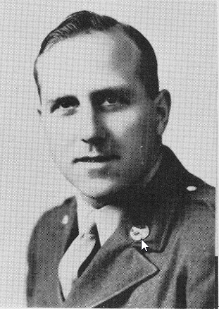
Lt. James M. Friedrichsen, left [below], son of Mr. and Mrs. E. L. Friedrichsen, of Loyalton, reported for induction at Ft. Snelling on 18 June 1941. In July, 1943, he departed for duty in the Pacific where he served with Company B, 63rd Infantry Regiment, 6th Division. His courageous conduct and leadership in action in New Guinea and Dutch New Guinea merited his field promotion to 2nd Lieutenant. On 26 February 1945, he was killed in action on Mt. Montalban on Luzon.
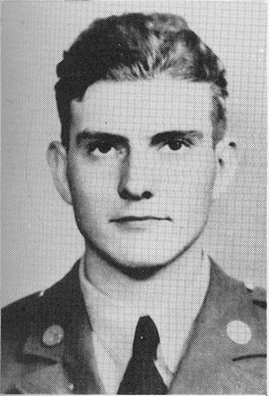
Pfc. Harold Erbe, right [below], son of Mr. and Mrs. Earl Erbe of Bowdle, entered service at Ft. Snelling on 27 October 1941, being one of the first to be drafted by Selective Service. Following training at Camp Wolters, Texas, he was directed to duty in Hawaii with an Infantry division. Participating in a series of combat experiences in the Pacific Theater, he was killed in action on Saipan on 2 July 1944.
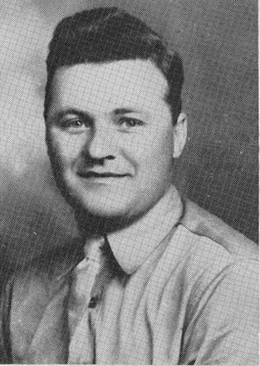
Corporal Aloysius M. Schumacher, left [below], son of Mrs. Martina Schumacher of Ipswich, reported for induction at Ft. Snelling on 15 March 1943. Following training at Ft. Kearns, Utah, and Ft. Pratt, Kansas, he went overseas in February, 1944. Stationed at Calcutta, India, he served with the Army Air Forces, being attached to the 44th Bombardment Group. Killed by an aircraft explosion on 22 January 1945.
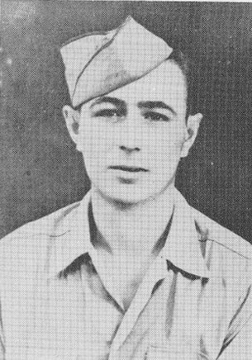
Lt. Calvin C. Miller, right [below], son of Mr. and Mrs. A. C. Miller of Loyalton, entered service at Ft. Snelling on 20 February 1941. Following initial training at Ft. Lewis, Washington, he transferred to the Army Air Corps; and in June, 1943, graduated as a 2nd Lieutenant at the Army Air Base, Marfa, Texas. Going overseas in February, 1944, he served as pilot of a "Flying Fortress" in the North Africa campaigns. On 2 April 1944, he was killed in action over Steyr, Austria, and is buried at the Military Cemetery at Metz, France.
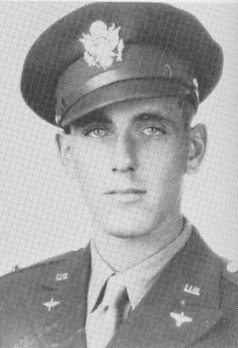
Theodore Feiock, left [below], son of Mr. Christ Feiock of Bowdle, entered the Navy in February, 1941. Following recruit training, he was assigned to submarine school and went to sea with the rating of Torpedoman Third Class. Serving aboard the USS Pickerel attached to Submarine Division 44, he was reported in June, 1943; and was declared lost in action on 10 August 1945.
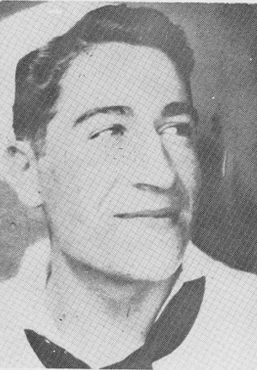
Albert Vilhauer, Hosmer, [below] son of Mr. and Mrs. Fred Vilhauer. (Service record not available.)
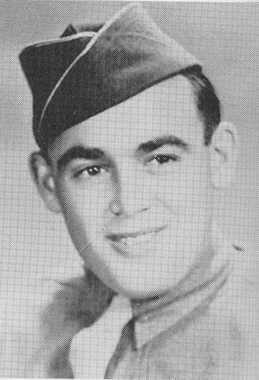
Pfc. Lloyd Blow, left [below], son of Mr. Ernest Blow, formerly of Ipswich, and husband of Ellen Blow-Papke of Mina, entered service at San Diego on 14 December 1943. Following his home base training in the Marine Corps, he shipped to the Pacific, where he served with Company F, 2nd Marine Battalion, 28th Marines, 5th Marine Division. Killed in action on Mt. Suribachi on Iwo Jima on 22 February 1945.
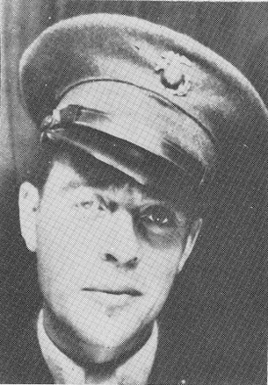
Robert G. Price, right [below], son of Mr. and Mrs. George Price of Mina, entered service at Aberdeen on 15 September 1942. Following recruit training at the Naval Station, Great Lakes, he subsequently attended training schools in Chicago, Norfolk, and Charleston. Serving overseas aboard the USS YMS-21, he participated in the invasions of Sicily and Salerno. On 1 September 1944, he was lost at sea when his ship was destroyed by a mine. His body was later recovered and buried at a military cemetery near Toulon, France.
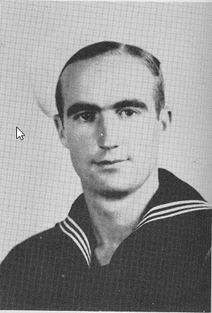
Private Bernard L. Williams, center, son of Mr. and Mrs. George D. Williams, formerly of Ipswich, entered service at Ft. McArthur, California, on 15 February 1942. Serving overseas with Company A, 312th Engineer Battalion, 87th Infantry Division, he experienced combat duty in the "Battle of the Bulge," and was killed in action on 11 January 1945 near Lebramont, Belgium.
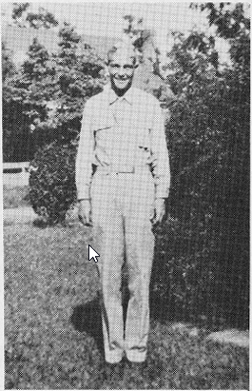
Private James L. Crisp, left [below], son of Mr. and Mrs. Ralph Crisp of Ipswich, reported for duty at Ft. Snelling on 30 December 1943. Following basic training, he was directed to Ft. McClellan, Alabama, for advanced training; and shipped overseas with Company D, 112th Infantry Regiment, 28th Division, in July, 1944. Killed in action on 20 December 1944, near St. Vieth, France, in the "Battle of the Bulge."
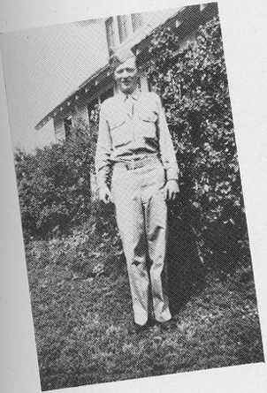
Sgt. Robert H. Leidholdt, right [below], son of Mrs. Jake Leidholdt of Bowdle, reported for induction on 12 April 1942. After receiving basic training at Williams Field, Arizona, he served at an air base in South Carolina until October, 1944, at which time he shipped overseas to India. On 12 June 1945, he was killed as a result of a plane crash in India.
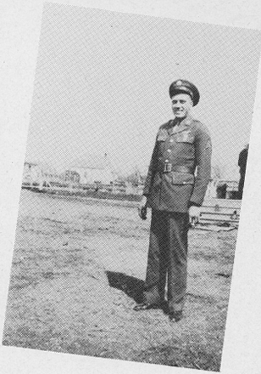
Lt. Harold M. Walth (not pictured), son of Mr. Martin Walth of Hosmer, entered service at Aberdeen in October, 1939. Following flight training at Army Bases in California and New Mexico, he was commissioned a 2nd Lieutenant, serving as a pilot of a B-24. In June 1943, he went overseas and before his death had completed more than fifty combat missions over China, Burma, and Siam. Killed in a plane crash near Kweilin, China, on 15 January 1944.

ADDITIONAL GOLD STAR VETERANS OF EDMUNDS COUNTY OF WHOM PICTURES AND SERVICE RECORDS WERE NOT AVAILABLE:
2nd Lt. Sebastion F. Baumgartner, Roscoe
John Dongl, Bowdle
Eugene MortelI, Hosmer
Leonard Mohr, Hosmer
Louis B. Krumm, Bowdle
*Rinehart Keppler, Hosmer
**Egird Zacher

*The story of the death of Rinehart Keppler, recipient of the Congressional Medal of Honor, appears in "Esquire's" feature as written by Paul Gallico, and reprinted on page ten of this history by their permission. Rinehart Keppler was the son of Reverend and Mrs. Gottlieb Keppler, formerly of Hosmer.
**Egird Zacher is listed by the War Department as of Edmunds County. This publication has been unable to obtain further identification.

