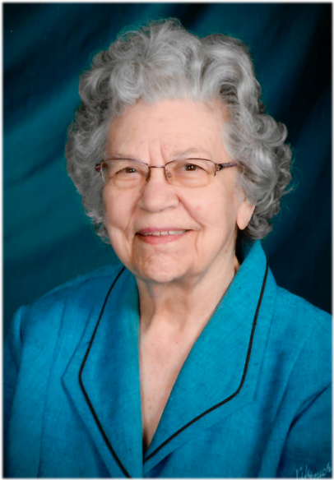
Fern Morse
Mar 20, 2017
Fern Leora Morse, 96, passed away on Sunday, March 19, 2017 surrounded by her family in her home.
She was born in Vermillion on September 30, 1920 to Leo and Dallie (Sealey) Marcotte. The eldest of six siblings, she attended school in Vermillion and in 1942, she enlisted in the Women’s Army Corps (WAC), where she served as a T-5 High Speed Radio Operator. She married her childhood friend, Warren Morse, in 1944. Fern and Warren lived in California for a short time, later moving back to South Dakota, and then, in 1951, moved to live in the Panama Canal Zone where they raised six children. While in the Canal Zone, Fern was employed by the U.S. Navy and retired after 30 years of service. Both Fern and Warren retired to their present home in Vermillion.
Fern was a member of Eastern Star; Odd Fellows/Rebekahs; American Legion; National Association of Federal Employees; Served as Mother Advisor for Rainbow Girls and for seven years; was the Supreme Deputy for the Order of Rainbow Girls in the Panama Canal Zone. She was active in church serving on the council for many years in the Canal Zone. She was always concerned about those less fortunate and would have special dinners for servicemen far from home in Panama. She organized several get-togethers for South Dakota people living in the Panama Canal Zone.
Preceding Fern in death are her husband, Warren Morse; son, Robert; brothers, Morris and Melvin Marcotte; sister, Ruth Lynch, daughters-in-law, Joann (Reed) Morse and Ann Catherine (Graham) Morse.
Survivors are sister, Betty Schmidt and brother, Roger Marcotte; sons, Richard (Susanna), Douglas and Charles Morse; daughters, Janelle(Pat) Kribell and Adrienne (David) Whitehead; 10 grandchildren; nine great grandchildren; two step-grandchildren; three step-great-grandchildren; and many nieces and nephews.
A memorial service will be held at 10:30 a.m. Thursday, March 23 at the First Baptist Church in Vermillion. Internment will at a later date in the National Cemetery in Sturgis, South Dakota.
Arrangements are being taken care of by Hansen Funeral Home in Vermillion, SD.
In lieu of gifts or flowers, please make donations to the Sanford Hospice, or Domestic Violence Safe Options Service in Vermillion.

