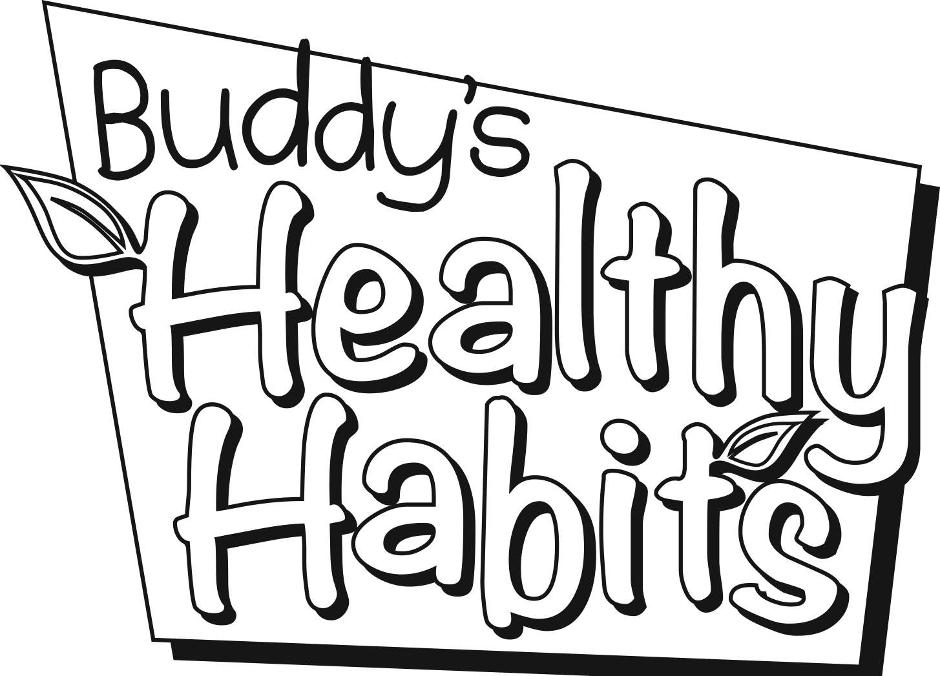
Brought to you by SDPB

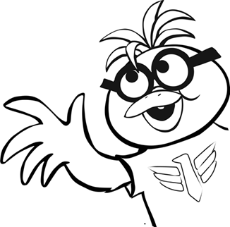
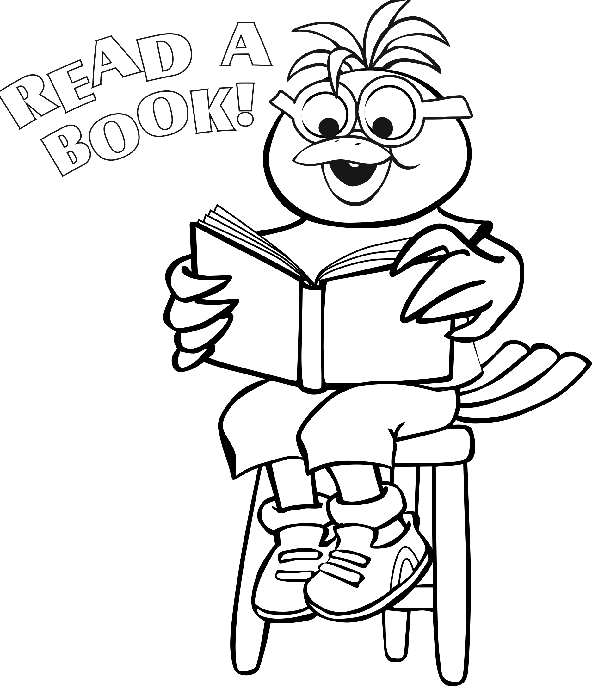

Open a book and peek. You never know who you will meet!

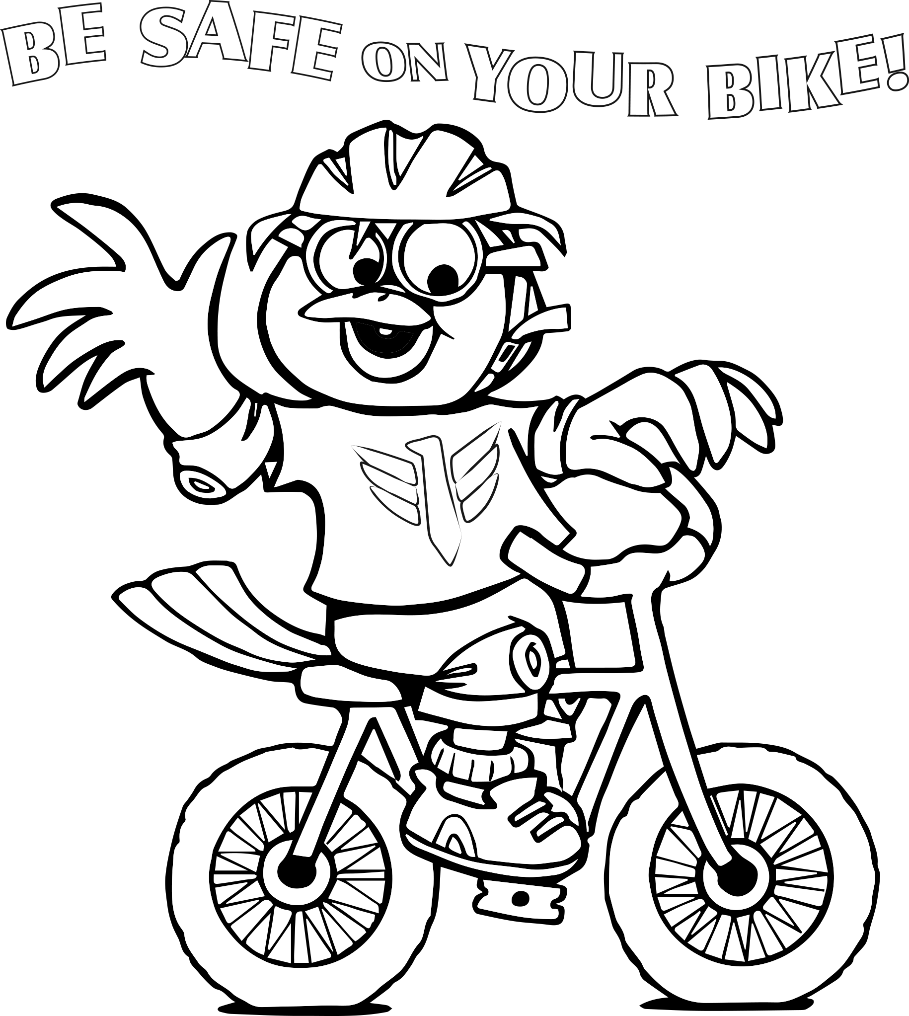

Helmet on the head and shoes on the feet. Stay on the sidewalk and not on the street! When riding a bicycle please be smart. Safety-first right from the start!
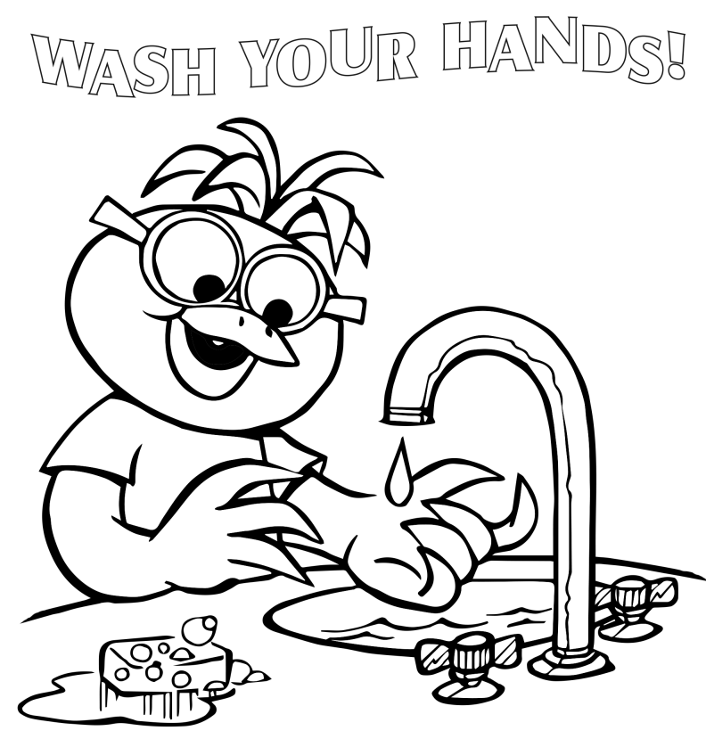

Wash your hands every day. Clean hands keep bad germs away!

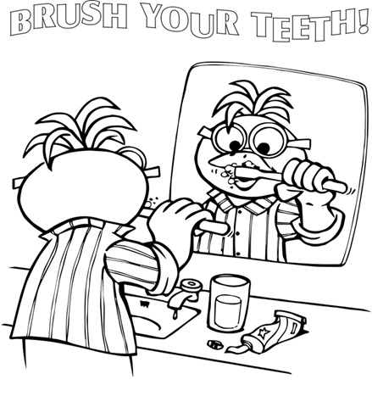

Keep your teeth healthy and bright. Brush your teeth both day and night!
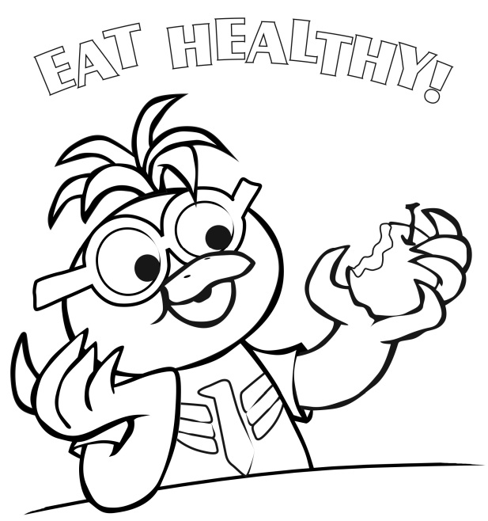

Take care of your body - you are what you eat. From the top of your head to the toes on your feet!

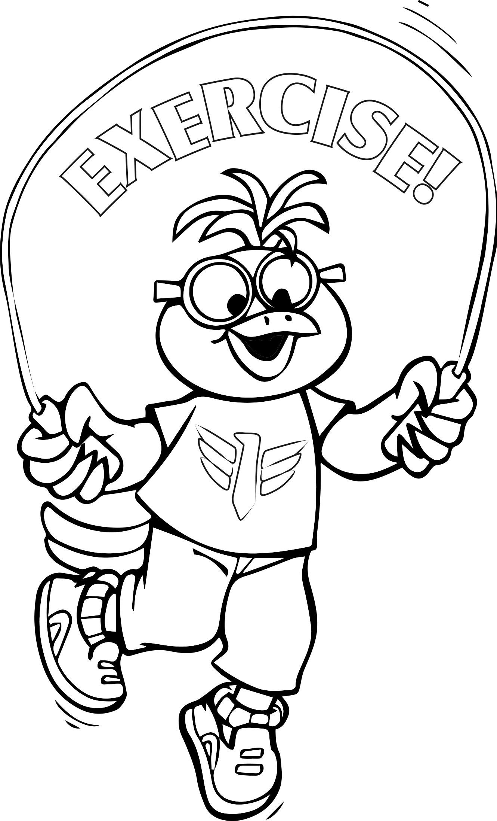

Run and jump, dance to a song! Hop and stomp and move along! Get moving, go outside and play. Exercise every day!


Beat a drum or sing a song. Blow a horn or clap along! Play guitar or hum a tune - even howl at night to the moon! Invite your friends, tell everyone! Making music is so much fun!

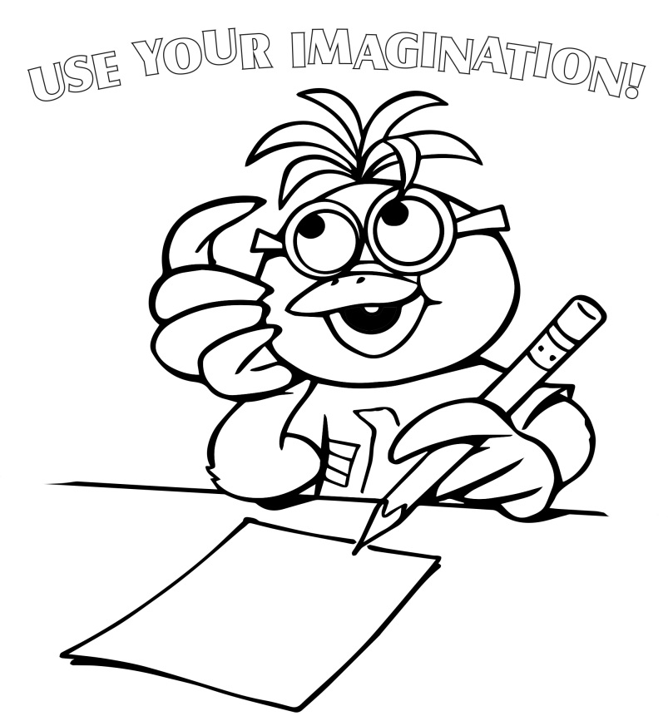
Create a dinosaur, buzz like a bee! Use your imagination and you'll see! Roar like a tiger, draw a tree. You can imagine anything you want to be!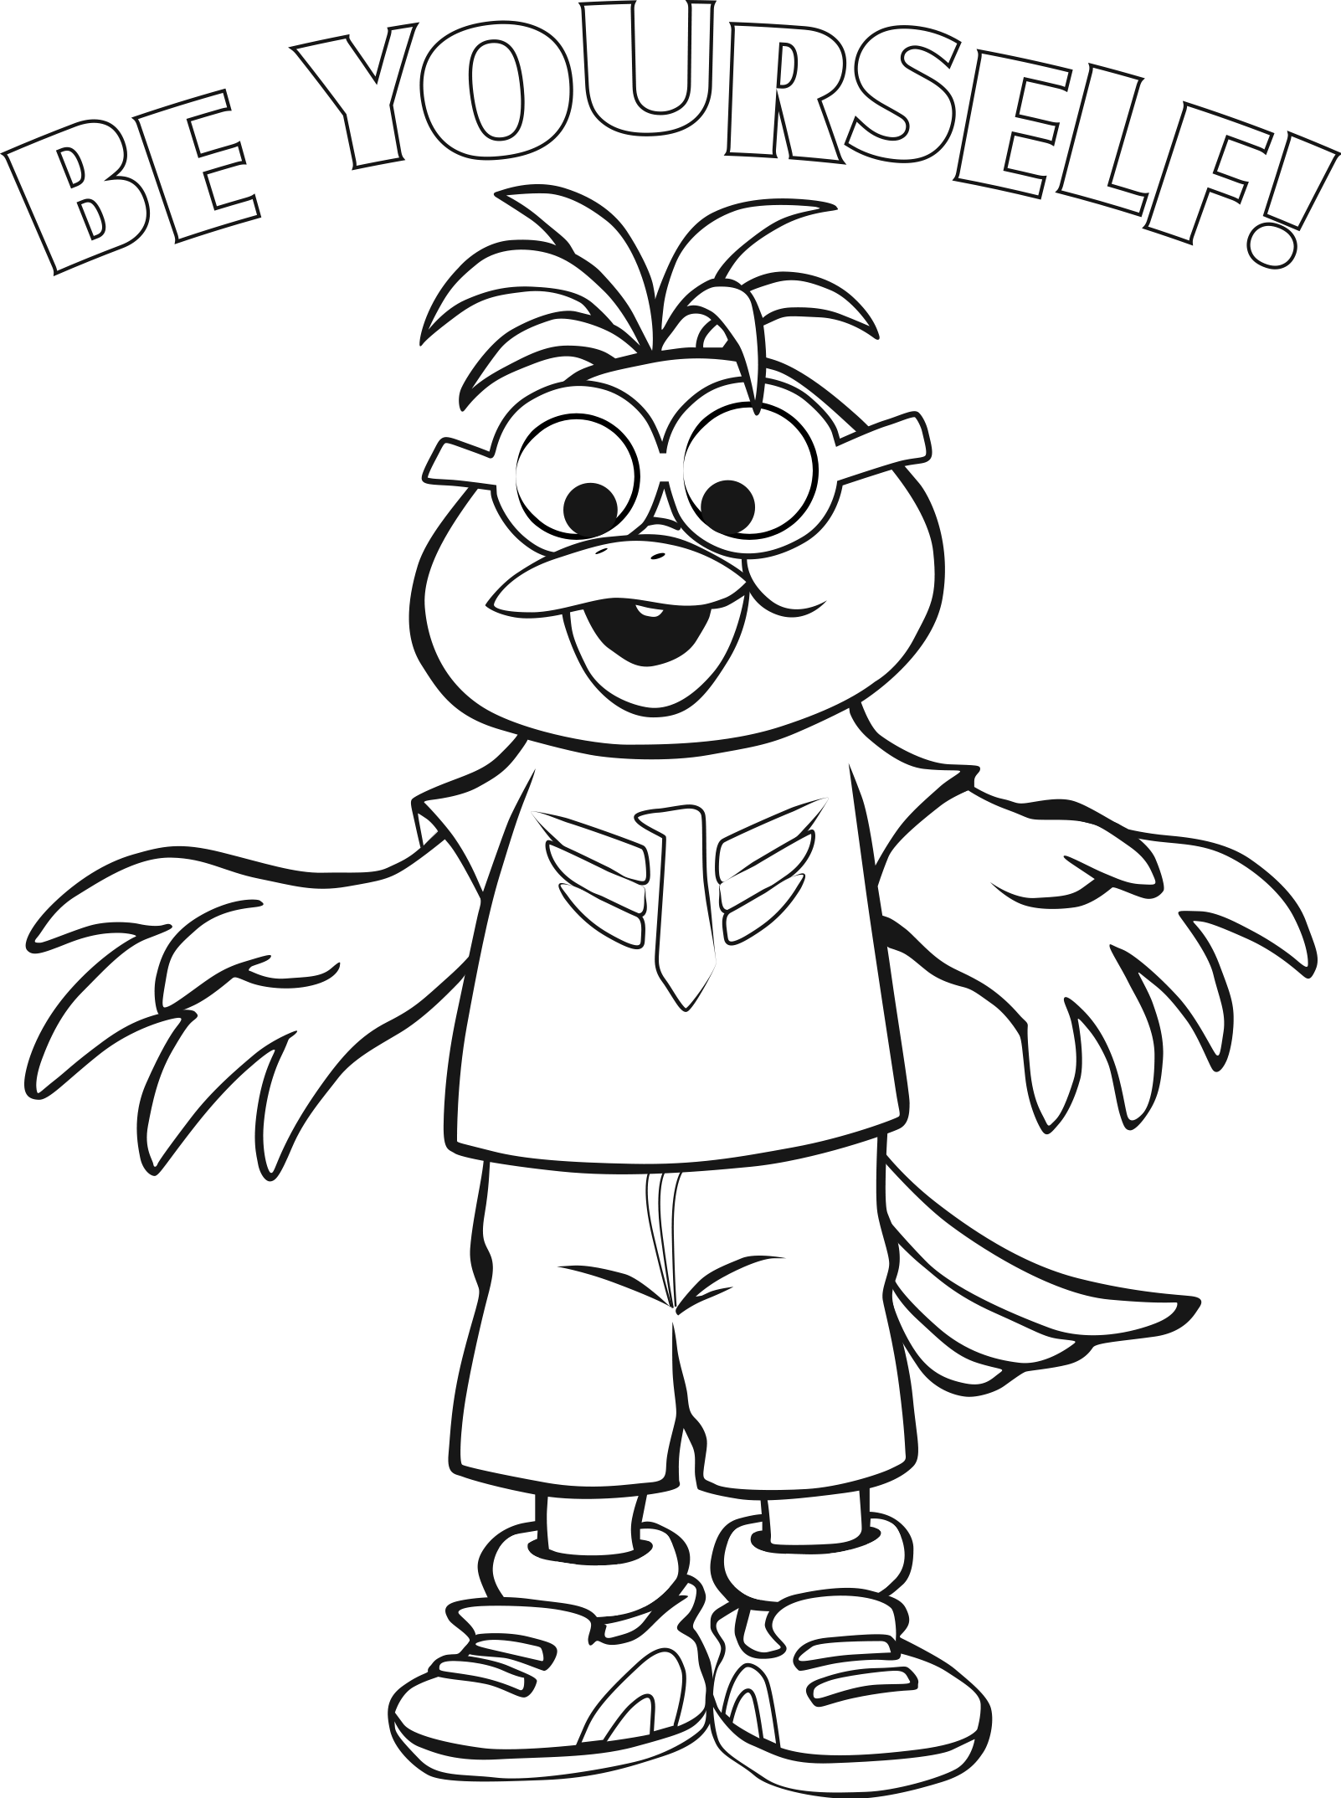
There is no one else quite like you and you are wonderful just being you! Believe these words, because they’re true. There is no better you than you!

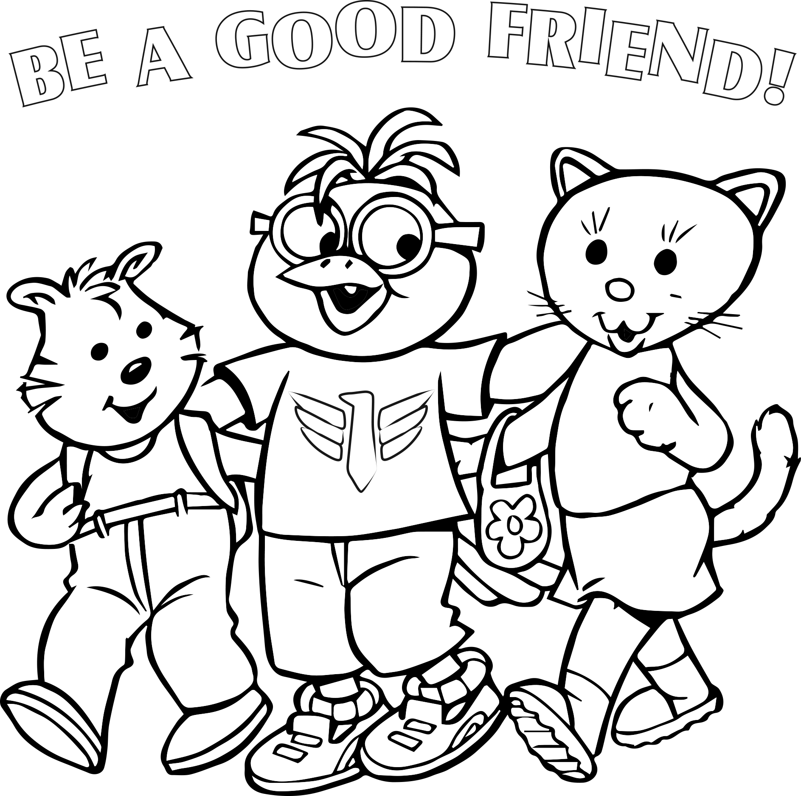

Be a good friend and show you care. Be a good friend and learn to share. Be a good friend when you play. Be a good friend every day!
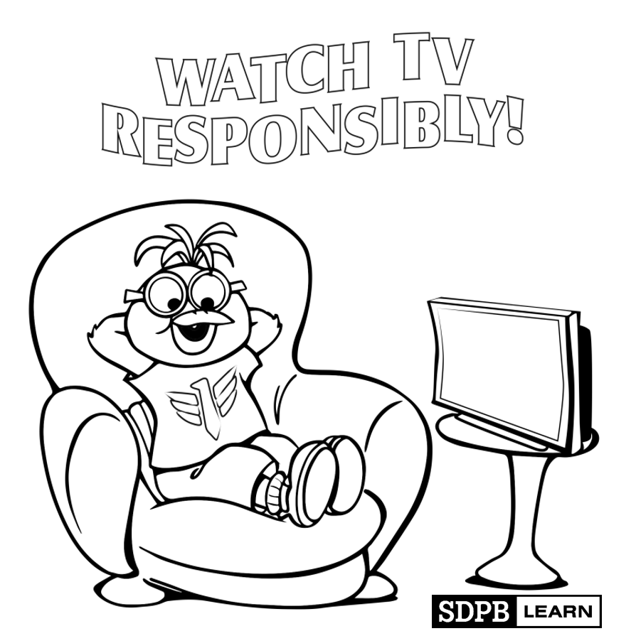

So many choices on TV. Be responsible with what you see. Your mind needs to learn and grow. SDPB has amazing shows! Learn, dream, and grow is what we do, and your pal Buddy is here for you! But don't watch all day - get out the door. There is a great, big world to explore!

