Class Activity: A Picture is Worth a Thousand Words

Introduction:
The following activity is like a standard book report with a twist. Each student must select a book to read and write a synopsis. Then, the students will draw a picture that represents the overall message of the book they selected. The illustrations will be displayed at the front of the room, and then all the students will guess which book matches each picture. Finally, each student will identify their illustration and book, provide a short overview of the book, and describe their illustration.

Materials:
- Library access (book selection)
- Computer access
- Drawing/copy paper
- Pencil, colored pencils, markers, etc.
- Check sheet
- A place to display illustrations

Process:
- The students should view Dakota Pathways #19: Telling Stories
- The students should read their book and complete the synopsis and illustration. The teacher will collect both the illustrations and the accompanying book.
- Each student should receive a check sheet. All the books chosen by the students should be placed at the front of the room. The books should be propped up so all the students can see the title of each book. The students should record the titles of the books displayed from left to right on their check sheets. The illustrations are displayed on a bulletin board or wall near the books. Each illustration is assigned a number - 1, 2, 3, etc. The students will use the check sheet to select one book for each numbered drawing.
- The student who read the first book displayed will come to the front of the room and identify their drawing. The student will give a brief overview of the book and describe their illustration. The other students should mark whether their guess was correct. Continue until all the students have identified their book. Each student should hand in their check sheet, synopsis, and illustration.

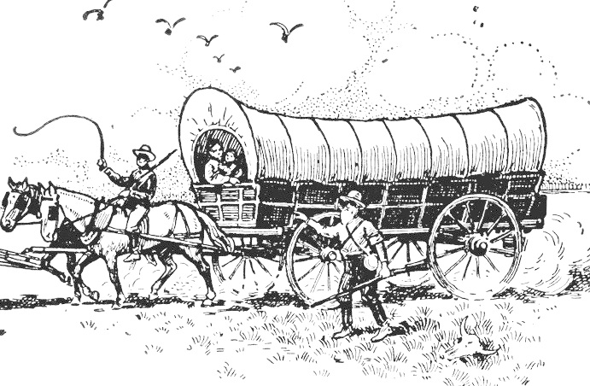
Image courtesy FCIT, http://etc.usf.edu/clipart



