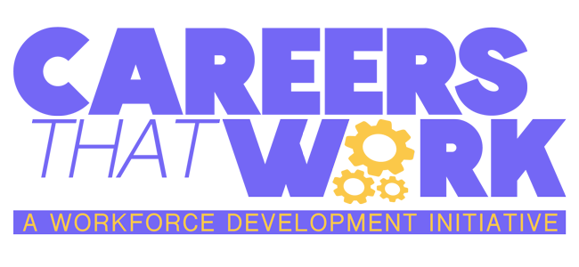


Licensed Professional Counselor Word Scramble
LNEATM THALEH

GIAEONDS

ICSLOTHI

YPMAETH

NEEGUNI

LSIECEN

TARESHTPI

Licensed Professional Counselor Word Scramble (Teacher Copy)
MENTAL HEALTH
DIAGNOSE
HOLISTIC
EMPATHY
GENUINE
LICENSE
THERAPIST

