Joseph Habeger Obituary
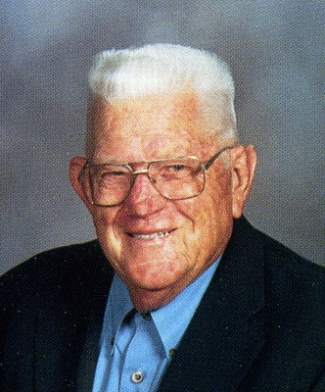
Joseph Habeger
Madison, SD - Joseph E Habeger, age 93, died at Bethel Lutheran Home on September 18, 2013.
He was born April 25, 1920 at Ramona, SD to John and Mae (Calligan) Habeger. He married Deloris Johnson at Ramona, SD on August 15, 1943. She preceded him in death in 1997.
He is survived by one son - Timothy (Shelby) of Atlanta, GA and one daughter - Sharon (Steven) Krog of Hartford, WI. One grand daughter - Nicolle and one grand son - Max.
He was also preceded in death by his parents, two brothers and two sisters.
Funeral Mass will be held at 10:30 AM on Saturday, September 21, 2013 at St Thomas Aquinas Church with Rev DeWayne Kayser officiating. Burial with military honors at the church cemetery.
He grew up in Ramona graduating from St Thomas High School in Madison. He graduated from Iowa State University in Ames. He enlisted in the National Guard in 1937 and went into active duty with the US Army Air Corps and served with the 15th Air Force during WWII, He flew 34 B-24 bomber missions out of Italy. He retired after 25 years as a Colonel and returned to Madison. He was a professor of Mathematics and Physics at Dakota State University for 20 years retiring in 1982. He was one of the founders of Prairie Village and the Prairie Village Historical Society. He was selected to the SD Hall of Fame in 2001.
There will be a parish scripture service at 7:00 PM on Friday at Weiland Funeral Chapel which is in charge of the arrangements.
To view a video tribute or to send a message of sympathy visit www.weilandfuneralchapel.com.

To plant trees in memory, please visit the Sympathy Store.
Published by Argus Leader on Sep. 19, 2013.

