RELUCTANT HEROES
by Dean O. Muehlberg

Loyd Brandt was typical of so many of those men, boys really, that went off to fight in World War II. He grew up in the hardscrabble existence that was part of pre-war rural South Dakota and America. Times were hard. Loyd and his brothers were “farmed out” to neighbors which meant long days of labor for room and board only. Like anyone trying to better themselves, make life a little more secure, and maybe see some of the world at the same time, he joined the Marines. His older brother, Harry, had joined in 1937, and his letters home wetted the appetite of the other brothers for some adventure.

Loyd is a handsome eighty years of age, looking more than twenty years younger. He is proud of his service and years in the Corps, but typical of one who has been part of the crucible of conflict, does not let on much about those things that shaped his youth. Like many who came through this gauntlet, this eye-opening glimpse of what men can do to other men, he came back, found work, raised a family, and retired. It was only then, so long after his ordeal, and when the normal trials of day-to-day existence calmed, that the images of his service in the Pacific at the age of 17, came back to haunt him. He sought help from veterans groups and associations, and today lives in an uneasy truce with those demons.

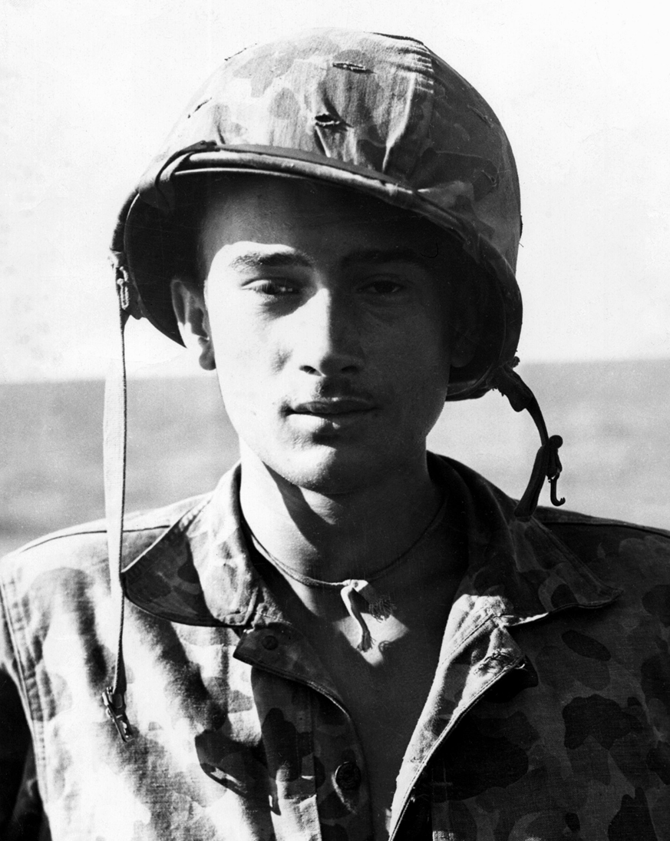
Seventeen year old Loyd Brandt in frog-skin utilities after sleeping around the clock on a destroy-er following several operations. Note dogtag cord. Dogtags were enclosed in rubber and hung down the back for noise and catch discipline. Right, Loyd today.
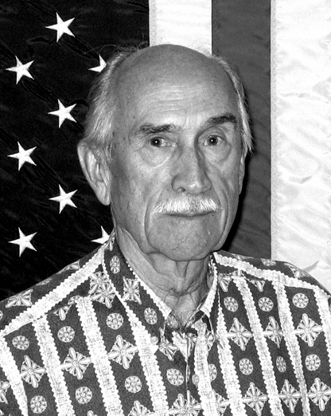

Loyd served from the islands of the Eniwetok Atoll through Iwo Jima to those of Okinawa, from February of 1944 through April of 1945, often withdrawing for rest and recovery on the very islands that they had fought for only days or weeks before. He was part of a great deal of the history of the entire Pacific cam-paign. He was on the detail that retrieved Lt. General Saito’s body from a cave on Saipan after the commander and the last defenders had fought to the death or com-mitted hara-kiri. He went ashore at night in rubber boats at Tsugen Shima off the coast of Okinawa to recon the island and left the island under fire with the rest of his unit, suffering two KIA and eight WIA. One squad of his unit covered the escape, literally backing into the sea and firing at the same time, allowing the others to find enough useable rubber boats to precede them, then finally dropping their weapons and swimming when they reached deep enough water.

At 800 hours, H-Hour, on February 18, 1944, Loyd and the other members of his 5th Amphibious Reconnaisance Company began the landing on the tiny island of Arbutus in the northern part of the ring of islands that is Eniwetok Atoll in the Pacific, a part of the Marshall Islands. They had entered the atoll from the south, traveling the twenty miles to its northern reaches through a break in the ring before loading into their landing craft, the LCP “Higgins” boat. This was one of Loyd’s first operations and he and his fellow Marines were being used as an assault company to contain the Japanese that would be trying to escape along the narrow isthmus that connected Arbutus to the larger island of Engebe where a main force of the enemy was entrenched and awaiting the invasion by the 22nd Marines. Loyd’s twin brother Lester was
with this other and much larger attacking force.

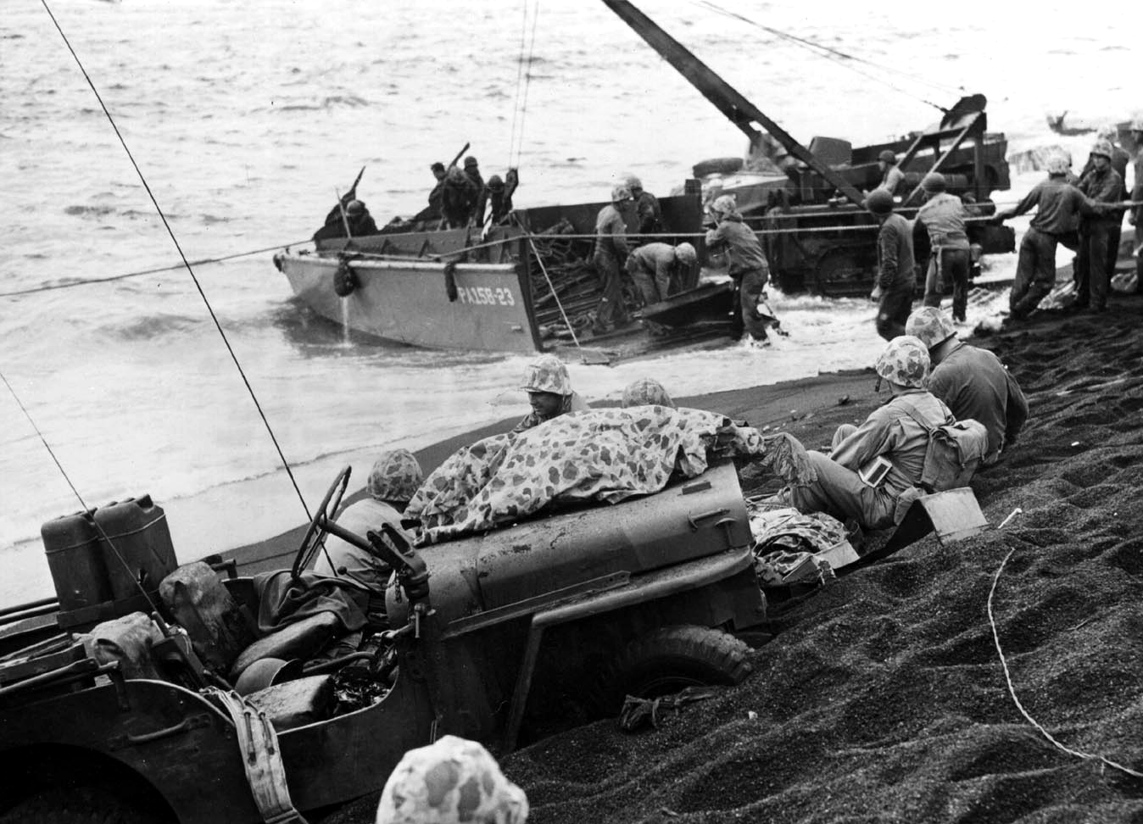

Fifth Marine Division men and equipment ashore on the Japanese held island of Iwo Jima in February 1945. The Higgins boat being unloaded in the surf is like the one Loyd Brandt rode onto Arbutus. He also landed with his unit on Iwo Jima. Note the painted-out jeep hood number.
Thirty men to an LCP, Loyd and the others stormed the small island on its southern shore, driving inland as far as they could before having to dig in. Loyd was part of the weapons platoon, and the 60mm mortars helped to save the day and prevent the Japanese from escaping, over-running Loyd’s small company, and fight-ing another day. At approximately noon their job was done. They left the island with their KIA and WIA and reboarded their destroyer, only to prepare for the several more recons and landings required in this one small atoll.

Loyd was part of the first Marine reconnaissance units used in the Pacific. He would go on to make over 55 landings with his company, many in rubber rafts, never knowing what would greet him in the darkness when his unit sneaked stealthily ashore into the backyard of the enemy, providing intelligence for the soon-to-come invasions. Many times they were used as assault or regular line troops, fighting their way across the dozens of small islands that had to be cleared. There were several days when sleep or rest were concepts that were not realizable. The timetable for recon missions was determined by the overall commander of the assault forces and they had to keep to the schedule.
Forty-five years after the seventeen-year-old Loyd had forged ashore at Arbutus amidst enemy shells and its life-changing experience, it was brought sud-denly back at a Dallas reunion of his old unit. A fellow Marine from that operation, Gunnery Sergeant Patrick, showed Loyd a picture, a clipping from a paper, and asked him if he recognized the people in it. It was a photo of the fighting on that island, a photo Loyd had no idea existed. One soldier, Private Smith, already wounded in seventeen places by shell fragments, was treating another, Lt. Lassiter, who had just been shot in the chest. The third soldier, on the left in the photo, was Sergeant Patrick. Loyd remembered the incident well, “I was just to the left of these men, out of the picture, and dropping rounds into the 60mm mortar as fast as I could to keep the Japs back!” After the reunion Loyd received a yellowed copy of an old war bond ad from a Scranton, PA newspaper of November 1944, in which the photo had been used, from the former 1st Lt. Russel Cory, a fellow recon Marine, and now retired Brigadier General.

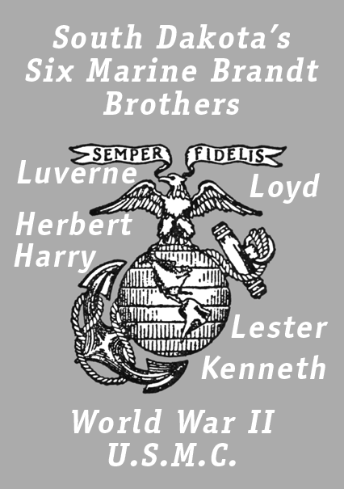

A copy of the ad is shown above. Lt. Lassiter survived to be wounded again more than once. Loyd recalls that he was a very fine and capable leader but had the unfortunate attribute of not being a good swimmer. His art in this area is described by the nickname that one of Loyd’s buddies, Joe Penkava, gave him. He was known as “Battlin’ Madelin, Queen of the Surf,” though not to his face.

On a subsequent operation at Ruunito Island, also in the Eniwetok Atoll, an incident occurred that sticks in Loyd’s memory. He was in an Amtrak, a self-propelled amphibious tank, loaded down with many Marines and many pounds of gear. As it started its trek to the beach the motor suddenly killed, setting it adrift in the chaos of the attack. It drifted over and under the
barrels of three of the Navy’s eight inch guns as the driver worked frantically to start the motor. Firing simultaneously, the surging compressed air from the barrels of the huge guns nearly capsized the Amtrak, sending it towards the shore and filling it with seawater. Now the men had to react. They bailed water like madmen, using their helmets to keep from sinking, a result that would have meant sure death for those aboard, their packs and equipment acting as personal anchors for each of them, carrying them swiftly to the bot-tom. Finally the motor was started and they made it to the beach where the terror of drowning had to be forgotten instantly, only to be replaced by the new terrors that lie just ahead. Loyd said their hearing was impaired for a week after this incident.

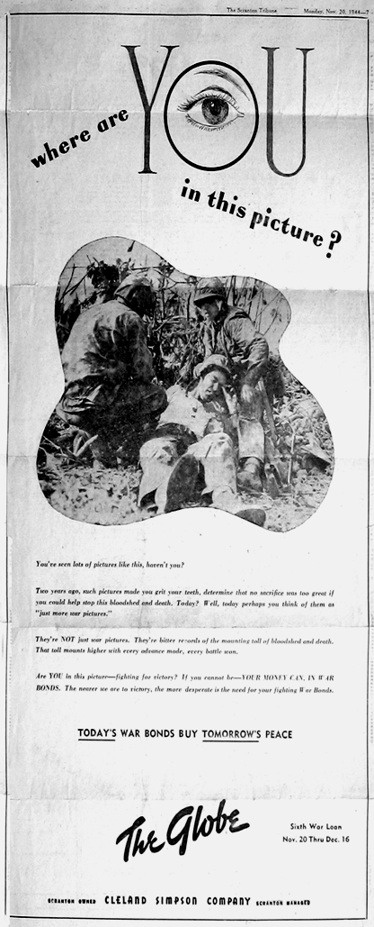Left, a November 1944 War Bond solicitation from a Scranton, PA newspaper, common during the war, in which a photo of action on Arbutus was used unbeknownst to the participants. Below, Marine Gunnery Sergeant Patrick, Lt. Lassiter and Private Smith during action on Arbutus in February 1944, as described herein.
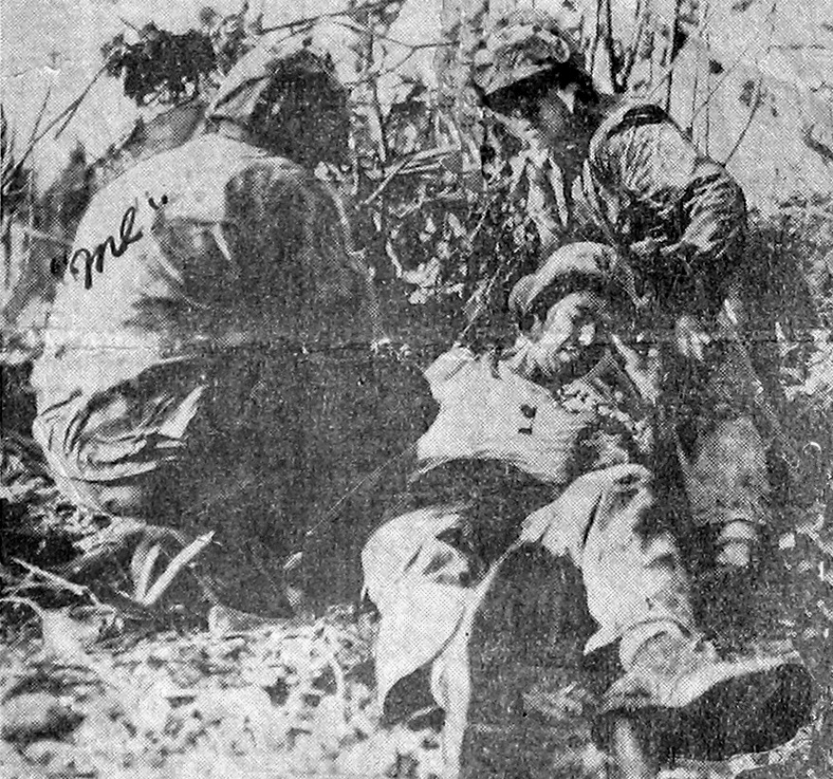

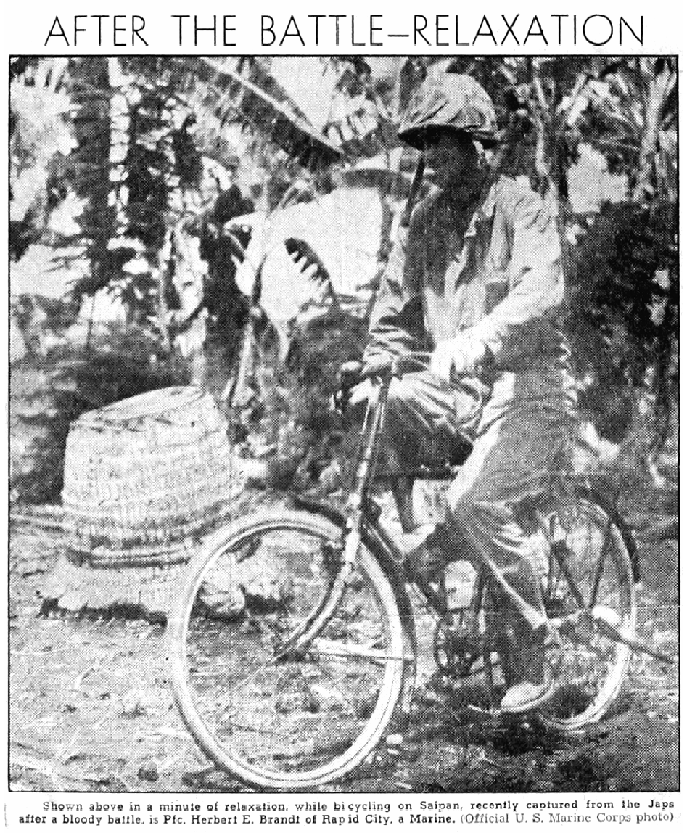

Above, Herbert Brandt riding a Japanese bicycle on Saipan only days before he was killed. Right, Herbert’s last letter home. It is in the form of “V-Mail,” the result of photographing the original and reducing it in size to cut the weight and volume of the correspondence. The photo is about three quarters actual size.

Loyd Brandt and the men of his weapons platoon are shown in the book “Swift, Silent, and Deadly” by Bruce F. Meyers (Naval Institute Press, 2004, ISBN 1-59114-484-1), a complete history of Marine Amphibious Reconnaissance in the Pacific from 1942 to 1945. Of the seven Brandt brothers, six served in the US Marine Corps in the Pacific in World War II. These brothers were Harry, Luverne, Kenneth, Lester, Loyd, and Herbert. One brother did not make it home. Almost as a premonition of what was to come, Loyd spent two days in a foxhole on Saipan staring at the body of a fellow Marine lying face down, grasping the tripod of a machine gun in rigor mor-tis, just forward of his position. Loyd couldn’t shake the feeling that this was his brother Herb, who he knew had passed this way only days before. He had to fight the impulse to run out and turn the body over. Finally, graves registration personnel came by and he was able to put it out of his mind. Only days later, however, what Loyd had feared for two days came to pass. As a bookend to the pain and tragedy of war, and the modern examination of it in the book and movie, “Born on the Fourth of July”, Loyd’s brother Herbert, died on the Fourth of July 1944 on Saipan in especially fierce fighting. Loyd was very close to Herbert and relates it was hard to get the news but that it might have been worse if he had not experienced the realities of war that he had already confronted. There was no time to grieve, only another burden to carry with him as he continued on with his unit in the Pacific. Herbert lives on in Loyd’s son, Douglas Herbert Brandt, who served with the US Army in Vietnam from 1970 to 1971.

Lester Brandt, Loyd’s twin, was severely wounded on Okinawa while running to the aid of another wounded soldier. A sniper’s round hit the BAR magazines on his back, which exploded and destroyed his kidney and spleen. He survived and lives in Napa, California today. It is easy to agree with the idea of “The Greatest Generation” when one meets someone like Loyd Brandt. Quiet and self-effacing, solid and steady, the men of this conflict pass off their trials as mere episodes among others in their lives. Yet the profound effect on their lives and outlooks is imprinted in their eyes and chiseled into their demeanor. They know their contribution was monumental, if only in small bites. They know what can be lost by gaining freedom. They know they may still suffer from those losses but know it was necessary. They, of anyone, know that life goes on, often without those who deserve recognition and who never received it because their remains lie in some graveyard thousands of miles from home.

Loyd never received a scratch for the months he spent in combat, oustside [sic] of a banged up knee he got running out into the dark to extinguish a fire started by a luminary grenade he had thrown from his position. It’s something he lives with like so many other survivors. There are no answers for the why of it all, and there never will be. Survivors are not to blame. They are here because someone out there wanted them here. They have to work at believing this, but as difficult as it is, they must. They must also be honored and val-ued by those who know them, and by those who do not know them – for the extraordinary sacrifices they made so long ago.

Dean O. Muehlberg is a US Army Vietnam veteran, and author of a book re-counting his Vietnam experiences, “REMF War Stories” (ISBN 1-4116-2944-2), available from www.lulu.com or www.amazon.com. Dean and his family live in Rapid City, South Dakota and he is a member of The Black Hills Veterans Writing Group.
(www.hpcnet.org/veterans)

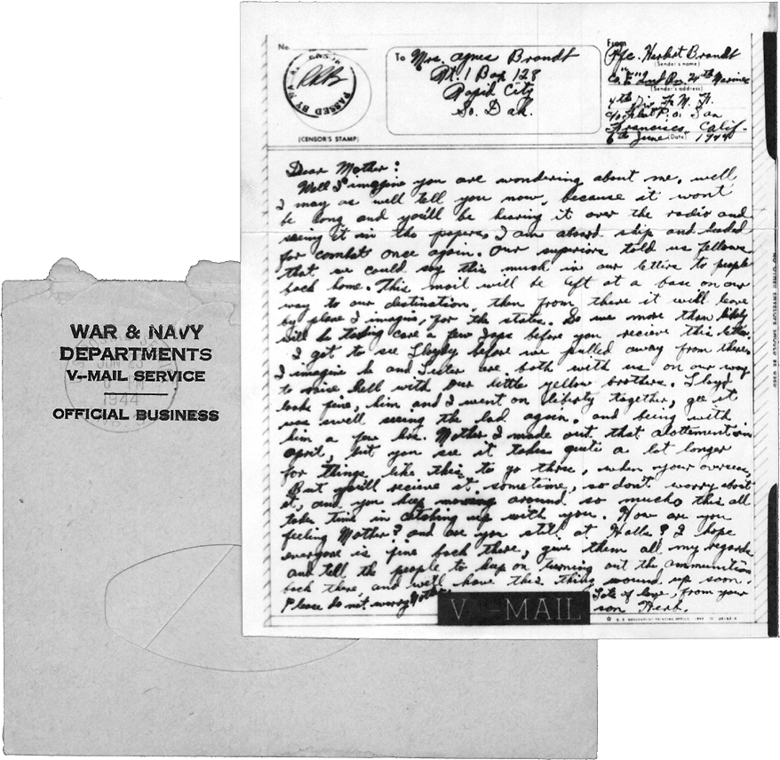
The image shows a piece of official World War II "V-Mail" stationery overlaid on top of its corresponding windowed envelope.
- The Envelope: Located on the left, it features a printed stamp reading "WAR & NAVY DEPARTMENTS / V-MAIL SERVICE / OFFICIAL BUSINESS." An oval cutout window is visible on the lower section.
- The Letter: Located on the right, the top section contains official form blocks. It is addressed to "Mrs. Agnes Brandt, R.R. 1 Box 128, Rapid City, So. Dak." The sender is listed as "Pfc. Herbert Brandt" with a Fleet Post Office (F.P.O.) San Francisco, Calif. address. It features a circular censor's stamp on the top left and is dated "8th June 1944." A black block at the bottom reads "V-MAIL".
Full Text Transcript:
Dear Mother:
Well I imagine you are wondering about me, well I may as well tell you now, because it won't be long and you'll be hearing it over the radio and seeing it in the papers, I am about ship and headed for combat once again. Our superiors told us fellows that we could say this much in our letters to people back home. This mail will be left at a base on our way to our destination, then from there it will leave by plane I imagine, for the states. So we more than likely will be taking care of a few Japs before you receive this letter.
I got to see Lloydy before we pulled away from there, I imagine he and Lester are both with me on our way to drive hell with our little yellow brothers. Lloydy looks fine, him and I went on liberty together, gee it was swell seeing the lad again, and being with him a few hrs. Mother I made out that allotment in April, but you see it takes quite a lot longer for things like this to go thru, when you're overseas, but you'll receive it sometime, so don't worry about it, and you keep moving around so much, this all takes time in catching up with you. How are you feeling Mother? And are you still at Wells? I hope everyone is fine back there, give them all my regards and tell the people to keep on turning out the ammunition back there and we'll have this thing wound up soon. Please do not worry Mother.
Lots of love, from your son Herb.
OCR limitations from the original photograph may have introduced transcription errors.
Unknown or uncertain text was preserved as closely as possible to the original image.

