On Vacation
Class Activity – Tourism Promotion: Then & Now
Introduction:
Tourism is big business in South Dakota, and it has been for a long time. “Travel South Dakota produces an annual report for each calendar year. The report provides an overview of the department's achievements during the preceding year.” (Current Report)

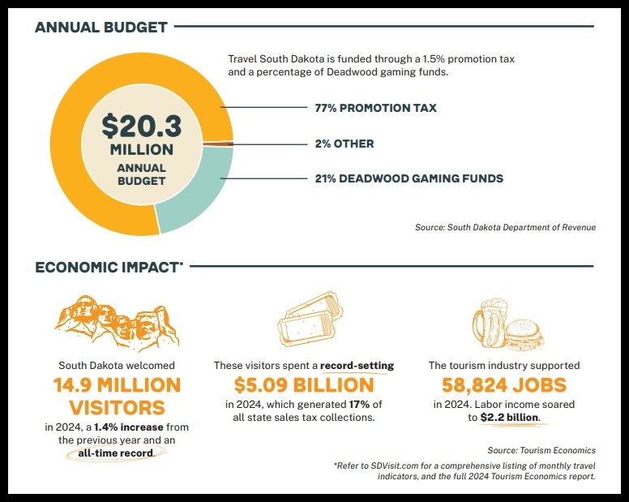

During this activity, your students will compare/contrast a South Dakota promotional film from 1938 to modern South Dakota tourism videos. Then your students will write a promotional blog entry (brochure) encouraging their family/friends to visit a destination in South Dakota.
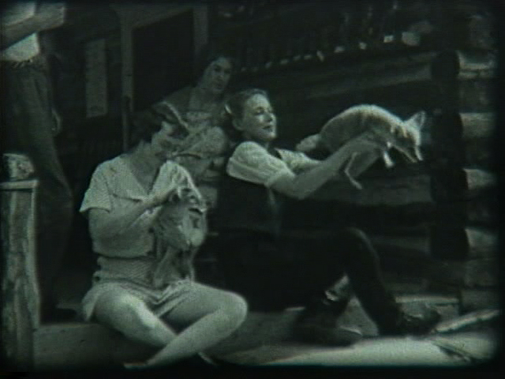
Women holding “tame” coyote pups. (Still from the film)
Process:

- Introduce the activity by showing the “Spearfish Canyon 1938” video (Watch PBS) and the photos on the following website. In 1938, the Burlington Northern Railroad produced and distributed the film to draw people to the Black Hills. The film would likely have been shown in movie theaters in advance of the featured program. (The film includes many situations that may have been encouraged at the time but seem dangerous/humorous now.)

- Watch current promotional videos on the South Dakota Department of Tourism YouTube site. A few direct links are provided below:
  - 5-minute spot
  - 1-minute spot
  - 30-sec spot

- Compare and contrast the video from 1938 to the modern Department of Tourism videos. Possible topics for discussion:

  - Safety concerns (Possible discussion: The 1938 video verbally encouraged dangerous activities; do the modern videos also encourage dangerous activities? If so, how do they encourage the activities differently and /or the same?)

  - Production format: The 1938 video is slower with complete narration compared to the current, fast-paced, music/technology-driven format. Do we expect this type of format now? Which is more appealing/entertaining?
  - Do they appeal to families?
  - Are they effective?

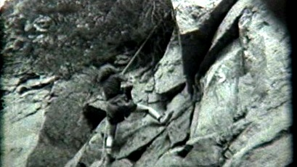
A young girl climbing a mountain in the Black Hills of SD. (Still from the film)

- Have the students select a location in South Dakota they have visited or would like to visit. They should research the location using the Internet. Personal photos or photos from trustworthy sites (South Dakota Tourism Flickr Account/ USDA NECS South Dakota) should be included.

- The students should design a promotional blog entry (brochure) encouraging their family/friends to visit the destination. (The blogs do not have to be published on a site unless you have the capabilities at your school.)

Taking it to the Next Level:

- Produce a promotional blog/video highlighting your school.



