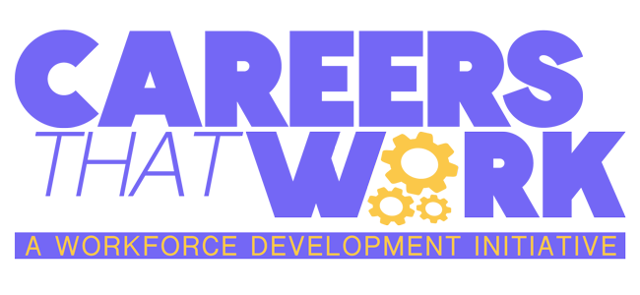


Lesson #3 - Careers That Work: Licensed Professional Counselor
Subject: Career Acquisition
Grade Levels: 6th Grade - 12th Grade

Standards
13.1.5.A - Describe the impact of individual interests and abilities on career choices.
13.1.5.B - Describe the impact of personal interest and abilities on career choices.
13.1.5.C - Relate the impact of change to both traditional and nontraditional careers.
13.1.5.F - Investigate people’s rationale for making career choices.
13.1.5.H - Connect personal interests and abilities and academic strengths to personal
career options.
13.1.8.A - Relate careers to individual interests, abilities, and aptitudes.
13.1.8.B - Relate careers to personal interests, abilities and aptitudes.
13.1.8.D - Explain the relationship of career training programs to employment
opportunities.
13.1.11.A - Relate careers to individual interests, abilities, and aptitudes.
13.1.11.B - Analyze career options based on personal interests, abilities, aptitudes,
achievements and goals.
13.1.11.C - Analyze how the changing roles of individuals in the workplace relate to new
opportunities within career choices.
13.1.11.E - Justify the selection of a career.
13.2.8.E - Explain, in the career acquisition process, the importance of the essential
workplace skills/knowledge, such as, but not limited to:
● Commitment
● Communication
● Dependability
● Health/safety
● Laws and regulations (that is Americans With Disabilities Act, child labor laws, Fair
Labor Standards Act, OSHA,
Material Safety Data Sheets)
● Personal initiative
● Self-advocacy
● Scheduling/time management
● Team building
● Technical literacy
● Technology

Objectives
Students will be able to outline the steps necessary to open a private counseling practice.

Duration
1 class period, 40 minutes
Materials
Personal computer or device

Activities
Tell the students:
You will be opening your own private counseling practice. Following the steps below, create a business plan and present it to the class.
- Decide what kind of a counselor you will be. Will you have a speciality? Family therapy? Couples counseling? Pediatrics? Eating disorders? Anxiety? Something else?
- Choose a business structure. Will you be a sole proprietor or will you have a business partner?
- Develop a vision or mission statement
- Name your therapy practice
- Outline a budget
  - How much do you expect to make (you can research average salaries for therapists online)
  - How much do you expect to spend (again, research things like rent, utilities, licenses)
  - Decide between private pay and insurance. Will you accept insurance payment?
- Decide what your therapy space will look like.
- Develop a marketing strategy. Will you use social media? Traditional marketing like television and radio? Or will you depend on your clients to bring in other clients (word of mouth)?

