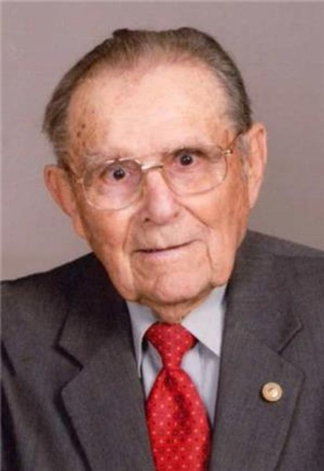
Eugene R Weidenbach
December 17, 1920 — February 27, 2021
Living a long, full life, Eugene was born on December 17, 1920 to Herbert and Lea (Auch) Weidenbach in a small farmhouse in Odessa Township in Yankton County. He was baptized January 30, 1921 at the Odessa Reform Church in Yankton County and confirmed July 6, 1935 at Bethany Reformed Church. Eugene attended Odessa School District 24 through the 8th grade and then served in the Civilian Conservation Corp (CCC) from the fall of 1937 through the spring of 1938.
In September 1942, Eugene was drafted into the U.S. Army at the age of 21 and served as a tank mechanic in the 533rd Ordinance Heavy Maintenance Company. He served 22 months overseas in Europe––receiving the French Jubilee of Liberty Medal for his service in the Battle of Normandy, American Theater Service Medal, European-African-Middle Eastern Theater Service Medal, and Good Conduct Medal 44. He was discharged and returned home on December 12, 1945.
Eugene and Lorene (Behl) were married September 8, 1946 at the Methodist Church in Scotland, South Dakota. Eugene proudly owned the original farm land that was homesteaded by his great-grandfather in 1873 and Eugene and Lorene spent many of their years on the farm.
Active in his community, Eugene served on numerous boards including the local Scotland Bethany Reform Church board, the national board of the Germans From Russia Heritage Society (12 years) and was president of the G.R.H.S. local chapter, the first president of the Yankton County Farm Bureau (15 years), the Yankton County Board of Education during the Yankton County reorganization (12 years), and served 15 years on the school board helping to build the former grade school in Scotland. He served on the original Landmann-Jungman Memorial Hospital Board of Directors for 15 years and was the last living original member. Eugene was also a member of the Scotland Historical Society, L.E.E. committee, and Gideons International. He was a member of the VFW post 2966 and American Legion Post 155 in Scotland for more than 65 years.

Eugene was a member at Salem Reformed Church in Menno. He and his wife Lorene enjoyed farming, gardening, spending time with family and friends, and traveling. They traveled from the North Arctic Circle to Acapulco, Mexico, along the Jordan River in Israel, and to many countries and cities in Europe. They were snowbirds to Mesa, Arizona for 13 years. In May 2004, Eugene went on the first S.D. Honor Flight to Washington D.C. to view the National WWII memorial where he was honored by Senator John Thune for his service. Lorene and Eugene retired and moved to Scotland in 2006, and Eugene stayed busy helping his sons Paul and Lyle on the farm, operating and fixing the machinery during harvest time, going to his grand and great-grandchildren’s church, school and sporting events, volunteering at the nursing home, and playing cards and dominos with family and friends. He also loved to go fishing for walleye with Lorene and his sons Paul and John, and teaching his grandkids to fish.
Eugene Raymond Weidenbach, 100, of Scotland, South Dakota passed away peacefully on February 27, 2021 at the Royal C. Johnson Veterans Memorial Hospital in Sioux Falls surrounded by his wife and children.
Eugene is proceeded in death by his son Delmar, his parents, his sisters Bernice Cass and Gladys Lund, brother Alvin, and daughters-in-law Leona Weidenbach and Lois Weidenbach.
He is survived by his wife Lorene of 74 years, his children Jeanette Herzog (Frank), Linda Pedersen (Leo), Lyle Weidenbach (Barb), Paul Weidenbach, and John Weidenbach (Deb), his 13 grandchildren, and 28 great-grandchildren and 3 step-great-grandchildren.
His family reflects on his incredible 100-year life, from traveling by horseback as a boy to serving in WWII to witnessing man land on the moon. He was the last living WWII veteran in Scotland. Eugene taught his family to love and serve the Lord, to work hard, to put family first and to be grateful for all that God provides. He will be greatly missed.

