Terminal Velocity Activity using Coffee Filters

During this activity, your students will use coffee filters to investigate air resistance, friction, and terminal velocity. Your students will design and conduct an experiment in which they will drop coffee filters to see how an increase in weight affects the rate at which the filters drop.
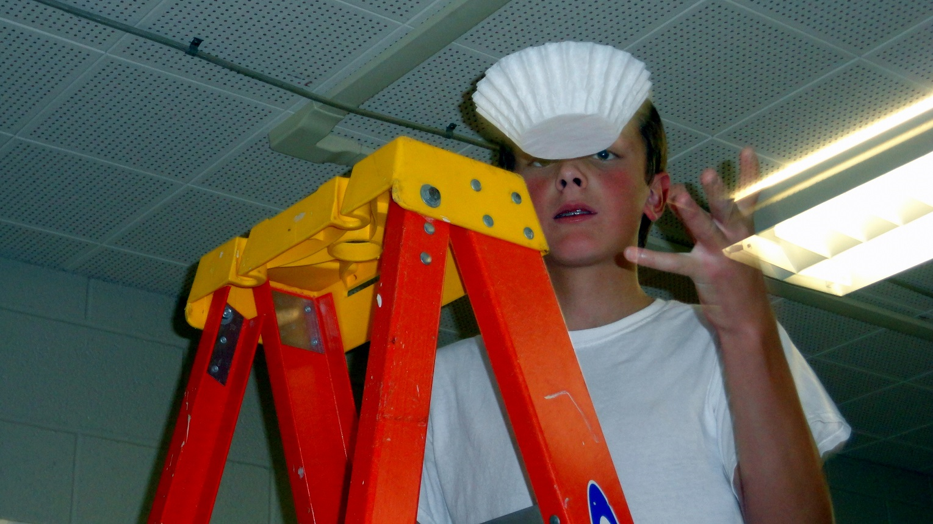

Lesson summary
Introduce the activity by teaching the students about historic snowstorms in your area. Visit with the students about different-sized snowflakes they have seen in the past. Excluding wind, discuss the rates at which different-sized snowflakes fell to the ground. In general, the larger the snowflakes, the slower the descent.
If you are from an area without snow, the following examples should work well. In South Dakota, we are always talking about the last big snowfall or storm. We all have memories of a particular storm, but how do they really compare? On February 8th and 9th of 1909, the Sioux Falls region experienced one of the largest snowfalls on record. The storm began in Sioux Falls at about 2:00 PM on Monday and ended early Wednesday morning. Officially the storm dropped 21” of snow in Sioux Falls. The snowfall was accompanied by high winds, which created large drifts.
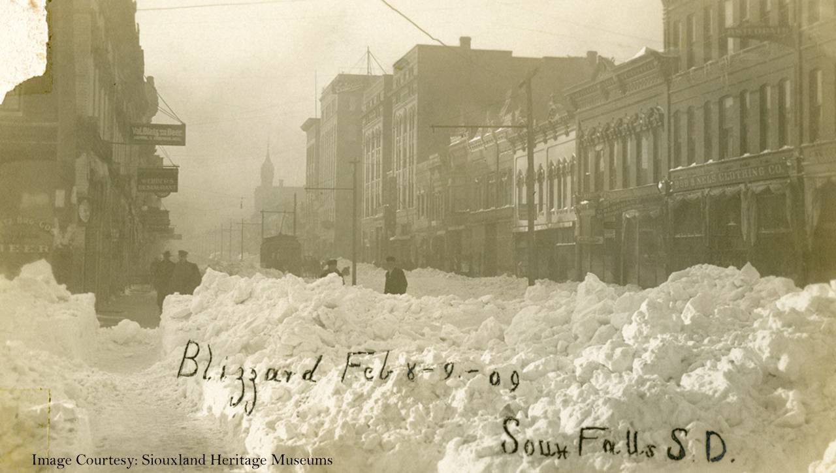
- View photos and learn more about this storm and other South Dakota storms at the following website - South Dakota Snowstorms.
- Interesting Historic Fiction
  - Laura Ingalls Wilder’s The Long Winter Research Article - Fact or Fiction? "The story of the winter of 1880/81 has been retold in historical fiction, including Laura Ingalls Wilder’s The Long Winter, as well as in local histories and folklore."
    - The aftermath of the long winter in South Dakota
      - The Missouri River Flood of 1881
      - A Meandering Past - The Flooding of the James River Valley 1881

Supplies
- Coffee filters
- Tall object
- Calculator
- Stopwatch
- Tablet to record results

Introductory activity
- The students should watch the following PBS LearningMedia video, which introduces and explains terminal velocity. (PBS LearningMedia – Earth’s Gravity)
- Show a simple demonstration in which a full sheet of paper is dropped at the same time as a crumpled-up piece of paper. Compare the drop rate of the two pieces of paper that have the same weight but a different surface area.

Culminating activity
- Your students will design and conduct an experiment in which they will drop coffee filters to see how an increase in weight affects the rate at which the filters drop.
  - They should drop one coffee filter multiple times. The time taken for each drop should be recorded and averaged.
  - They should continue the experiment by stacking one additional filter and recording the amount of time the filters take to fall the same distance. The time taken for each drop should be recorded and averaged.
  - They should continue the experiment by stacking additional filters (adding one at a time) and recording the amount of time the filters take to fall the same distance. The time taken for each drop should be recorded and averaged.
They will increase the weight without increasing the surface area. The air resistance (drag force) does not change. Example results are shown below. (The greater the distance dropped, the easier it will be to observe time.)
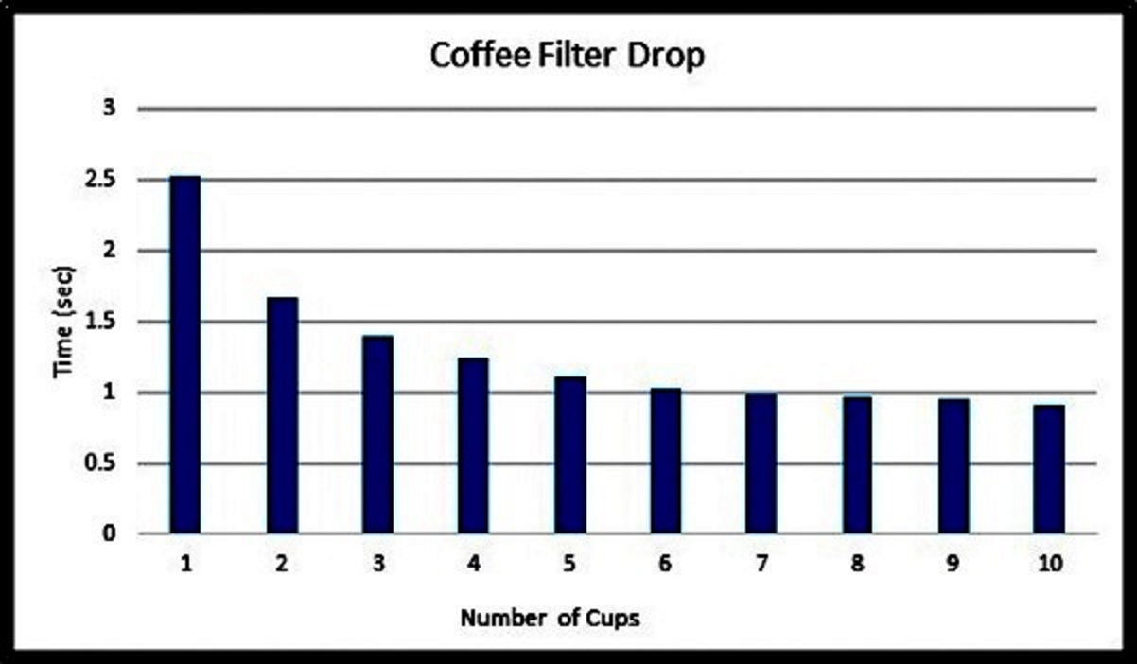
This is an interesting and inexpensive phenomenon-based activity to introduce your students to vector (magnitude and direction) addition in relation to the forces of falling objects. The two vectors in this investigation include weight (gravity) and drag (air resistance).
Coffee filters work extremely well for this activity because each filter has a large surface area for its weight, resulting in terminal velocity being reached relatively quickly. Terminal velocity is reached once the dropped filter(s) stop accelerating. Once terminal velocity is reached, the filter(s) will continue to fall at the same downward velocity.



