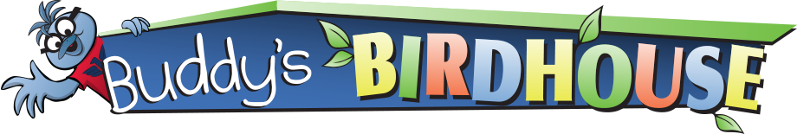

Common Bird Calls in South Dakota
Below are links to the sounds of some of Buddy’s bird friends found in South Dakota. Take a walk outside with a family member or friend and listen for the following bird sounds.
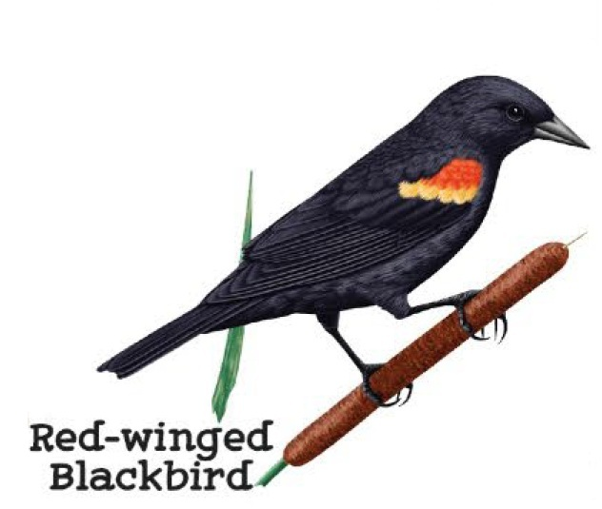

Birds:
Blue Jay
Cooper’s Hawk
White-breasted Nuthatch
American Goldfinch
House Sparrow
Black-capped Chickadee
American Robin
European Starling
Northern Cardinal
Dark-eyed Junco
Red-winged Blackbird
House Finch
American Tree Sparrow
Downy Woodpecker
Rock Pigeon
American Crow
Red-breasted Nuthatch
Hairy Woodpecker
Bown-Headed Cowbird

Additional bird sounds found at the Cornell Lab.



